Table 1-1 Fermentation reactions examples
Product | Reaction | ΔG^{0’}(kJ/mole)
Lactate | C₆H₁₂O₆ 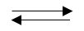2 CH₃CH(OH)COO⁻ + 2 H⁺ | -198.1
Butyrate | C₆H₁₂O₆ + 2H₂O CH₃2(CH₂)COO⁻ + 2 HCO₃⁻ +2 H₂ + 3H⁺ | -254.4
Propionate + Acetate | 1.5 C₆H₁₂O₆ 2 CH₃CH₂COO⁻ + CH₃COO⁻ + HCO₃⁻ + 4H⁺ | -109.9

Table 1-2 Acetogenic reactions examples
Substrate | Reaction | ΔG^{0’} (kJ/mole)
Lactate | CH₃CH(OH)COO⁻ + 2 H₂O CH₃COO⁻ + HCO₃⁻ + 2H₂ + H⁺ | -3.96
Butyrate | (CH₃)₂(CH₂)COO⁻ + 2 H₂O 2 CH₃COO⁻ + 2 H₂ + H⁺ | +48.1
Propionate | CH₃CH₂COO⁻ + 3 H₂O CH₃COO⁻ + HCO₃⁻ + 3 H₂ + H⁺ | +76.1

Table 1-3 – Different types of methane-forming microorganism
Substrate | Substrate utilization reaction | Archaea
Hydrogen | CO₂ + 4 H₂ + H⁺CH₄ + 3 H₂O | Methanobacteriales, Methanococcales, Methanomicrobiales, Methanopyrales
Acetic acid | CH₃COOH CH₄ + CO₂ | Methanosarcinales
Formate | 4 HCOO⁻ + 4 H⁺ CH₄ + 3 CO₂ + 2 H₂O | Methanobacteriales, Methanomicrobiales, Methanococcales
Methanol | 4 CH₃OH 3 CH₄ + CO₂ + 2 H₂O | Methanosarcinales
Methylamines | 4 (CH₃)₃N + H₂O 9 CH₄ + 3 CO₂ + 6 H₂O + 4 NH₃ | Methanosarcinales

Table 1-4 – Fixed film reactors treating industrial wastewaters
Wastewater treated | Packing material | OLR  (kg COD/m³ d) | COD_{rem} (%) | HRT  (d) | Methane Yield (m³CH₄/kg COD_{rem}) | References
Distillery | Charcoal, coconut coir and nylon | 23.3 | 64 | 8 | 0.31 | Acharya et al. (2008)
Bulk drug industry | PVC rings | 10 | 60 - 70 | 1.7 | 0.25 | Gangagni Rao et al. (2005)
Distillery | Charcoal | 8 - 19 | 80 - 51 | 8 | - | Acharya et al. (2011)
Sugary | PVC pipe pieces | 3.0 | 82 | 0.5 | - | Pradeep et al. (2014)

Table 1-5 – UASB reactors treating different industrial wastewaters
Wastewater treated | OLR (kg COD/m³d) | COD_{rem}  (%) | HRT  (h) | Methane Yield (m³CH₄/kg COD_{rem}) | References
Dairy | 28 | > 90 | 48 | - | Kalyuzhnyi et al. (1997)
Sugary | 4 | > 90 | 43 | 0.34 | Mijaylova Nacheva et al. (2009)
Sugary | 24 | 80 | 7 | 0.35 | Mijaylova Nacheva et al. (2009)
Textile | 6 | > 90 | 24 | - | Somasiri et al. (2008)
Brewery | 3 | 85 | 12 | 0.34 | Cronin and Lo (1998)

Table 1-6 – AFR treating different industrial wastewaters
Wastewater treated | Carriers type | OLR  (kg COD/ m³ d) | COD_{rem}  (%) | HRT (d) | Methane Yield (m³CH₄/kg COD_{rem}) | Reference
winery distillery (IFBR) | perlite | 4.5* | 85* | 1.5 | - | Garcia-Calderon et al. (1998)
Brewery (IFBR) | triturated polyethylene | 10 | < 90 | 4 | 0.35 | Alvarado-Lassman et al. (2008)
Brewery (IFBR) | Silica | 30 | < 90 | 4 | 0.35 | Alvarado-Lassman et al. (2008)
petrochemical | bone charcoal | 21.7 | 95 | 2.5 | 0.45 | Patel and Madamwar (2001)
petrochemical | bone charcoal | 20.4 | 95 | 4 | 0.37 | Patel and Madamwar (2001)
IFBR – Inverse Fluidized Bed Reactor; * as Total Organic Carbon (TOC).

Table 1-7 – Anaerobic baffled reactor treating different industrial wastewaters
Wastewater treated | OLR  (kg COD/m³ d) | COD_{rem} (%) | HRT (d) | Methane Yield (m³CH₄/kg COD_{rem}) | References
Brewery | 5.6 | 90 | 15 | - | Hassan and Dahlan (2013)
Pulp and Paper | 5 | 60 | 48 | 0.18 | Grover et al. (1999)
Palm Oil Mill | 1.6 | 77 | 3 | 0.33 | Faisal and Unno (2001)

Table 1-8 – Anaerobic hybrid reactor treating different wastewaters
Reactor Type | Wastewater treated | OLR  (kg COD/m³d) | COD_{rem} (%) | HRT (d) | Methane Yield (m³CH₄/kg COD_{rem}) | References
AF-UASB | distillery | 8.7 | 80 | 5 | 0.34 | Sunil Kumar et al. (2007)
UASFF | yeast | 9 | 75 | 3 | 0.32 | Büyükkamaci & Filibeli (2002)
UASB-MBBR | fruit-juice | 6 | 65 | 0.8 | 0.33 | Tawfik & El-Kamah, (2012)
UASB-MBBR | winery | 25 | > 80 | 0.75 | - | Wahab et al. (2014)
UASB-AFR | synthetic* | 6 | 75 | 1.7 | 0.21 | Kundu, Sharma, & Sreekrishnan (2013)
*glucose and yeast; AF-UASB: anaerobic filter – upflow anaerobic sludge blanket reactor; UASF: upflow anaerobic sludge bed fixed film reactor; UASB-MBBR: upflow anaerobic sludge blanket – moving bed biofilm reactor; UASB-AFR: upflow anaerobic sludge blanket – anaerobic fluidized bed.

Table 1-9 – Different type of media and specific surface area
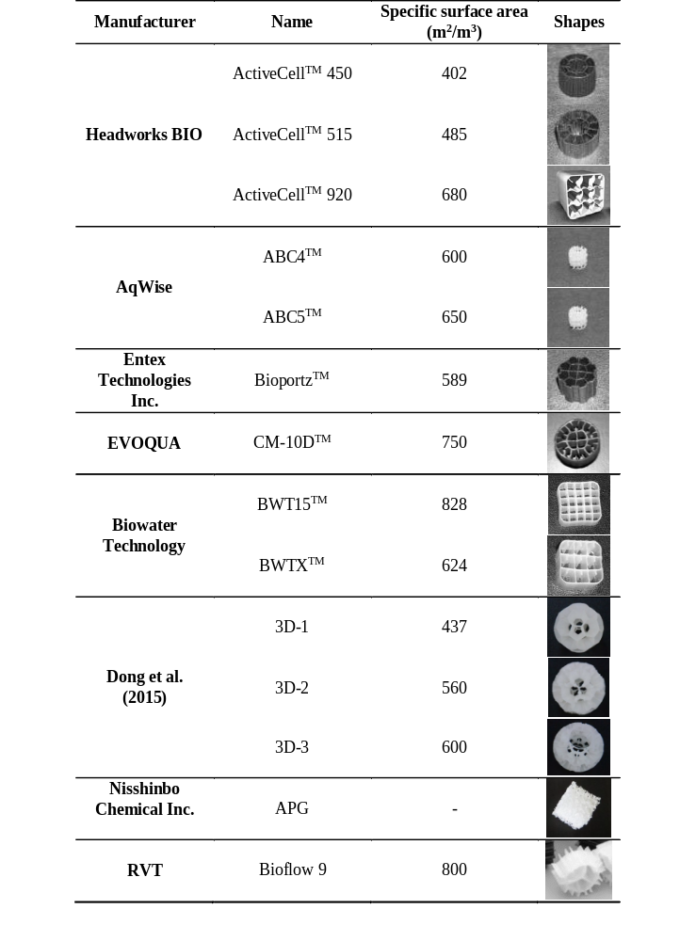
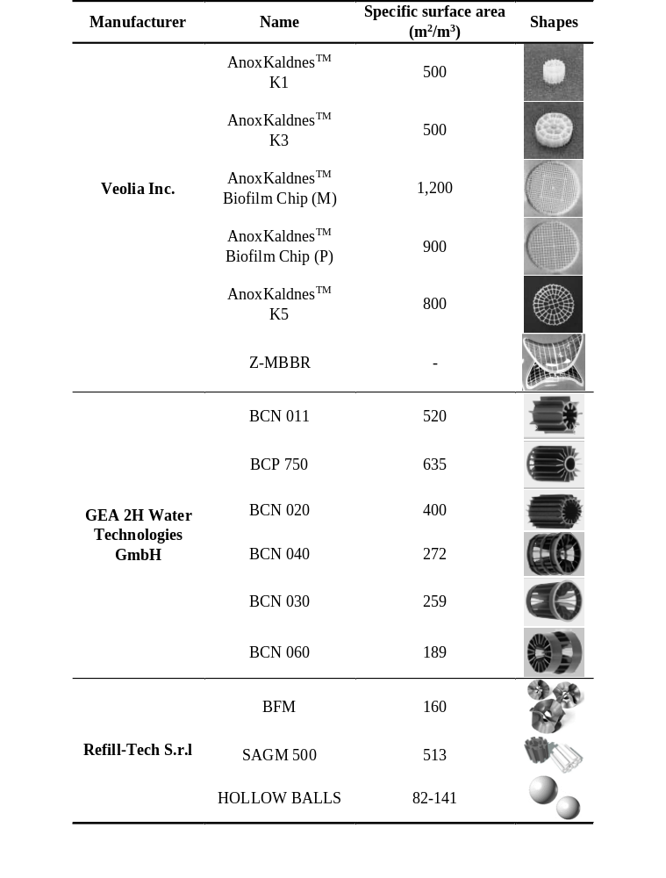
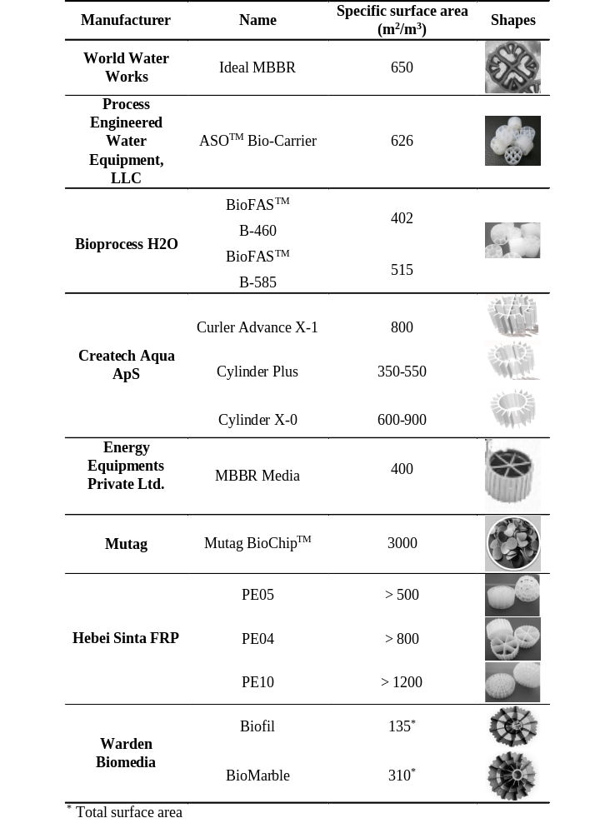
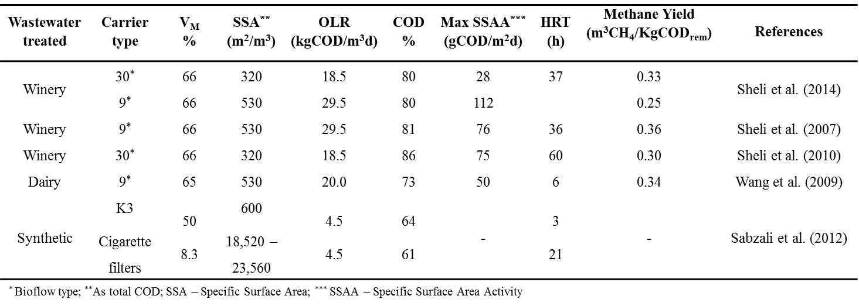
Table 1-10 – AMBBR treating industrial wastewater
Table 1-11 – Typical brewery wastewater characteristics (Chastain et al., 2011)
Parameter | Typical Range | Unit
Water to beer ratio | 4 – 10 | L/L
Wastewater to beer ratio | 1.3 – 3.5 | L/L
BOD₅ | 0.6 – 5 | kg/m³
COD | 1.8 – 5.5 | kg/m³
Total Nitrogen | 0.03 – 0.1 | kg/m³
Total Phosphorus | 0.03 – 0.1 | kg/m³
pH | 3 – 12 | -
Total suspended solids | 0.2 – 1.5 | kg/m³

Table 1-12 – Requirement from City of Winnipeg sewer by-law No.92/2010
Parameter | Threshold | Unit
TSS | 0.35 | kg/m³
BOD₅ | 0.3 | kg/m³
TN | 0.06 | kg/m³
TP | 0.01 | kg/m³
Animal or vegetable oil and grease | 0.1 | kg/m³
Mineral or synthetic oil and grease | 0.15 | kg/m³
pH | 5.5 – 11 | -

Table 2-1 – Micronutrient concentrations
Micronutrient | Value | Units
FeCl₂•4H₂O | 1.5 | mg/L
MnSO₄•H₂O | 0.085 | mg/L
CaCl₂ | 0.18 | mg/L
MgSO₄•H₂O | 0.69 | mg/L
CoCl₂•6H₂O | 0.48 | mg/L
H₃BO₃ | 0.006 | mg/L
ZnSO₄•7H₂O | 0.14 | mg/L
CuSO₄•5H₂O | 0.0025 | mg/L
Na₂MoO₄•2H₂O | 0.556 | mg/L
NiCl₂•6H₂O | 2.38 | mg/L
Na₂SeO₃•5H₂O | 0.263 | mg/L

Table 2-2 - Brewery wastewater characterization
Parameter | Value | Unit
sCOD | 5.8 ± 2.2 | kg sCOD/m³
COD | 6.9 ± 2.7 | kg TCOD/m³
BOD₅ | 5.3 ± 0.2 | kg BOD₅/m³
BOD₅/COD | 0.77 | -
TSS | 0.35 ± 0.12 | kg TSS/m³
VSS | 0.3 ± 0.1 | kg VSS/m³
BOD₅ is the 5 days Biological Oxygen Demand; sCOD is the soluble Chemical Oxygen Demand; COD is the total Chemical Oxygen Demand; TSS is the Total Suspended Solids and VSS are the Volatile Suspended Solids.

Table 3-1 – AMMBR influent and effluent characteristics for the entire study
 | Parameter | Minimum | Maximum | Average | Standard Deviation | Unit
Influent | pH | 6.4 | 7.1 | 6.7 | 0.1 | -
Influent | TSS | 0.1 | 3.6 | 0.5 | 0.6 | kg TSS/m³
Influent | VSS | 0.1 | 2.3 | 0.4 | 0.4 | kg VSS/m³
Influent | sCOD | 2.6 | 5.9 | 3.8 | 1.0 | kg sCOD/m³
Influent | TCOD | 2.8 | 9.2 | 5.0 | 1.6 | kg TCOD/m³
Influent | BOD₅ | 2.1 | 7.1 | 3.8 | 1.2 | kg BOD₅/m³
Effluent | pH | 6.7 | 7.3 | 7.0 | 0.1 | -
Effluent | Alkalinity | 1.3 | 2.0 | 1.6 | 0.1 | kg CaCO₃/m³
Effluent | TSS | 0.1 | 0.8 | 0.3 | 0.2 | kg TSS/m³
Effluent | VSS | 0.1 | 0.8 | 0.3 | 0.1 | kg VSS/m³
Effluent | sCOD | 0.1 | 1.8 | 0.7 | 0.5 | kg sCOD/m³
Effluent | TCOD | 0.3 | 2.6 | 1.1 | 0.6 | kg TCOD/m³
Effluent | BOD₅ | 0.2 | 2.0 | 0.9 | 0.5 | kg BOD₅/m³
Results presented neglecting the first week after a particular change of HRT was made.

Table 3-2 – Review of AMBBR processes treating industrial wastewater
Wastewater treated | Carrier |  | sCOD rem (%) | SALR  (g sCOD/m² d) | Reference
Wastewater treated | Type | SAA  (m²/m³) | sCOD rem (%) | SALR  (g sCOD/m² d) | Reference
Wine distillery | R30* | 320 | 85 | 87 | Sheli et al. (2010)
Wine distillery | R9* | 530 | 80 | 85 | Sheli et al. (2014)
Dairy | R9* | 530 | 85 | 58 | Wang et al. (2009)
Brewery | AC920 | 680 | 70 | 87 | This study
Brewery | AC920 | 680 | 80 | 56 | This study
Brewery | AC920 | 680 | 85 | 40 | This study
Brewery | AC920 | 680 | 90 | 24 | This study
* Bioflow manufactured by Raushert Co.
Table 4-1 – Beer production and wastewater generation rates
Size | Beer Production (m³/d) | Wastewater : beer produced (m³/d)
Size | Beer Production (m³/d) | 2 : 1 | 4 : 1 | 10 : 1
Small | 3 | 5 | 11 | 27
Medium | 137 | 274 | 548 | 1370
Large | 411 | 822 | 1644 | 4110

Table 4-2 – Mass of COD produced in different breweries size

Size | Wastewater : beer produced (kg COD/d)
Size | 2 : 1 | 4 : 1 | 10 : 1
Small | 30 | 40 | 49
Medium | 1507 | 2000 | 2466
Large | 4521 | 6000 | 7397

Table 4-3 – Surface area loading rates at particular sCOD percentage removal
sCOD % removal | SALR (g sCOD m³/d)
80 | 69
85 | 46
90 | 23

Table 4-4 – Total surface area required to achieve COD 80 and 90 % removals
 | > 80 COD rem |  |  | > 90 COD rem
 | Wastewater : beer production |  |  | Wastewater : beer production
Brewery size | 2 : 1 | 4 : 1 | 10 : 1 | 2 : 1 | 4 : 1 | 10 : 1
Small (m²) | 542 | 719 | 887 | 1245 | 1653 | 2038
Medium (m²) | 27102 | 35971 | 44348 | 62267 | 82645 | 101891
Large (m²) | 81305 | 107914 | 133044 | 186800 | 247934 | 305672

Table 4-5 – Media volume (m³) required for the three types of media selected
Size | Wastewater per beer ratio | > 80 COD rem |  |  | > 90 COD rem
Size | Wastewater per beer ratio | AC450 | AC515 | AC920 | AC450 | AC515 | AC920
Small | 2 : 1 | 1.3 | 1.1 | 0.8 | 3.1 | 2.6 | 1.8
Small | 4 : 1 | 1.8 | 1.5 | 1.1 | 4.1 | 3.4 | 2.4
Small | 10 : 1 | 2.2 | 1.8 | 1.3 | 5.1 | 4.2 | 3.0
Medium | 2 : 1 | 67 | 56 | 39.9 | 155 | 128 | 92
Medium | 4 : 1 | 89 | 74 | 52.9 | 206 | 170 | 122
Medium | 10 : 1 | 110 | 91 | 65.2 | 253 | 210 | 150
Large | 2 : 1 | 202 | 168 | 119.6 | 465 | 385 | 275
Large | 4 : 1 | 268 | 223 | 158.7 | 617 | 511 | 365
Large | 10 : 1 | 331 | 274 | 195.7 | 760 | 630 | 450

Table 4-6 – Design parameters for AC920 media at 70% fillings
sCOD removal  (%) | Total surface area required  (m²) | Volume media required  (m³) | Reactor volume  (m³) | Effluent concentration  (gBOD₅/L)
85 | 19500 | 29 | 41 | 0.675
90 | 39100 | 58 | 82 | 0.45

