Supplementary Data (Web Only Files)

Taru Manyanga, Maria Froese, Ryan Zarychanski, Ahmed M. Abou-Setta, Carol Friesen, Michael Tennenhouse, and Barbara L. Shay. Pain management with acupuncture in osteoarthritis: A systematic review and meta-analysis

Table S1. Research question using PICOS structure
Table S2. Study eligibility criteria
Table S3. PubMed/MEDLINE search strategy
Table S4. Needle location for each trial
Figure S1. Funnel plot for pain intensity
Figure S2. Subgroup analysis (clinical considerations)
Figure S3. Subgroup analysis (methodological considerations)
Figure S4. Adverse Events

Table S1. Research question using PICOS structure
Population | Adults (18 years or older) diagnosed with osteoarthritis
Intervention | Traditional acupuncture
Comparator(s) | Usual care, no treatment, sham acupuncture
Outcomes | Primary Outcome  - Pain intensity  Secondary Outcomes  - Functional mobility  - Health related quality of life  Safety Outcomes  - Adverse events
Study design | Prospective randomized controlled trials

Table S2. Study eligibility criteria
Inclusion Criteria | 1. Majority of studies (>80%) where participants are adults (18 years and older)) diagnosed with osteoarthritis.  2. Prospective, randomized controlled trials  3. Acupuncture administration.
Exclusion Criteria | 1. Studies involving animals.  2. All patients received some sort of acupuncture-based intervention  3. Quasi-randomized controlled trials (e.g., alternate randomization, randomization according to hospital number) and non-randomized trials (e.g. cohort and case-control studies).  4. Studies in which electro-acupuncture was the intervention, or electrical stimulation of the needles was performed.

Table S3. PubMed/MEDLINE search strategy
- Osteoarthritis [MeSH Terms]
- Osteoarthritis OR Osteoarthritides OR osteoarthroses OR Degenerative arthritis OR Degenerative Arthritides OR Osteoarthrosis Deformans
- Acupuncture[MeSH Terms]
- Acupuncture OR Acupuncture therapy OR (Acupuncture AND therap*)
- (randomized controlled trial[pt] OR controlled clinical trial[pt] OR randomized[tiab] OR placebo[tiab] OR drug therapy[sh] OR randomly[tiab] OR trial[tiab] OR groups[tiab] NOT (animals[mh] NOT humans [mh])
- (#1 OR #2) AND (#3 OR #4) AND #5

Table S4. Needle location for each trial
Scharf, 2006 | ST34; ST36; Xiyan; SP9; SP10; GB34
Williamson, 2007 | ST35; ST36; Xiyan; SP9; SP10; GB34; Liv3
Foster, 2007 | ST34; ST35; ST36; Xiyan; SP9; SP10; GB34
Witt, 2006 | ST34; ST35; ST36; Xiyan; SP9; SP10; GB33; GB34
White, 2011 | Not specified
Vas, 2004 | ST36; ST40; SP9; GB34; EXLE5
Levi-Ari, 2011 | ST35; Xiyan; SP5; GB34
Soni, 2012 | ST34; ST36; SP9; SP10; GB34; L3; L8
Haslam; 2001 | ST44; GB29; GB30; GB34; GB43; L14
Saleki, 2013 | ST34; ST35; ST36; SP9; SP10; GB34
Ashraf, 2013 | ST35; ST36; ST44; GB34; EX31; EX32; DU 20; BL60
Dickens | Not specified

Figure S1. Funnel plot for pain intensity
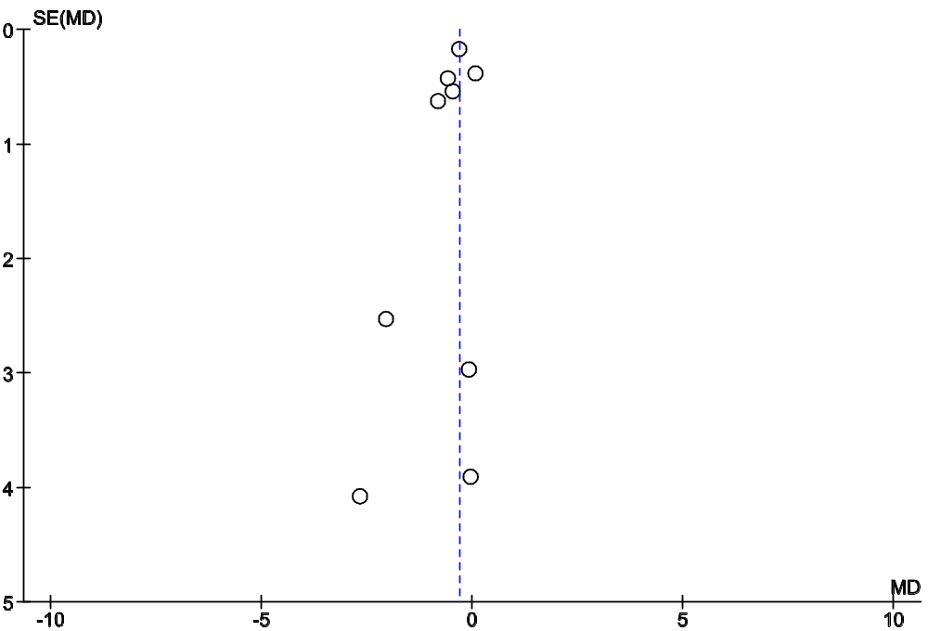

SE = standard error; MD = mean difference

Figure S2. Subgroup analysis

Mean Difference
IV, Random, 95% CI
Point
Estimate
Lower
limit
Upper
limit
-0.38
-0.69
-0.06
-0.06
-0.56
0.44
-0.30
-0.65
0.05
-0.27
-0.67
0.14
-0.25
-0.57
0.07
Duration of Intervention
More than 4 weeks
Four weeks or less
Type of Comparator
Sham acupuncture
Other comparator
Number of sessions
Ten or more
Less than 10
-0.59
-1.18
-0.01

-2.00

-1.00

0.00

1.00

2.00

Favours Acupuncture
Favours Control
Clinical considerations

CI = Confidence interval; IV = inverse variance

Figure S3. Subgroup analysis
Mean Difference
IV, Random, 95% CI
Point
Estimate
Lower
limit
Upper
limit
-0.59
-1.18
-0.00
-0.21
-0.51
0.09
-0.22
-0.66
0.22
-0.33
-0.67
0.01
Risk of bias
Low risk
Unclear/ High risk
Number of centres
Single centre trials
Multicentre trials
Methodological considerations

-2.00
-1.00
0.00
1.00
2.00
Favours Acupuncture
Favours Control

CI = Confidence interval; IV = inverse variance

Figure S4. Adverse Events
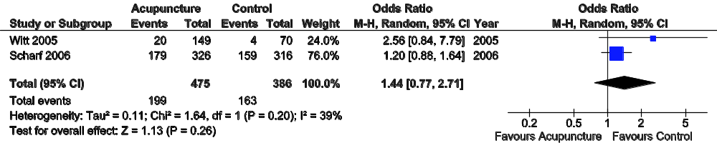
Boxes and horizontal lines represent point estimates, varying in size according to the weight in the analysis, and 95% confidence intervals. Chi² = Chi-squared df = degrees of freedom; CI = Confidence interval; I² = I-squared; M-H = Mantel-Haenszel; P = P value; Tau² = Tau-squared; Z = Z score

