Validation and application of a metagenomics protocol to the root-associated fungal communities of Northern wild rice (Zizania palustris)
By:
Abby Spring
A thesis submitted to the Department of Biological Sciences, University of Manitoba,
In partial fulfillment of the requirements for the course
BIOL 4100 (Honours Thesis)
for the degree of
Bachelor of Science (Honours)
© August, 2025

Abstract
The occurrence of root-associated fungi in wetland plants is not yet well-understood, despite recent indications that some contain diverse mycobiomes, including potential plant mutualists. Although arbuscular mycorrhizal fungi (AMF) can be neutral and even parasitic, emerging evidence suggests that AMF provide benefits to many wetland plants, as in terrestrial soils. Dark septate endophytes (DSEs) occur in wetland plants at similar or greater frequencies than AMF and may also confer benefits to host plants. Zizania palustris (Northern wild rice, manômin) is an emergent annual macrophyte found in shallow lakes and slow-moving rivers in central and eastern North America, where it is harvested from both wild stands and cultivated paddies. Despite the significance of this plant to Indigenous peoples and emerging agricultural interests, its fungal diversity in traditional rice lakes or wild stands is currently unknown. To identify the root-associated fungal communities of Z. palustris collected from wild stands across Manitoba and determine its mycorrhizal status, I undertook ITS and 18S targeted amplicon sequencing of the rhizosphere soil and determined the incidence of fungal structures within roots via microscopy. Since wetland soils contain contaminants that inhibit metabarcoding, I optimized DNA extraction and amplification protocols prior to their application to these samples. The ITS data suggested that the rhizosphere is primarily basidiomycotan and ascomycotan. The 18S data identified three genera of AMF available in the surrounding rhizosphere for association with Z. palustris: Glomus, Acaulospora, and Claroideoglomus. The root incidence data showed consistent fungal colonization by aseptate and dematiaceous hyphae, with somewhat lower incidence of hyaline hyphae and AMF-like structures, despite complete inundation of all plants. While confirmation of Z. palustris as a mycorrhizal plant requires sequencing of the root-endogenous fungi, this thesis presents preliminary data confirming the presence of AMF in the rhizosphere and AMF-resembling structures within the roots.

Table of Contents
Abstract……………………………………………………………………………………………i
List of Tables …………………………………………………………………………………… iv List of Figures …………………………………………………………………….…….………. v Introduction ……………………………………………………………………………...……... 1 Materials & Methods …………………………………………………………………………... 7 Results …………………………………………………………………………………………. 17 Discussion ……………………………………………………………………………………... 32
Conclusion …………………………………………………………………………………….. 44
Literature Cited ………………………………………………………………………………. 46
Appendix ………………………………………………………………………………………. 55

List of Tables
Table 1. Environmental metadata associated with Zizania palustris root and rhizosphere soil samples 1 to 3 collected from five basins in Nopiming and Whiteshell Provincial Parks……... 12
Table 2. DNA concentration and purity ratios of DNA extracted from Juncus roots collected from the Tallgrass Prairie Preserve, Manitoba…………………………………………………. 18

List of Figures
Figure 1. Dematiaceous hyphae (a-d), aseptate hyphae (e-f), chytrids (g), and hyaline septate hyphae (h) in Zizania palustris roots stained with acid fuchsin………………………………. 14
Figure 2. Agarose gel of unsuccessful 18S PCR products…………………………………… 19
Figure 3. Agarose gel of successful ITS PCR products……………………………………… 21
Figure 4. Agarose gel of ITS and 18S amplicons of Zizania palustris rhizosphere soils……. 23
Figure 5. The frequency of hyaline (a), dematiaceous (b), and aseptate hyphae (d) and AMF-like structures (c) in Zizania palustris roots collected from five Manitoba basins………………... 24
Figure 6. The incidence of fungal structures in Zizania palustris roots collected from five basins across Manitoba……………………………………………………………………………….. 27
Figure 7. Average read quality and length of Oxford Nanopore Technology amplicon sequencing reads………………………………………………………………………………. 28
Figure 8. Heatmap depicting the relative abundances of 18S OTUs from Zizania palustris rhizosphere soil with taxonomic assignment using the MaarJAM database of Glomeromycotina 18S sequences (Öpik et al. 2010)…………………………………………………………….. 30
Figure 9. Heatmap depicting the relative abundances of ITS OTUs from Zizania palustris rhizosphere soil with taxonomic assignment using the UNITE database of fungal ITS sequences (Abarenkov et al. 2022)……………………………………………………………………… 31

Introduction
The occurrence of root-associated fungi, including arbuscular mycorrhizal fungi, dark septate endophytes, and other saprotrophic, endophytic, or pathogenic fungi in wetland plants is not yet well-understood, despite the highly diverse mycobiomes of such plants (Kohout et al. 2012; Ban et al. 2017; Sudová et al. 2020). The predominant fungal phyla associated with wetland plant roots are Ascomycota and Basidiomycota, representing up to 95% of these fungal communities (Huang et al. 2022; Ding et al. 2023; Iqbal et al. 2023; Wang et al. 2023). Chytridiomycota, another fungal phylum present in most habitats, is also frequently associated with wetland plant roots (Freeman et al. 2009; Kohout et al. 2012; Stephenson et al. 2013). Glomeromycotina, the arbuscular mycorrhizal fungi (AMF), are also present in wetland plant mycobiomes (Kohout et al. 2012). Since AMF are obligate symbionts that colonize plant roots in a typically mutualistic relationship, they are the most studied members of wetland plant mycobiomes (Smith and Read 2008). AMF enhance plant access to nutrients, particularly phosphorus, via extra-radical mycelia, in exchange for plant-assimilated carbon (Smith and Read 2008). While arbuscular mycorrhizal associations can be neutral and even parasitic, a meta-analysis by Ramírez-Viga et al. (2018) suggests that AMF are mostly beneficial to wetland plants and may be as beneficial in wetlands as they are in terrestrial soil. Dark septate endophytes (DSEs), belonging to Ascomycota, are similar in function and frequency of occurrence in wetland plants to AMF, but are much less studied (Jumpponen and Trappe 1998; Santillán-Manjarrez et al. 2019). These two groups of plant symbionts sometimes co-exist in the root space and promote plant growth via a potentially synergistic relationship (Jumpponen and Trappe 1998; Della Monica et al. 2015; Santillán-Manjarrez et al. 2019). Given the benefits typically supplied to the plant by fungal symbionts, determining the mycorrhizal status of individual wetland plant species will set the stage for experimental work to understand the reciprocity of individual plant-fungal mutualisms, and the extent to which plant productivity and reproductive success derive from potential fungal partners.
As intracellular colonizers, AMF and DSEs are constituents of both the root endosphere and the rhizosphere, which is the soil surrounding and affected by the root (Hartmann et al. 2008). Since the fungi in the root endosphere are derived directly from the rhizosphere, the endosphere mycobiome contains only a subset of the rhizosphere mycobiome and is thus less diverse (Wang et al. 2023). The fungal communities inhabiting the endosphere exhibit less variation between sampling sites than do other compartments, such as the rhizosphere soil or surrounding water (Wang et al. 2023). This difference suggests that plant roots filter the rhizosphere mycobiome, allowing only some species to colonize. Contradictory to this is the consensus that the assembly of wetland plant mycobiomes is stochastic rather than deterministic (Bahram et al. 2016; Ban et al. 2017; Huang et al. 2022; Iqbal et al. 2023; Wang et al. 2023). However, environmental factors still explain a portion of the variation in mycobiomes between wetlands, suggesting that environmental filtering occurs, which is characteristic of deterministic community assembly (Huang et al. 2022; Iqbal et al. 2023). Specifically, the mycobiomes of different wetlands vary in terms of species diversity, abundance, and composition (Kohout et al. 2012; Martin et al. 2018; Iqbal et al. 2023; Wang et al. 2023; Senapati et al. 2024). These variations are occasionally attributed to between-wetland differences in depth, pH, and soil redox potential. For example, pH is correlated with soil fungal diversity and abundance in terrestrial plants, a relationship that is occasionally upheld in wetland plants (Maestre et al. 2015; Ding et al. 2023; Wang et al. 2023; Iqbal et al. 2023). Furthermore, wetland plant mycobiomes, specifically the composition of AMF communities, are affected by water depth (Miller and Bever 1999; Martin et al. 2018; Klymiuk and Sikes 2019). Soil flooding sometimes suppresses mycorrhization of wetland plant roots, which occurs because mycorrhizal development is inhibited by anoxia, and waterlogged soils are anoxic (Mosse et al. 1981; Ponnamperuma 1984; Khan and Belik 1995; Miller 2000; Wang et al. 2010). Lastly, while fungi prefer weakly reducing conditions, soil redox potential is insufficient in explaining the varying AMF colonization of wetland plant roots (Christensen and Wigand 1998; Seo and Delaune 2010; Martin et al. 2018). Therefore, varying abiotic conditions may contribute to differences in plant mycobiomes between wetlands.
Zizania palustris, or Northern wild rice, is an emergent annual macrophyte found in shallow lakes and slow-moving rivers in central and Eastern Canada (Aiken et al. 1988; Painchaud and Archibold 1990). Z. palustris is harvested from both wild stands and cultivated paddies, serving as an important food source (Terrell et al. 1997). Whether Z. palustris can host AMF in traditional rice lakes and wild stands remains unknown. However, Z. palustris grown in a mesocosm in agricultural soil was shown to host AMF upon microscopic examination (pers. obs. Az Klymiuk, Prairie Wetland Salinity Experiment). Similarly, an Asian species of wild rice, Zizania latifolia, which diverged from Z. palustris 3.74 million years ago, is mycorrhizal (Xu et al. 2010; Yu et al. 2020).
Another aquatic grain, Oryza sativa L. (Asian or white rice), can also host AMF (Li et al. 2023a; Li et al. 2023b). Interestingly, inoculation of O. sativa with AMF reduces heavy metal contamination of the edible plant tissues (Li et al. 2023a; Li et al. 2023b). Whether arbuscular mycorrhizal infection would confer this function in Z. palustris is unknown but has implications for its use as a food source. In O. sativa, arbuscular mycorrhizal colonization is more common in plants from upland fields than those from lowland fields (Ilag et al. 1987). This, paired with the fact that arbuscular mycorrhizal colonization was reduced upon flooding of the soil (Hajiboland et al. 2009) suggests that arbuscular mycorrhizal colonization is less frequent in waterlogged soils than dry soils. Despite this, plant productivity of O. sativa under flooded conditions is still enhanced by ~30% when plants are inoculated with AMF (Hajiboland et al. 2009). Currently, the mycorrhization of Zizania palustris is entirely unknown; comparisons with the role of AMF in Oryza suggest that this foundational work may have important applications in wild rice agriculture and restoration in North America. Determining the mycorrhizal status of Z. palustris is particularly critical because wild rice production is limited by phosphorus, the uptake of which could be enhanced by inoculation with the appropriate AMF species (Lee 1987; Senapati et al. 2024). The anoxia of flooded wetland soils can reduce soil redox potential. Furthermore, redox potential and pH are related such that a decrease in pH leads to a decrease in redox potential, and vice versa (Ponnamperuma 1984; Zhang et al. 2021). Phosphorus availability, an important driver in the relationship between plants and AMF, increases with a decrease in either pH or redox potential (Zhang et al. 2021). Since the primary function of AMF is to enhance plant access to phosphorus, phosphorus bioavailability heightened by anoxic wetland soils may negate the benefits provided by AMF, making a mutualistic symbiosis less likely (Smith and Read 2008; Johnson 2010). When soils are high in phosphorus, parasitic AMF symbioses are more likely (Ramírez-Viga et al. 2018). However, phosphorus availability depends on the inundation, redox state, and pH, all of which can vary quite widely between and within basins.
A major component of my research entailed establishing the extent to which wild stands of Z. palustris are mycorrhizal, and which fungal species they form associations with. This work was conducted using standard microscopy assays (McGonigle et al. 1990) and further explored with targeted amplicon sequencing of the rhizosphere, using a combination of fungal ‘barcode’ regions that have emerged as global standards for understanding fungal diversity (Op de Beeck et al. 2014). Metagenomics typically consists of DNA extraction, amplification of a target sequence via the polymerase chain reaction (PCR), preparation of the DNA library for sequencing by adding barcodes and adapters, and sequencing (Navgire et al. 2022). Metagenomics is uniquely challenging in wetland soils, due to the presence of humic acids and iron (Armstrong 1967; Watson and Blackwell 2000), both of which introduce challenges to the extraction and PCR amplification of target DNA.
Humic substances are organic compounds produced via decomposition of plant and animal tissues present in soils (Schnitzer 1982). Humic substances are grouped into humic acids, fulvic acids, and humin based on their solubilities at different pH values (MacCarthy 2001). Humic acids, which are defined by their insolubility in acidic solutions, share their molecular weight and net charge with DNA, resulting in their co-extraction from soil samples (MacCarthy 2001). Additionally, humic acids are not sufficiently removed by standard DNA purification methods, making humic contamination an issue in soil metabarcoding studies (Holben 1994; Watson and Blackwell 2000; Matheson et al. 2010). Tsai and Olson (1992b) found that the presence of 10 ng of humic acid in a 100 μL reaction was sufficient to inhibit PCR. This has been attributed to the interaction of humic acids with DNA polymerase to prevent polymerization (Tsai and Olson 1992a; Sutlovic et al. 2008), as well as with template DNA to reduce the amount of available substrate (Opel et al. 2010). Interestingly, PCR inhibition persists despite increases in the volume of template DNA, suggesting it is more likely that humic acids achieve their inhibition via interaction with DNA polymerase (Tsai and Olson 1992a). Moreover, humic acids also absorb light at 260 nm, as does DNA. Thus, absorbance by the contaminating humic acids cannot be distinguished from DNA via spectrophotometry, complicating standard procedures for assessing DNA purity (Holben 1994; Fatima et al. 2014; Wnuk et al. 2020). Since humic acids can contain aromatic rings, they also absorb light at 230 nm, allowing detection of humic contamination using A260/A230 ratios (Fatima et al. 2014; Wnuk et al. 2020).
Fungal metagenomics studies are further complicated by the presence of various metals that inhibit PCR (Kuffel et al. 2021; Howarth et al. 2022). Of particular relevance to wetland soils is iron, which forms plaques on macrophyte roots due to the redox dynamics of these systems (Armstrong 1967; Wium-Andersen and Andersen 1972; Mendelssohn and Postek 1982; Crowder and MacFie 1986). Kuffel et al. (2021) found that ferrous iron (Fe2+) was one of the strongest inhibitors of PCR when compared to eight other metals occurring in soils. While the mechanism by which ferrous iron inhibits PCR is unknown, other PCR-inhibiting metals present in soils facilitate crosslinking between DNA and proteins, minimizing DNA-DNA polymerase interaction and thus inhibiting PCR (Wedrychowski et al. 1986; Kuffel et al. 2021). In Z. palustris, iron plaques form on the root surface as well as inside the epidermal and cortical cells (Jorgenson et al. 2012). Thus, the inhibitory effects of iron are expected to occur in root samples and rhizosphere soil samples.
Soil contaminants like humic acids and iron necessitate the validation of molecular methods prior to their application in the metabarcoding of soil samples. A major component of my honours project was methods validation, in which I determined the optimal DNA extraction kit and the necessity of a subsequent DNA purification step based on DNA concentration and purity data. These methods validation experiments used soils and roots collected from wet meadows at the Tallgrass Prairie Preserve. Fungal diversity in wet tallgrass meadows has been previously studied (Miller and Bever 1999; Miller 2000; Miller and Sharitz 2000), so these samples provided an appropriate test environment for methods development and validation. Additionally, I optimized our PCR protocol for the amplification of fungal DNA using two primer pairs to separately target arbuscular mycorrhizal fungi and the more general fungal communities inhabiting root and soil samples (Guillen-Otero et al. 2023). Following methods validation, the optimal method was applied to Zizania palustris rhizosphere soils to identify the fungal communities therein (root-endogenous mycobiomes will be assessed in the next phase of my research). These amplicon libraries were sequenced with the Oxford Nanopore MinION benchtop platform; my honours project is a pilot project on this platform in the Klymiuk Lab. Ultimately, over the course of this project, the rhizosphere-associated mycobiome of Zizania palustris was characterized and the extent to which this plant exhibits mycorrhization in wild stands was determined.

Materials & Methods
Part 1: Methods validation
Sample selection. Juncus spp. (J. compressus or J. balticus) were obtained from three sites at the Nature Conservancy’s Tallgrass Prairie Preserve in southern Manitoba, Canada in July 2024. Sites included an early succession oldfield (GPS: 49.13879 N, 96.74050 W) and a hayfield under active production (GPS: 49.14306 N, 96.74101 W), with areas of standing water at these two sites serving as the third site, seasonally wet. At each site, three whole Juncus plants were collected in Ziploc bags, for nine samples total. Finally, we selected three surface-sterilized Carex hystericina root samples from a previous sampling season, collected from three separate fully-inundated plants growing in a persistent wetland (Rennie River, GPS: 50.116459 N, 95.632810 W).
Sample processing. Root samples were rinsed to remove soil and debris, then surface-sterilized to remove any surficial microorganisms via immersion in 95% EtOH for 30 seconds, 20% bleach (1% sodium hypochlorite) for 2 minutes, and 70% EtOH for 2 minutes, then rinsed thoroughly in ultrapure water and stored at -80°C (adapted from Arnold et al. 2007 and Romero-Jiménez et al. 2022).
DNA extractions. Prior to DNA extraction, the three root samples collected from each site were pooled to create one representative sample for each site. Extractions were performed on each of these samples using the DNeasy Plant Pro, DNeasy PowerSoil Pro, and DNeasy PowerMax Soil kits (all Qiagen). The PowerSoil Pro and PowerMax Soil kits are intended to remove humic acids (Qiagen 2022; Qiagen 2023), whereas the Plant Pro kit is intended to remove PCR inhibitors present in plant tissue (Qiagen 2019). Extractions were performed in duplicate such that DNA was extracted twice from each pooled sample using the same kit. The homogenization step of the protocol of each kit was omitted. Otherwise, the manufacturer’s guidelines were followed. For the Plant Pro and PowerSoil Pro kits, root tissue was homogenized in the provided bead tubes via 4 cycles of shaking at 30 Hz for 30 seconds and 30 seconds of rest using a bead beater homogenizer (adapted from pers. comm. M Bakker, for Prairie wetland salinity experiment Zizania palustris samples). For the PowerMax Soil kit, roots were homogenized using a mortar and pestle and liquid nitrogen due to the large sample mass required.
Purification. Following DNA extraction, one duplicate from each pooled sample was purified using the New England Biolabs Monarch PCR and DNA Cleanup kit. DNA extracted using the PowerMax Soil kit were excluded from purification due to high sample volumes.
DNA concentration and purity. To estimate the DNA concentration of our samples, a Qubit 1X dsDNA broad range assay was performed. To determine DNA purity, a NanoDrop spectrophotometer was used to measure A260/280 and A260/230. These data informed kit selection for characterization of the Z. palustris mycobiome.
PCR troubleshooting
Initial ITS + 18S PCR with Juncus root DNA. For each sample, two PCRs were performed, with different primer pairs to target different fungal phyla. The primer pair NS31/AML2 specific to the 18S rDNA was used to target the arbuscular mycorrhizal fungi (Simon et al. 1992; Lee et al. 2008; Öpik et al. 2010). The primer pair ITS1F/ITS4 designed for the ITS rDNA was used to target more general fungal communities (White et al. 1990; Gardes and Bruns 1993; Op De Beeck et al. 2014). The PCR mix included 5 μL of 5X Platinum II Green PCR buffer, 0.5 μL of dNTPs (10 mM), 1.25 μL of each primer (10 μM), 0.15 μL of Platinum II Hot-Start Taq DNA polymerase, 0.1875 μL of bovine serum albumin (20 μg/μL), 15.5625 μL of PCR-grade water, and 1 μL of DNA for a final 25 μL volume. PCR was also performed on a positive control (DNA extracted from an unidentified pure fungal culture, UME063) and a negative control (PCR-grade water).
18S PCR. An initial denaturation step was done at 98°C for 2 min, followed by 35 cycles of denaturation at 98°C for 10 s, annealing at 56°C for 30 s, and extension at 72°C for 30 s, and a final extension at 72°C for 2 min (Guillen-Otero et al. 2023).
ITS PCR. An initial denaturation step was done at 95°C for 3 min, followed by 25 cycles of denaturation at 95°C for 30 s, annealing at 55°C for 30 s, and extension at 72°C for 30 s, and a final extension at 72°C for 5 min (Guillen-Otero et al. 2023).
Gel electrophoresis. To assess PCR success, 18S and ITS PCR products were run in a 1% agarose gel at 80V for 1.5h in 1X TBE buffer. The gel was stained with SYBR Safe DNA gel stain. PCR products and the 1 kb plus DNA ladder were loaded with 10X gel loading solution.

Hot-Start Taq PCR.
Since the initial PCR as described above was unsuccessful, we optimized the cycling parameters described in Guillen-Otero et al. (2023) for the Platinum II Hot-Start Taq polymerase and PCR buffer we used. Additional 18S and ITS PCRs were done as follows: initial denaturation at 94°C for 2 minutes, followed by 35 cycles of denaturation at 94°C for 15 seconds, annealing at 60°C for 15 seconds, and extension at 68°C for 15 seconds (Thermo Fisher Scientific 2018). These reactions were performed on positive control DNA samples. These samples included UME063 and DNA extracted from mycorrhizal trap culture rhizosphere soil and roots (RR1). Gel electrophoresis was performed as described above, except loading dye was not used for this gel because of the PCR buffer’s dual function as a loading dye.
Modified Hot-Start Taq protocol.
When the Hot-Start Taq PCR as described above was unsuccessful, it was modified and repeated. First, 40 cycles were completed rather than 35. Fresh dilutions of dNTPs and both primers were used. Additional 1:10 dilutions of the DNA samples were included to rule out any PCR inhibition arising from compounds left over from DNA extraction. Also, fresh Taq and PCR buffer were used to rule out any issues arising from potential improper storage of these reagents. The RR1 positive control was the template used for this PCR.
When the above Hot-Start Taq protocol was unsuccessful, we further adjusted the PCR cycling and components according to suggestions specified for the absence of bands (Bio-Rad, 2025). After an error was noticed with our previous dNTP dilutions, the dNTP mix was prepared such that each dNTP was at a final concentration of 200 μM. Additional reactions were completed with double the template DNA volume. To test for issues with primer resuspension, additional reactions were performed with primer concentrations of 20 μM each. PCR cycling was as follows: initial denaturation at 95°C for 3 min, followed by 35 cycles of denaturation at 95°C for 30 seconds, annealing at 60°C for 30 seconds, and extension at 68°C for 1 minute. Template for this PCR was the RR1 positive control.
Successful PCR. Since PCR failed again after the above troubleshooting, we suspected issues with our primers. Fresh ITS1F/ITS4 and NS31/AML2 were ordered from IDT instead of Fisher and resuspended in molecular grade water instead of 1X TE buffer. We also tested two new Taq DNA polymerases from NEB and Qiagen, both of which are not hot start.
For the ITS1F/ITS4 primers, cycling times and temperatures as described in Guillen-Otero et al. (2023) were used, except annealing was performed at 45°C rather than 55°C. Template for this PCR included the positive controls RR1 and UME063. These DNA samples were also diluted 1:10 and 1:20. Negative controls were performed using PCR-grade water. The PCR components were as follows: 2.5μL of NEB 10X ThermoPol buffer or Qiagen 10X PCR buffer, 0.15μL of NEB Taq DNA polymerase or Qiagen Taq DNA polymerase, 0.5μL of dNTPs (10mM), 1.25μL of each primer (10μM), 0.1875μL of bovine serum albumin (20μg/μL), 18.1625μL of PCR water, and 1μL of template DNA for a final 25μL volume. Gel electrophoresis was performed as described above, except the gel was precast with SYBR Safe DNA gel stain and a 1 kb DNA ladder was used, with samples loaded using 6X purple DNA gel loading dye (both NEB).
Part 2: Wild rice mycobiome
Sample selection. Zizania palustris plants were sampled from four water bodies in Nopiming Provincial Park, MB and one in Whiteshell Provincial Park, MB in July and August 2024 (Table 1).

Table 1. Environmental metadata associated with the Zizania palustris root and rhizosphere soil samples 1 to 3 collected from five basins in Nopiming and Whiteshell Provincial Parks. Measurements were taken in the water column at the site of each uprooted plant. P-values are from a one-way ANOVA. Mean and SD represent all measurements taken at each basin (n = 3).
Sample | Depth  (cm) | Secchi Depth (cm) | Redox potential (mV) | pH | Water temp (°C) | TDS (ppm) | GPS coordinates
Beresford Lake (Nopiming Provincial Park)
1 | 90 | 66 | 72.0 | 6.82 | 24.5 | 0.0346 | 50°51’11.09”N, 95°14’47.50”W
2 | 57 | 57 | 215.6 | 6.67 | 25.2 | 0.0318 | 50°50’56.28”N, 95°14’45.78”W
3 | 100 | 76 | 217.8 | 6.91 | n/a | 0.0333 | 50°51’29.48”N, 95°14’48.17”W
Mean ± SD | 82.3 ± 22.5 | 66.3 ± 9.50 | 168.5 ± 83.5 | 6.80 ± 0.12 | 24.9 ± 0.495 | 0.0332 ± 0.00140
Cat Creek (Nopiming Provincial Park)
1 | 51 | 33 | 106.2 | 5.85 | 21.8 | 0.0300 | 50°36’21.06”N, 95°24’47.46”W
2 | 50 | 50 | 112.5 | 6.29 | 25.7 | 0.0257 | 50°36’09.75”N, 95°25’07.43”W
3 | 31 | 31 | 95.2 | 5.98 | 25.6 | 0.0274 | 50°36’08.76”N, 95°25’05.52”W
Mean ± SD | 44 ± 11.3 | 38 ± 10.4 | 104.6 ± 8.76 | 6.04 ± 0.226 | 24.4 ± 2.23 | 0.0277 ± 0.00217
Cat Lake (Nopiming Provincial Park)
1 | 72 | 50 | 110.1 | 6.06 | 25.1 | 0.0352 | 50°36’31.98”N, 95°27’18.06”W
2 | 57 | 41 | 12.3 | 6.42 | 26.8 | 0.0320 | 50°36’34.50”N, 95°27’28.50”W
3 | 25 | 25 | 41.0 | 6.35 | 24.8 | 0.0319 | 50°36’39.54”N, 95°27’33.23”W
Mean ± SD | 51.3 ± 24.0 | 38.7 ± 12.7 | 54.5 ± 50.3 | 6.28 ± 0.191 | 25.6 ± 1.08 | 0.0330 ± 0.00188
Bird Lake (Nopiming Provincial Park)
1 | 56 | 56 | -23.9 | 7.57 | 22.9 | 0.0264 | 50°28’37.44”N, 95°17’34.08”W
2 | 53 | 53 | 64.2 | 7.26 | 22.2 | 0.0248 | 49°28’33.38”N, 95°17’05.94”W
3 | 79 | 79 | -74.0 | 7.36 | 23.1 | 0.0236 | 50°28’47.97”N, 95°16’09.69”W
Mean ± SD | 62.7 ± 14.2 | 62.7 ± 14.2 | -11.2 ± 70.0 | 7.40 ± 0.158 | 22.7 ± 0.473 | 0.0249 ± 0.00140
South Cross Lake (Whiteshell Provincial Park)
1 | 97 | 97 | -70.0 | 6.49 | 22.5 | 0.0650 | 49°50’38.40”N, 95°16’25.75”W
2 | 89 | 64 | -14.7 | 6.99 | 24.8 | 0.0513 | 49°50’21.00”N, 95°15’17.50”W
3 | 88 | 69 | 1.1 | 6.92 | 23.0 | 0.0110 | 49°50’00.19”N, 95°15’00.99”W
Mean ± SD | 91.3 ± 4.93 | 76.7 ± 17.8 | -27.9 ± 37.3 | 6.80 ± 0.27 | 23.4 ± 1.21 | 0.0424 ± 0.0281
P-value | 0.029 | 0.017 | 0.0086 | 0.000077 | 0.1648 | 0.5297
Sampling protocol. At each basin, three Z. palustris samples were collected at the greatest possible distance from each other. For each sample, rhizosphere soil was scraped directly from the roots into a 15mL RNAse/DNAse-free tube and the whole plant was collected in a Ziploc bag, with immediate storage on ice. At the site of each uprooted plant, a YSI ProQuatro sensor (Hoskin Scientific) was dropped into the water to collect environmental metadata including temperature, total dissolved solids (TDS), redox potential, and pH from the water column directly above the soil from which each plant was extracted. A Secchi disc was used to measure Secchi depth and total water depth. A one-way analysis of variance (ANOVA) was performed on these data to determine the significance of differences in these variables between sampling sites.
Sample processing. From the whole plant samples, roots were removed, washed, surface-sterilized as described previously, and frozen alongside the soil samples at -80°C.
Root staining and microscopy. To best assess the fungal colonization of Z. palustris roots, we compared acid fuchsin and lactophenol cotton blue staining methods. For lactophenol cotton blue staining, roots cleared with 10% potassium hydroxide were placed in a drop of water to which lactophenol cotton blue was added. After 10 seconds, the stain was absorbed off and the root was rinsed with water to lift off residual stain. For acid fuchsin staining, surface-sterilized roots were stored in 70% EtOH at -20°C, cleared with 10% potassium hydroxide for 10 minutes, rinsed with distilled water, immersed in 2% hydrochloric acid for 15 minutes, then stained with acid fuchsin for 5 minutes, and rinsed with distilled water (Klymiuk and Sikes 2019). Roots were destained in water at 4°C for one week and mounted on glass slides using Eukitt mounting medium. Since both staining methods yielded similar results, acid fuchsin was chosen for ease of use and more consistent stain retention. For each sample from each basin, 200 root intersects at 40x were examined for the presence of aseptate hyphae, hyaline septate hyphae, dark/dematiaceous septate hyphae, spores, and AMF structures such as vesicles and arbuscules (Fig. 1, McGonigle et al. 1990; Klymiuk and Sikes 2019).
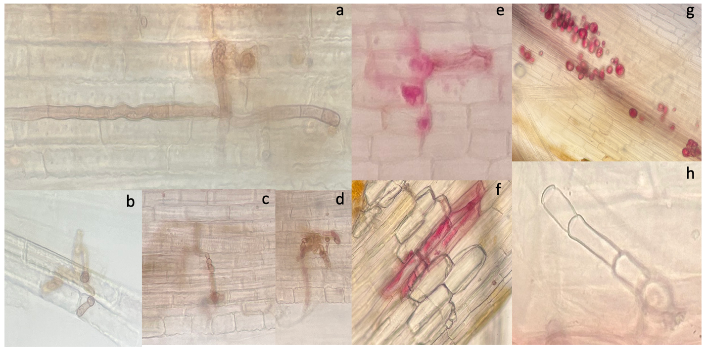
Figure 1. Dematiaceous hyphae (a-d), aseptate hyphae (e-f), chytrids (g), and hyaline septate hyphae (h) in Zizania palustris roots stained with acid fuchsin.
Root fungal incidence data analysis.
For preliminary analyses of the fungal incidence data collected as described above, histograms and barplots were constructed in R (v4.5.0) for each fungal structure (aseptate hyphae, dematiaceous hyphae, hyaline hyphae, and AMF-like structures (vesicles and arbuscules)) using basin, depth, pH, and redox potential as explanatory variables. To select appropriate models, we assessed Akaike information criterion (AIC) and Bayesian information criterion (BIC) values for generalized linear models (GLMs) and generalized linear mixed models (GLMMs) using binomial, negative binomial, and Poisson distributions. Our fungal incidence data for roots are zero-inflated, and a GLM with negative binomial distribution was preferred for our analysis (Appendix A). As a post-hoc statistical analysis, we performed general linear hypothesis/Tukey-Kramer tests, which performs pairwise comparisons between group means to determine if they significantly differ from each other (Lee and Lee 2018).
DNA extraction
DNA of Z. palustris rhizosphere soil samples was extracted using the PowerSoil Pro kit, purified with the Monarch PCR & DNA Cleanup kit (NEB), and quantified with a Qubit fluorometer. DNA was similarly extracted from the Z. palustris root samples, but due to low DNA yield and the assumption that the proportion of fungal DNA in these samples was even lower than in the rhizosphere samples, the root DNA samples were excluded from amplification at this time. However, the elucidation of the root-endogenous mycobiome will form a core component of my future MSc. thesis. The rhizosphere mycobiome is presented in this honours thesis.
PCR
ITS. Initially, PCR was performed using the same protocol that successfully amplified our positive control DNA samples: initial denaturation at 95°C for 3 minutes, followed by 25 cycles of denaturation at 95°C for 30 seconds, annealing at 45°C for 30 seconds, and extension at 72°C for 30 seconds, with a final extension at 72°C for 5 minutes. Each 25μL reaction contained 2.5μL Qiagen 10X PCR buffer, 0.15μL Qiagen Taq DNA polymerase, 0.5μL dNTPs (10mM), 1.25μL of each primer (10μM, ITS1F/ITS4 from IDT), 0.1875μL bovine serum albumin (20μg/μL), 18.1625μL of PCR water, and 1μL of template DNA. Gel electrophoresis of the PCR products was performed as described previously. Amplification was successful for the positive control (RR1) but failed for the Z. palustris rhizosphere soil samples.
18S. PCR components and cycling were identical to those used in the ITS PCR, except an annealing temperature of 49.9°C specific to the NS31/AML2 primer pair was used. Gel electrophoresis showed that amplification was successful for the positive control (RR1) but failed for the rhizosphere soil samples, as occurred in the ITS PCR.
Subsequently, both the ITS and 18S PCRs were repeated identically, except 40 cycles were completed instead of 25. Gel electrophoresis of products from both PCRs showed successful amplification of the Z. palustris rhizosphere soil samples. PCR products were purified with the Monarch PCR & DNA Cleanup kit (NEB) and quantified with the Qubit dsDNA HS assay Kit.
Library preparation & Sequencing. Purified 18S and ITS amplicons were barcoded and pooled for sequencing using the Oxford Nanopore Native barcoding kit 24 V14 (SQK-NBD114.24), according to the manufacturer’s protocol (Oxford Nanopore Technologies 2022). During separate 48h runs, the pooled ITS and 18S amplicons were sequenced on a MinION Flow Cell (FLO-MIN 114, R10.4.1) using a MinION Mk1B sequencer. Data collection, live high-accuracy basecalling (v4.3.0), and demultiplexing were performed using the MinKNOW sequencing software (v25.03.9).
Processing and analysis of sequencing data
To process our raw basecalled and demultiplexed reads, we used the ONT-AmpSeq pipeline (Schacksen et al. 2024). This pipeline generates statistics and plots of the sequence data using NanoPlot (version 1.42.0) to assess the quality and read lengths from Nanopore sequencing (De Coster et al. 2018). The optimal Q-score and read length for the data can be deduced from the plots and applied in the main pipeline, which creates taxonomically annotated operational taxonomic unit (OTU) tables. CHOPPER is used to filter and trim the raw reads based on the input Q-score and read length (De Coster and Rademakers 2023). Reads are then polished using RACON and mapped using MINIMAP2 to draft consensus sequences produced by VSEARCH (Rognes et al. 2016; Vaser et al. 2017; Li 2018). VSEARCH is additionally used to generate OTU tables, with clustering at both 97% and 99% sequence identities (Rognes et al. 2016). For our OTUs, taxonomic assignment was performed via BLAST+ (Altschul and Gish 1996) using ITS and 18S fungal databases (NCBI 2025). Taxonomic assignment also used the SINTAX algorithm (Edgar 2018) where the RDP and UNITE databases of fungal ITS sequences were used for the ITS data (Deshpande et al. 2016; Abarenkov et al. 2022), while the SILVA 18S database and AMF-specific 18S MaarJAM database was used for the 18S data (Quast et al. 2012; Öpik et al. 2010). Based on the NanoPlot statistics, we used a Q-score cutoff of 20. The minimum and maximum read lengths were 560 and 940 bp for ITS sequences and 460 and 780 bp for 18S sequences (Appendix B).

Results
Part 1: Methods Validation
DNA concentration and purity
The purity and concentration of DNA extracted using three different kits were measured to determine the optimal kit for root and rhizosphere soil samples specifically. On average, the Plant Pro and PowerSoil Pro kits both yielded more highly concentrated DNA of superior purity compared to the PowerMax Soil kit (Table 2). The PowerSoil Pro kit slightly outperformed the Plant Pro kit in extracting high concentrations of DNA. Although DNA purity from the Plant Pro and PowerSoil Pro kits were quite comparable, the Plant Pro kit slightly outperformed the PowerSoil Pro kit in both the A260/280 and A260/230 ratios (Table 2). The additional purification step after DNA extraction almost consistently improved DNA concentration and DNA purity, as reflected by higher concentration and more suitable purity ratios (Table 2).

Table 2. DNA concentration and purity (absorbance ratios) of DNA extracted from Juncus roots collected from the Tallgrass Prairie Preserve, Manitoba. Sites include oldfield (OF), hay meadow (HM), standing water (SW), and Rennie River during a previous collecting season (RR) using three different extraction kits. Values pertaining to samples subjected to the purification step are italicized (“purified”). Mean and SD represent all DNA samples extracted with the indicated extraction kit (n = 8).
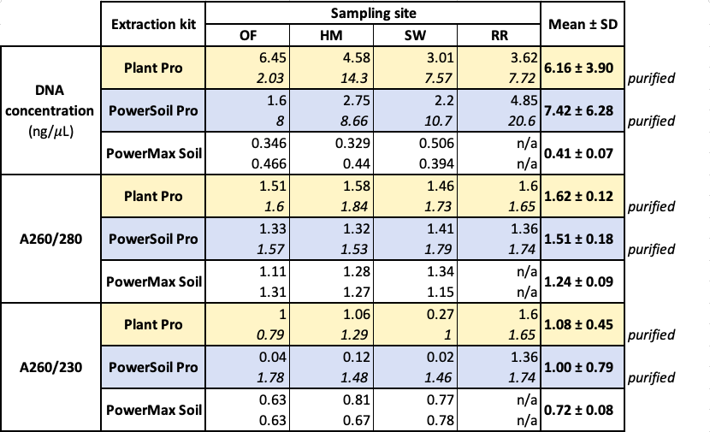
PCR troubleshooting
Unsuccessful PCRs
PCR amplifications were consistently unsuccessful until we used fresh primers from IDT and Taq DNA polymerase from Qiagen, as demonstrated by gel electrophoresis of the PCR products. All agarose gels from these unsuccessful PCR runs appeared the same: the DNA ladder was present with adequate band separation, but bands were absent in the lanes into which PCR products were loaded (Fig. 2). None of the troubleshooting described above resulted in the presence of bands, regardless of the primer pair used.
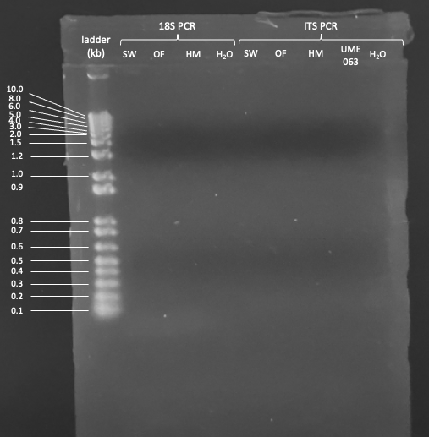
Figure 2. Agarose gel of unsuccessful 18S PCR products. Samples include DNA extracted from Juncus roots (SW = standing water; OF = oldfield; HM = hay meadow), an unidentified pure fungal culture (UME063), and PCR-grade water (H₂O) using the ITS1F/ITS4 and NS31/AML2 primer pairs. The 1% agarose gel was prepared and electrophoresed in 1X TBE buffer at 80V for 1.5h.
Successful PCR
Multiple bands were present on the agarose gel loaded with the ITS PCR products amplified using the NEB and Qiagen Taq DNA polymerases with the fresh IDT primers and the new annealing temperature. The bands of the 1 kb DNA ladder were adequately separated for our purposes. The lane loaded with NEB Taq-amplified RR1 had multiple bands corresponding to those of the DNA ladder (Fig. 3). In all lanes into which PCR product was loaded, there was a smeared band at the bottom of the gel below the last band of the ladder. There was also faint smearing around the 2.0 kb band of the ladder in these same lanes. However, this smearing was much lighter or absent in the lanes of the gel into which the NEB Taq- and Qiagen Taq-amplified negative control PCR products (H₂O) were loaded. The lanes containing Qiagen Taq-amplified RR1 PCR products (RR1, RR1 1:10, RR1 1:20) each had a distinct band between the 0.5 and 1.0 kb bands of the ladder, corresponding to 600 to 700 bp. These distinct 600-700 bp bands were absent in the lanes into which NEB Taq-amplified PCR products (RR1 1:10, RR1 1:20, UME 063) were loaded.

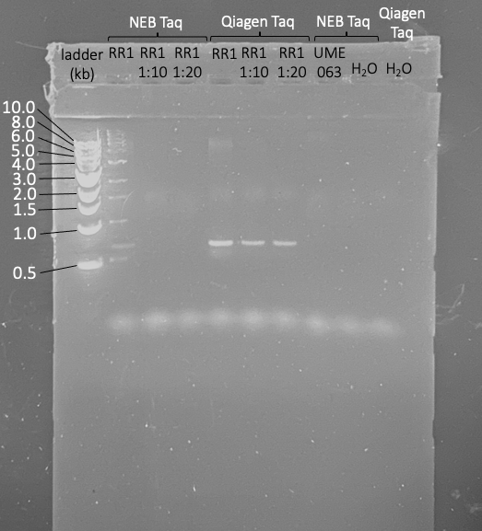
Figure 3. Agarose gel of successful ITS PCR products. Samples include DNA extracted from mycorrhizal trap culture rhizosphere soil and root samples (RR1), an unidentified pure fungal culture (UME063), and water as a negative control (H₂O), amplified with ITS1F/ITS4 primers. Two different Taq DNA polymerases were used for amplification, as indicated. 1:10 and 1:20 refer to template DNA dilutions. The 1% agarose gel was prepared and electrophoresed in 1X TBE buffer at 80V for 1.5h.
Z. palustris rhizosphere soil PCR
Unsuccessful
Application of the ITS PCR protocol that successfully amplified our positive control mycorrhizal trap culture DNA (RR1) to our Zizania palustris rhizosphere soil samples did not result in successful amplification, as shown via gel electrophoresis. No distinct bands were present in the lanes containing Z. palustris rhizosphere PCR products, although template was present. However, amplification was still successful for the positive control, as demonstrated by the presence of a distinct band around 700 bp.
Successful
After implementing 40 cycles of annealing, extension, and denaturation, the ITS and 18S PCR protocol as described above successfully amplified the Z. palustris rhizosphere samples. The gel loaded with amplicons from both PCRs had distinct bands roughly corresponding to 600 bp for the 18S amplicons and 700 bp for the ITS amplicons (Fig. 4). These bands were absent from lanes containing negative control PCR products (H2O; Fig. 4).

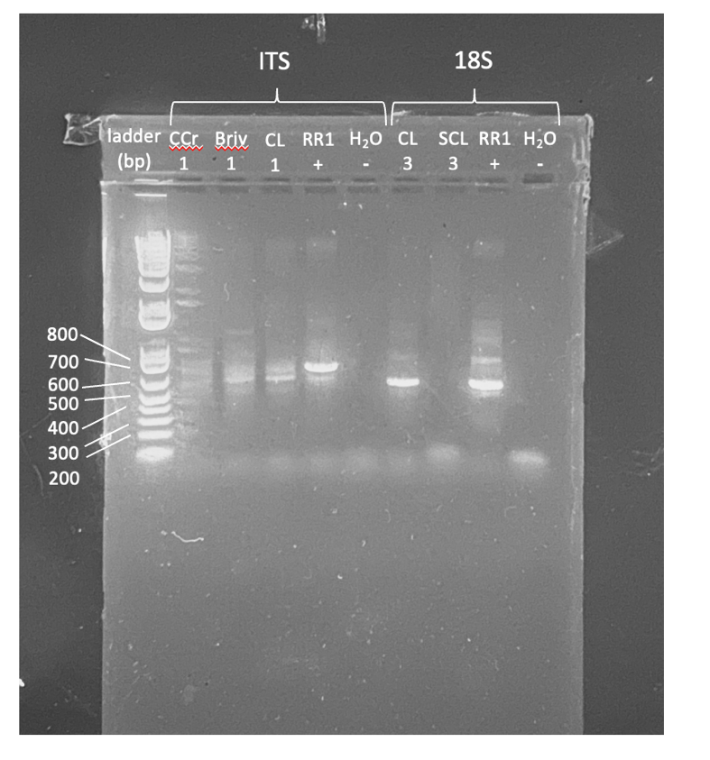
Figure 4. Agarose gel of ITS and 18S amplicons of Zizania palustris rhizosphere soils. Samples include Z. palustris rhizosphere soils (CCr1, Briv1, CL1, CL3, SCL3), mycorrhizal trap culture rhizosphere soil and roots (RR1 +), an unidentified pure fungal culture (UME063), and water as a negative control (H₂O -). The 1% agarose gel was prepared and electrophoresed in 1X TBE buffer at 80V for 1.5h.
Part 2: Wild Rice Mycobiome
Environmental parameters
The one-way analysis of variance (ANOVA) that I performed on our environmental parameter measurements showed significant differences in pH, redox potential, depth, and Secchi depth between sampling sites (P < 0.05) (Table 1). The points at which Z. palustris plants were sampled from Cat Creek and Cat Lake were shallower on average than the other three sampling sites (Table 1). Cat Creek and Cat Lake are part of the same basin and were both more acidic (pH < 6.5) compared to Beresford Lake, South Cross Lake, and Bird Lake, which all had circumneutral pH (pH = 6.5-7.5). Beresford Lake, Cat Creek, and Cat Lake, all located in Nopiming Provincial Park, had redox potentials above 100 mV, while Bird Lake (Nopiming) and South Cross Lake (Whiteshell) both had redox potentials below 100 mV (Table 1). No significant differences in temperature and total dissolved solids (TDS) measurements were found between sites (P > 0.05) (Table 1).
Incidence of fungal structures in wild rice roots
The histograms depicting the frequency of each fungal structure in our samples most closely resembled negative binomial and zero-inflated negative binomial distributions (Fig. 5). While we intended to record the incidence of fungal spores in our samples, they were entirely absent from the examined roots and were thus excluded from any analyses.
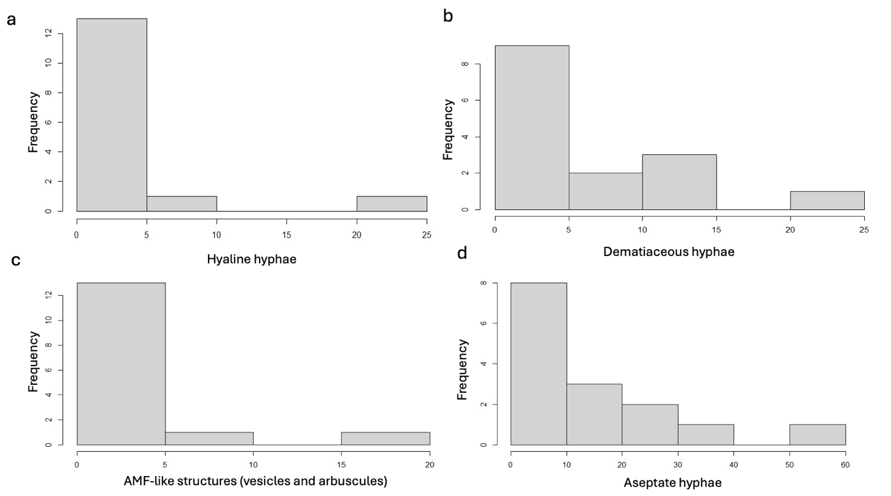
Figure 5. The frequency of hyaline (a), dematiaceous (b), and aseptate hyphae (d) and AMF-like structures (c) in Zizania palustris roots collected from five Manitoba basins. Roots were stained, mounted on glass slides, and examined for the occurrence of each fungal structure using the root intersect method (McGonigle et al. 1990, n=200 observations per sample, 3 samples per basin).
When our data was fit to various distributions under both generalized linear models (GLMs) and generalized linear mixed models (GLMMs), the Akaike information criterion (AIC) and Bayesian information criterion (BIC) values for the GLMMs were generally lower than those for the same distribution using GLMs (Appendix A). However, the lowest AIC and BIC values for each fungal category overall were for either the GLM negative binomial or GLM zero-inflated negative binomial distribution. The incidence of aseptate hyphae was consistently best fit to a GLM negative binomial distribution, while that of hyaline hyphae was consistently best fit to a GLM zero-inflated negative binomial distribution, regardless of whether depth, pH, or redox potential was specified as the explanatory variable (Appendix A). However, whether the incidence of dematiaceous hyphae and AMF structures (vesicles or arbuscules) was best fit to the GLM negative binomial or zero-inflated negative binomial distribution depended on whether depth, pH, or redox potential was used as the explanatory variable (Appendix A). Regardless, the AIC and BIC values for both distributions only differed from each other slightly (Appendix A).
Overall, aseptate hyphae were the most frequently observed fungal structures across Z. palustris roots from all five basins (Fig. 6a). The incidence of aseptate hyphae was similar between South Cross Lake, Bird Lake, and Beresford Lake (as per Tukey-Kramer), but significantly different from incidence in Cat Creek and Cat Lake (Fig. 6a, P ≤ 0.05). Despite their belonging to the same water body, the incidence of aseptate hyphae was significantly different between Cat Lake and Cat Creek, with low incidence in Cat Creek and high incidence in Cat Lake (Fig. 6a, P ≤ 0.05). The incidence of AMF-like structures was also significantly different between basins but was consistently lower than that of aseptate hyphae (Fig. 6a, P ≤ 0.05). Aseptate hyphae are characteristic of mucuromycotan fungi, of which AMF are a subphylum (Glomeromycotina), but do not in themselves indicate mycorrhization or necessarily the presence of AMF. Nevertheless, the incidence of AMF-like structures generally mirrored the incidence of aseptate hyphae at each basin (Fig. 6a). The incidence of hyaline hyphae was also significantly different between basins with low incidence overall, except in South Cross Lake and Cat Lake (Fig. 6a, P ≤ 0.05). Dematiaceous hyphae, present in all five basins, was the next most-frequently observed fungal structure overall, with no significant differences in incidence between basins (Fig. 6a).
At least low levels of fungal colonization were persistent regardless of soil inundation and there were no significant differences in fungal incidence on the basis of depth (Fig. 6b, P > 0.05). Hyaline hyphae and AMF-like structures both occur at low levels except in plants collected from the shallowest depths, although this was not significant. There is no consistent trend in the incidence of dematiaceous hyphae with respect to depth.
Fungal structures are present at both acidic and circumneutral pH (Fig. 6c). There are no significant differences in the incidence of fungal structures on the basis of pH, except for hyaline hyphae (Fig. 6c, P < 0.05). Hyaline hyphae and AMF-like structures both have slightly higher incidence at acidic pH than at circumneutral pH. However, the incidence of aseptate and dematiaceous hyphae does not differ consistently on the basis of pH. Cat Creek and Cat Lake, as part of the same water body, were the only acidic basins. Despite this shared characteristic, fungal incidence is considerably higher in Cat Lake than Cat Creek.
Overall, the redox potential at plant collection points was most frequently between 0 and 100 mV, which corresponded to an increased prevalence of fungal structures within this range (Fig. 6d). Fungal incidence was higher in highly reducing conditions (< 100 mV) than in moderately reducing conditions (> 100 mV). There were significant differences in the incidence of hyaline and aseptate hyphae on the basis of redox state (P ≤ 0.05), but not in the incidence of dematiaceous hyphae and AMF-like structures (Fig. 6d, P > 0.05). The incidence of dematiaceous hyphae and AMF-like structures was relatively consistent over all redox potentials. Hyaline hyphal colonization was completely absent at redox potentials over 100 mV and most prevalent when redox potential was between 0 and 100 mV. Aseptate hyphal colonization is highest at redox potentials under 100 mV and lower when redox potential is over 100 mV.
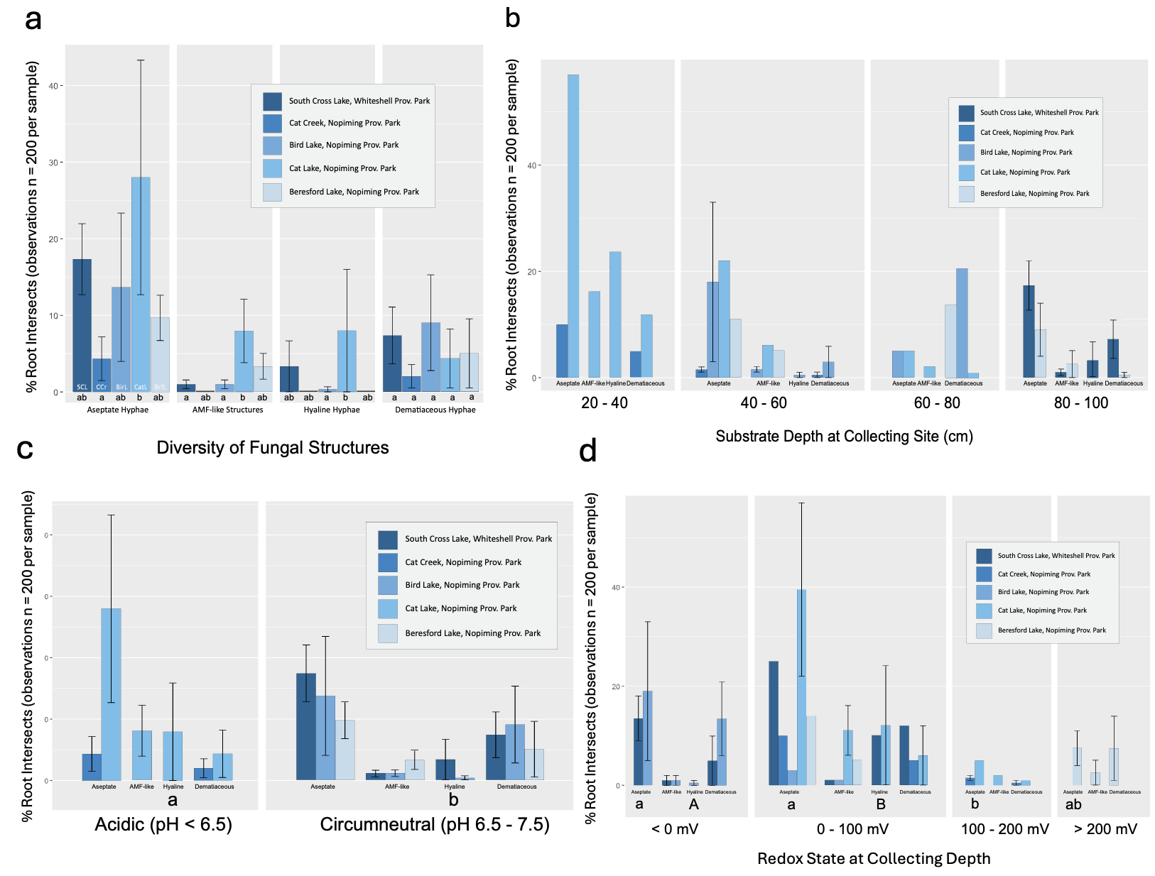
Figure 6. The incidence of fungal structures in Zizania palustris roots collected from five basins across Manitoba. The x-axis represents fungal structure (a), water depth (b), water pH (c), and water redox state (d) at the site of plant collection. The y-axis represents the percentage of root intersects (n=200 per sample, with 3 samples per basin) containing the indicated fungal structure (as per McGonigle et al. 1990). Error bars represent the standard error (SE) of the mean. The results of the Tukey-Kramer post-hoc analysis (P ≤ 0.05, for a GLM with a negative binomial distribution) comparing the incidence of a given fungal structure between different basins, depths, pH conditions, and redox states are expressed as letters under the X-axis.

Oxford Nanopore sequence data
Statistical analysis of the Nanopore sequencing quality and read length using NanoPlot (De Coster et al. 2018) informed the parameters used for the ONT-AmpSeq pipeline. With a Q-score cutoff of 9 during the Nanopore sequencing runs, the average Q-score was 14.2 for the ITS reads and 14.1 for the 18S reads (Appendix B). Most of our reads had a Q-score greater than 10 (97.0% for ITS, 97.1% for 18S; Fig. 7), while only around half had a Q-score greater than 15 (51.4% for ITS, 48.6% for 18S; Fig. 7). However, very few reads had a Q-score over 20 (0.9% for ITS, 0.75 for 18S), and 0.0% had a Q-score greater than 25 for both ITS and 18S (Fig. 7). Therefore, a conservative quality cutoff of Q20 was used for both ITS and 18S sequences in the pipeline, given it was the highest possible Q score with sufficient reads and would minimize ‘discovery’ of spurious or singleton OTUs. Mean read lengths of 775.6 bp for ITS and 765.3 bp for 18S also informed the minimum and maximum read length cutoffs used for the pipeline (Appendix B).

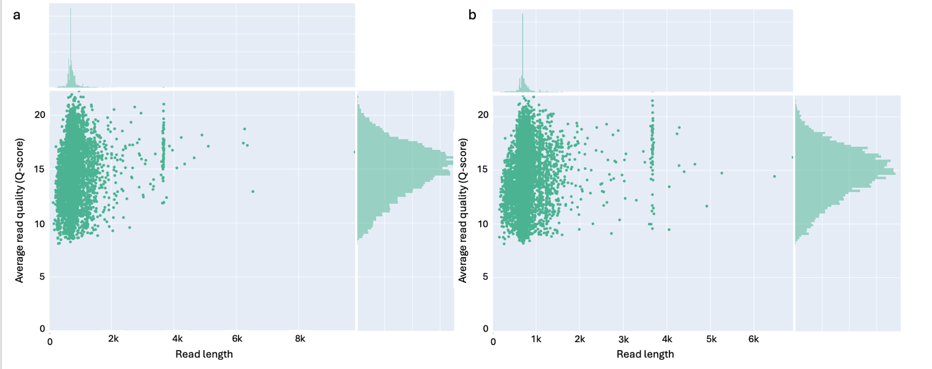
Figure 7. Average read quality and length of Oxford Nanopore Technology amplicon sequencing reads. ITS (a) and 18S (b) amplicon libraries were prepared using the ONT native barcoding kit 24 V14 (SQK-NBD114.24) and sequenced on an R10.4.1 MinION flow cell, with high-accuracy basecalling (v4.3.0) using the MinKNOW software (v25.03.9). Plots were generated using NanoPlot (v1.42.0) as per Schacksen et al. (2024).
From the 18S sequences, there were 3, 510 OTUs generated when either the SILVA or MaarJAM database was used. Of the 25 OTUs in the heatmap, 21 of them were unclassified, matching no sequences in the database (Fig. 8). 17 of the OTUs only occurred once in a single sample and were thus singletons (Fig. 8). Most of these singletons came from only a few samples with high numbers of singletons (Fig. 8). One singleton OTU did match to a sequence in the database belonging to the class Glomeromycetes. The three non-singleton classified OTUs corresponded to sequences representing the genera Glomus, Claroideoglomus, and Acaulospora (Fig. 8). The OTUs corresponding to Acaulospora sequences were present in all five sites, while those corresponding to Glomus were present in all sites but Cat Lake; those corresponding to Claroideoglomus were present in all sites except South Cross Lake and Bird Lake (Fig. 8). When the taxonomic assignment of the 18S sequences was completed using the SILVA database, only one of the OTUs on the heatmap matched to a known fungal sequence in the database, while the other OTUs were either unclassified or matched to non-fungal sequences such as the genera Rotifera and Nematoda (Appendix C).
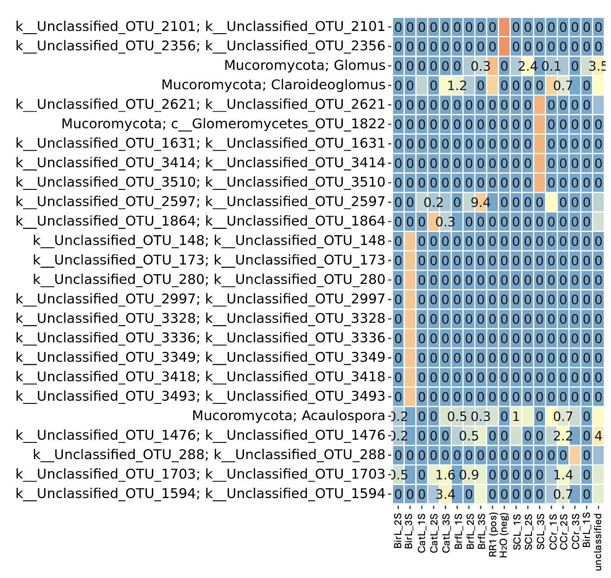
Figure 8. Heatmap depicting the relative abundances of 18S OTUs from Zizania palustris rhizosphere soil with taxonomic assignment using the MaarJAM database of Glomeromycotina 18S sequences (Öpik et al. 2010). This heatmap was generated via the ONT-AmpSeq pipeline (Schacksen et al. 2024) using a 97% sequence identity with a read quality cutoff of Q20. Sample IDs indicate the basin from which rhizosphere soil was collected (BirL=Bird Lake, CatL=Cat Lake, BrfL=Beresford Lake, SCL=South Cross Lake, CCr=Cat Creek).
From the ITS sequences, 10, 029 OTUs were generated when the UNITE database was used. Of the 25 OTUs in the UNITE heatmap, 4 were unclassified, 11 matched to database sequences but were only specified at the kingdom level, while 10 OTUs matched to specific fungal taxa (Fig. 9). These taxa include the genera Mrakia, Sporobolomyces, Pholiota, and Solicoccozyma and the family Ceratobasidiaceae in the phylum Basidiomycota, the genus Babjevia in the phylum Ascomycota, and the phylum Chytridiomycota, specifically the order Rhizophydiales (Fig. 9). The basidiomycotan and ascomycotan genera were generally present in all samples except South Cross Lake 3 (SCL_3S) and Bird Lake 3 (BirL_3S). The chytridiomycotan OTUs were present in one Beresford Lake sample and the negative control. The Ceratobasidiaceae OTUs were only present in the positive and negative control.
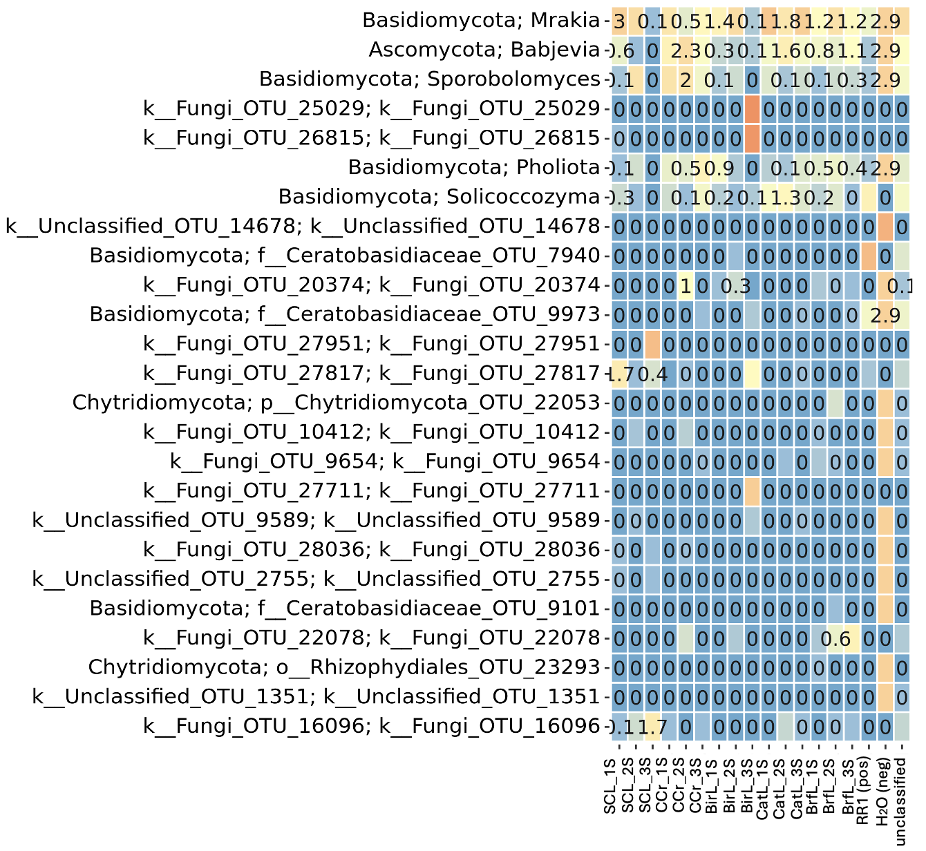
Figure 9. Heatmap depicting the relative abundances of ITS OTUs from Zizania palustris rhizosphere soil with taxonomic assignment using the UNITE database of fungal ITS sequences (Abarenkov et al. 2022). This heatmap was generated via the ONT-AmpSeq pipeline (Schacksen et al. 2024) using a 97% sequence identity with a read quality cutoff of Q20. Sample IDs indicate the basin from which rhizosphere soil was collected (SCL=South Cross Lake, CCr=Cat Creek, BirL=Bird Lake, CatL=Cat Lake, BrfL=Beresford Lake).
From the ITS sequences, 29, 024 OTUs were generated when the RDP database was used. Of the 25 OTUs in the RDP heatmap, 16 were unclassified and 9 matched to fungal taxa in the database (Appendix D). These taxa include the genera Mrakia, Sporidiobolus, Pholiota, and Cryptococcus and the family Ceratobasidiaceae in Basidiomycota, the genus Mortierella in Zygomycota (now Mucuromycota), and the genus Pichia in Ascomycota (Appendix D). Most of the basidiomycotan genera were present in all barcodes/samples except for SCL_3S and BirL_3S, and the negative control. Similarly, the Mortierella OTU was present in all barcodes but BirL_3S and the negative control. The Pichia OTU was similarly lacking in SCL_3S, BirL_3S, and a few other samples/barcodes. The Ceratobasidiaceae OTUs were present in only a few samples.

Discussion
Protocol development: DNA concentration and purity
As demonstrated by the DNA concentration and purity data, the Plant Pro and PowerSoil Pro extraction kits are superior to the PowerMax Soil kit. Additionally, the PowerMax Soil kit is incompatible with downstream applications like PCR due to the high volumes and therefore low DNA concentrations the kit produces. While the DNA yields and purity ratios of the Plant Pro and PowerSoil Pro kits were quite similar, the DNA extracted by the PowerSoil Pro kit had slightly higher concentration but slightly lower purity than the DNA extracted by the Plant Pro kit, on average. While the DNA purity data can be used to predict how the DNA extracted by each kit will perform during PCR, the PCR success of each DNA sample was not directly tested.
The factor with the greatest effect on DNA concentration and purity was the additional purification step completed with the DNA purification kit following DNA extraction. While the increased DNA concentration associated with the purification step directly results from elution of the same amount of DNA in a lower volume, the improved purity ratios likely result from contaminant removal. An A260/280 ratio of 1.8 to 2.0 indicates pure DNA, or DNA free from protein contamination (Yeates et al. 1998; Wnuk et al. 2020). Although most of our DNA samples were below this range, the purification step invariably brought them closer, likely because it removed contaminating proteins that were bringing our ratios down. An A260/230 ratio of 2.0 to 2.2 indicates pure DNA, or DNA free from aromatic compounds like humic acids and compounds used during DNA extraction, including guanidine salts and ethanol (Yeates et al. 1998; Olson and Morrow 2012; Wnuk et al. 2020; Faraldi et al. 2022; Zepeda and Verdonk 2022). Our A260/230 ratios were very far out of range before purification, and relatively closer after purification. The purification step likely removed these contaminants, improving DNA purity and favouring its use for downstream applications such as PCR and sequencing.
One shortcoming of our experimental design is that the DNA concentration and purity data for purified and non-purified DNA came from completely different DNA extraction samples, rather than from the same DNA extraction that was then subjected to purification. A more direct comparison could have been achieved if DNA concentration and purity was measured for the same DNA sample before and after the completion of the purification step.
Protocol development: PCR troubleshooting
Gel electrophoresis of the unsuccessful PCRs consistently produced gels with a visible DNA ladder but no bands in the lanes containing PCR products. This result indicates unsuccessful amplification of the sequences targeted by the primers. Gel electrophoresis issues were not suspected because the bands of the DNA ladder were adequately separated. Additionally, the tracking dyes of the loading dye moved properly through the gel, suggesting that our running conditions were appropriate. Since the absence of bands could have resulted from low concentration or contamination of our template DNA, we performed all subsequent PCRs with positive controls verified to have high DNA concentration. These controls consisted of DNA from mycorrhizal trap culture rhizosphere soil and roots (RR1) and DNA from an unidentified pure fungal culture (UME063). The use of these positive controls allowed us to isolate the PCR protocol in our troubleshooting.
After the initial PCR failed, we optimized our cycling parameters for the hot start Taq DNA polymerase we used, which allows universal cycling parameters regardless of the primers used. However, amplification failed again. Since changing the cycling parameters made no difference, we suspected issues with our PCR components. We used new Taq and PCR buffer and prepared fresh primer and dNTP solutions. Again, changes to these PCR components did not solve the problem. At this point, it was possible that the template DNA was causing issues. While the positive control DNA samples had high DNA concentration, the purity of the extractions was never verified, such that contaminants could be inhibiting the PCR. To rule out this possibility, we included diluted samples of our DNA templates in the next PCR run. We also ran some samples with higher primer concentrations to rule out potential issues with primer resuspension. Additionally, a calculation error affecting our preparation of the dNTP solution was realized and fixed. Despite these changes, amplification still failed.
Next, we suspected that the 1X TE buffer used to resuspend our primers may be inhibiting our PCR, since EDTA binds magnesium ions and can thereby inhibit DNA polymerase (Schrader et al. 2012). Due to additional suspicion about the quality of the primers we initially ordered, we ordered fresh primers from IDT and resuspended them in PCR-grade water. We also tested two new kinds of Taq DNA polymerase that were not hot start, requiring us to revert to the Guillen-Otero et al. (2023) cycling parameters. Using the melting temperatures indicated for our primers, we calculated the annealing temperature for the ITS1F/ITS4 primer pair. This calculation gave us a temperature of 44.7°C, which is much lower than the 55°C annealing temperature used in Guillen-Otero et al. (2023) for these same primers. In fact, this 55°C annealing temperature is higher than the melting temperature for this primer pair, meaning that our primers were theoretically unable to anneal to our template DNA, which would prevent any amplification from occurring during the subsequent extension step. After these changes were implemented, amplification was successful.
The agarose gel from this successful PCR had some bands of the size expected for fungal DNA amplified by the ITS1F/ITS4 primer pair, as well as some unexpected bands. The band adjacent to the DNA ladder had several bands aligning with those of the ladder, indicating spillover of the ladder. In all lanes loaded with PCR product, there was a smeared band at the bottom of the gel below the last lane of the ladder. Bands of this size can result from unincorporated nucleotides, residual primers, or degraded DNA fragments. Also present in these lanes was a faint band of around 2.0 kb. This band could result from the presence of template DNA, as well as non-specific primer binding and resulting off-target amplification, which can occur if the annealing temperature is too low (Ye et al. 2012). The strongest bands in the gel were roughly 600 to 700 bp in length and occurred in the lanes loaded with PCR product amplified by the Qiagen Taq. A faint band of the same length in the lane loaded with NEB Taq-amplified RR1 suggests that the NEB Taq successfully amplified the target region, but only when the template DNA was undiluted. Amplicons from the ITS1F/ITS4 primer pair can vary in length from 420 to 825 bp but can also be between 500 to 580 bp (Manter and Vivanco 2007; Guillen-Otero et al. 2023). Given that our bands are near/within this range, amplification of fungal DNA was successful following this protocol and was best with the Qiagen Taq. While this protocol was successful for our positive control DNA samples, it was not successful for our Z. palustris rhizosphere soil. This issue was fixed by implementing 40 cycles of amplification rather than 25, which has been shown to adequately amplify samples with low microbial biomass (Witzke et al. 2020). Given that amplification of DNA from soil required this much troubleshooting, and soils typically have higher microbial biomass than root samples, we have yet to amplify and sequence the DNA extracted from Z. palustris roots.
Zizania palustris mycobiomes: Environmental parameters
Environmental parameters such as pH, depth, and redox potential determine whether a wetland can sustain Zizania palustris growth and affect the fungi inhabiting these systems (Aiken et al. 1988; Painchaud and Archibold 1990; Miller and Bever 1999; Seo and DeLaune 2010; Huang et al. 2022). As such, tracking differences in these parameters between wetlands may explain patterns of Z. palustris growth and fungal occurrence. Productive rice lakes are distinguished from non-productive rice lakes by differences in pH and redox potential (Painchaud and Archibold 1990). The mean pH of our sampled wetlands was 6.66, which is comparable to previously reported means of 6.6 and 6.7 and within the pH range typical of productive rice lakes (Painchaud and Archibold 1990). Similarly, the mean depth of our sampled wetlands of 66 cm was close to previously reported depths of 69.9 to 77.2 cm (Pillsbury and McGuire 2009). However, our mean redox potential was 57.7 mV, which is far from the mean of -112 mV reported for productive rice lakes (Painchaud and Archibold 1990). Interestingly, redox potential is the dominant variable distinguishing between non-productive and productive rice lakes, where a redox potential of -150 mV is optimal for Z. palustris growth (Painchaud and Archibold 1990). Our mean redox potential is indicative of oxidizing conditions, while literature values indicate reducing conditions. This difference likely arose because we measured redox potential in the water directly above the soil from which we extracted a plant, while redox potential is typically measured in the soil. Therefore, although redox potential affects both Z. palustris and fungal growth, the significant differences in redox potential between our wetland sites are unlikely to correspond to any observed differences in the fungal communities present.
Zizania palustris mycobiomes: Incidence of fungal structures in wild rice roots
Initial staining of Zizania palustris roots with acid fuchsin and lactophenol cotton blue was performed to compare staining methods and verify the presence of root-endogenous fungal structures. While both stains allowed visualization of similar structures, acid fuchsin was favoured because it allowed simultaneous and therefore more consistent staining of all root samples, which our lactophenol cotton blue staining method did not allow.
Microscopic analysis showed that Zizania palustris roots collected from five different basins were consistently colonized by at least low levels of various fungal structures. Histograms and model fitting showed that incidence data were generally best fit to negative binomial distributions. Klymiuk and Sikes (2019) similarly found that fungal incidence had a negative binomial distribution in Typha roots. The overall incidence of fungal structures varied between basins with some sites, particularly Cat Lake, having higher incidence than others. The incidence of aseptate hyphae, AMF-like structures, and hyaline hyphae significantly differed between basins. This result contrasts to Klymiuk and Sikes (2019), who found no significant differences in the occurrence of any fungal structures between basins. The only fungal structure for which incidence did not significantly differ on the basis of basin was dematiaceous hyphae, which was present at relatively consistent levels regardless of basin identity, depth, pH, and redox potential. Dematiaceous hyphae are formed by dark septate endophytes (DSEs), which colonize plant roots via septate, dematiaceous/darkly pigmented hyphae (Jumpponen and Trappe 1998; Kohout et al. 2012; Santillán-Manjarrez et al. 2019). While DSE do colonize wetland plant roots (Kohout et al. 2012), colonization may be more frequent in dry soils than flooded soils (Santillán-Manjarrez et al. 2019). This trend of lower fungal incidence in flooded soils compared to dry soils also applies to other fungal structures. For example, Klymiuk and Sikes (2019) found that any degree of soil flooding suppressed hyphal colonization of Typha roots. Therefore, the consistent colonization of our fully inundated Z. palustris roots with fungal structures, and the lack of any significant differences on the basis of depth, was unexpected.
The presence of fungal structures in wild rice sampled from both acidic and circumneutral basins suggests that pH is not a strong predictor of fungal incidence in Z. palustris roots, as only hyaline hyphae had significantly different incidence depending on pH. Hyaline hyphae are formed by various fungal pathogens that exhibit optimal development at more acidic pH (Payne et al. 1994; Walsh et al. 2004; Qi et al. 2023). This preference explains why hyaline hyphal incidence was significantly higher in acidic basins than circumneutral basins. Otherwise, the negligible effect of pH on fungal incidence is supported by the fact that Cat Lake and Cat Creek were the only acidic basins we sampled yet despite this shared characteristic and their belonging to the same water body, fungal incidence still varied quite considerably between them. The lack of a strong effect of pH on fungal incidence in Z. palustris roots is somewhat contradictory to previous reports that pH is an important determinant of fungal community structure in wetland soils (Huang et al. 2022; Ding et al. 2023). Additional sampling across more rice lakes is needed to verify that this trend holds across this plant’s endemic and introduced range.
Fungal incidence was higher overall in highly reducing conditions (ORP < 100mV) than moderately reducing conditions (ORP > 100 mV), although this was only significant for aseptate and hyaline hyphae. This trend was unexpected as weakly reducing conditions (ORP > 250 mV) are more favourable for fungal development (Seo and DeLaune 2010). Similarly, a significant effect of redox potential on arbuscular mycorrhization of Z. palustris root samples is unexpected, as redox state seems to only have a minimal effect on AMF colonization of other species (Christensen and Wigand 1998; Martin et al. 2018). A possible explanation for these discrepancies is that the act of measuring redox potential in a basin often changes the redox potential due to water disturbance. This disruption could explain why our two deepest basins, South Cross Lake and Beresford Lake, which may be expected to have similarly low redox potentials due to higher soil inundation, unexpectedly had quite different redox potentials. Furthermore, there are many factors that can vary between and within basins that were not measured and may have had more explanatory power than those we did measure, such as available nitrogen and phosphorus levels (Ding et al. 2023). The distances between our samples within each basin were often quite considerable, such that different samples within the same basin may have behaved more similarly to completely different sites. Increased sample size would likely resolve some of these issues by decreasing the distance between samples and minimizing outliers that may be obscuring trends, particularly because standard error was quite high overall.
Overall, aseptate hyphae was the most frequent fungal structure in Z. palustris roots. Arbuscular mycorrhization of wetland plants can be detected microscopically by the presence of aseptate hyphae, vesicles, and arbuscules (Smith and Read 2008; Martin et al. 2018). The subphylum Mucuromycotina consists of mucoralean fungi that also produce aseptate hyphae and frequently inhabit soils (Ziaee et al. 2017). Since the incidence of AMF-like structures (vesicles and arbuscules) mirrors the incidence of aseptate hyphae in each basin but at lower levels, the aseptate hyphae is likely attributable to AMF rather than mucoralean fungi. However, there is increasing evidence that mucoralean fungi also engage in AMF-like mutualistic symbioses with their host plants (Field et al. 2019). Therefore, the origin of the aseptate hyphae as either mycorrhizal or mucoralean may not have any implications on the overall effect of the colonization on the plant. Additional support for the mycorrhization of Z. palustris roots comes from their extensive aerenchyma (Stover 1928). This tissue, responsible for oxygen transport to the roots of wetland plants, may coincide with the occurrence of AMF (Miller 2000; Xu et al. 2016). Since mycorrhization is inhibited by anoxia, roots with extensive aerenchyma are more likely to be adequately oxygenated, theoretically favouring the development of AMF (Khan and Belik 1995). Therefore, given that Z. palustris roots contains fungal structures resembling AMF and can host AMF in a mesocosm environment, it likely hosts AMF in wild stands as well. The extent to which these associations are functional mycorrhizas is not yet known and must be tested in axenic resynthesis experiments.
Quality of Oxford Nanopore amplicon sequencing
The average read quality of our Oxford Nanopore sequence data was 14.1-14.2, which is comparable to the Q-score achieved in other studies using Oxford Nanopore (Q15) but lower than other sequencing methods like Illumina (Q25) (Bejaoui et al. 2025). A Q-score of 30, which is generally considered optimal, denotes one incorrect base call in every thousand base calls, or a 99.9% base call accuracy (Ewing and Green 1998). The highest Q-score that was adequately represented in our sequence data was Q20, which corresponds to one incorrect base call per hundred base calls, or 99% accuracy (Ewing and Green 1998).

MaarJAM vs. SILVA
The heatmap generated for the 18S sequences with the MaarJAM database contained many unclassified singleton OTUs appearing only once in the dataset. While singletons can represent uncharacterized species, given that taxonomic assignment with the SILVA database returned various non-AMF taxa, these singletons most likely resulted from errors during sequencing and/or off-target amplification (Dickie 2010). The 40-cycle PCR we implemented to adequately amplify our rhizosphere soil samples may have resulted in amplification of contaminating DNA sequences, which are prevalent in soil samples (Witzke et al. 2020). Amplification of contaminating DNA explains the occurrence of non-fungal OTUs in the SILVA heatmap. Additionally, AMF-specific 18S primers sometimes fail to amplify recently characterized AMF species and AMF sequences from field samples (Lee et al. 2008). As such, the four non-singleton unclassified OTUs that occurred in multiple samples could correspond to uncharacterized or recently characterized AMF species, although off-target amplification is simultaneously possible.
More importantly, we have identified three genera of AMF that inhabit the rhizosphere of Zizania palustris: Acaulospora, Glomus, and Claroideoglomus. Acaulospora was identified in all our basins. As a genus of around 60 species, Acaulospora has very wide distribution and new species are continuously being described. Our OTUs did not match to any Acaulospora sequences at the species level but did match to sequences isolated from trees in South American rainforests in which Acaulospora diversity is particularly high (Haug et al. 2004; Beck et al. 2007; Kottke et al. 2008; da Silva et al. 2022). Glomus, identified in all basins but Cat Lake, is the largest genus of AMF consisting of ~85 species and has similarly wide distribution to Acaulospora (Ouhaddou et al. 2025). Claroideoglomus, a smaller and more recently defined genus of AMF (Schüßler and Walker 2010), was identified in all our basins except South Cross Lake and Bird Lake. Our OTUs did not match to any formally described Claroideoglomus species but did match sequences as geographically separated as those from Acaulospora and Glomus (Vandenkoornhuyse et al. 2002; Lee et al. 2008).
AMF incidence vs. heatmap
Although we have confirmed the presence of fungal structures resembling AMF in Z. palustris roots and the presence of DNA corresponding to three genera of AMF in the surrounding rhizosphere soil, whether these identified genera accurately reflect the specific taxa colonizing Z. palustris roots cannot be confirmed until after metabarcoding of root DNA. It can be assumed that the rhizosphere is a pool of AMF available for association with Z. palustris roots. However, this does not seem to be the case upon comparison of the MaarJAM heatmap and root incidence data. Interestingly, the Cat Creek and Beresford Lake samples, the basins with the lowest incidence of aseptate hyphae, had the highest incidence of the three AMF genera in their surrounding rhizosphere soil. Meanwhile, Cat Lake, South Cross Lake, and Bird Lake, the basins with the highest incidence of aseptate hyphae, had comparably low incidence of the three AMF genera in their respective rhizosphere soils. While it may be assumed that a higher incidence of AMF taxa in the surrounding soil would increase the likelihood that a plant’s roots are colonized by those taxa and therefore have higher aseptate hyphal incidence, it is also possible that the presence of only one or a couple AMF genera is sufficient for the same extent of mycorrhizal colonization. Both possibilities are supported by other studies: plant roots sampled from the field are often simultaneously colonized by multiple AMF species (Mummey et al. 2009). However, plants directly inoculated with multiple species end up being predominantly colonized by only one of those species (Jansa et al. 2008). Therefore, the extent to which the AMF composition of a plant’s roots reflects the diversity of AMF taxa available in the environment is inconclusive. The incidence of AMF structures may be similarly uninformative, as the production of vesicles varies between different AMF species (Jansa et al. 2008). Another possibility is that the low diversity of AMF taxa in the rhizosphere of some samples was the result of unsuccessful amplification of those samples. For example, the MaarJAM heatmap shows that both South Cross Lake 3 (SCL_3S) and Bird Lake 3 (BirL_3S) completely lack OTUs corresponding to the three AMF genera and simultaneously have a high number of unclassified singleton OTUs, which may result from amplification of contaminating DNA as previously described. Metabarcoding of the Z. palustris root-endogenous fungal communities should resolve these uncertainties.
ITS
The substantial number of unclassified OTUs in the UNITE heatmap is likely due to the amplification of contaminating DNA due to implementation of the 40-cycle PCR as described for the 18S samples. The slightly lower number of unclassified OTUs in the ITS dataset compared to the 18S dataset may result from the lower specificity of the UNITE and RDP databases, which encompass all fungi, compared to the 18S databases, which encompass only AMF. In the UNITE heatmap, most of the classified OTUs were from the phyla Basidiomycota and Ascomycota, which are the primary constituents of wetland plant root endosphere communities (Huang et al. 2022; Ding et al. 2023; Iqbal et al. 2023; Wang et al. 2023). The basidiomycotan taxa consisted of three genera of yeasts (Mrakia, Sporobolomyces, and Solicoccozyma) and one genus of saprotrophic mushrooms (Pholiota). All three yeast genera are distributed worldwide and are frequently isolated from soils and sometimes aquatic systems, while members of Pholiota are specifically isolated from temperate soils (Xin and Zhou 2007; Mašinová et al. 2016; Lee et al. 2020; Fatemi et al. 2022). The Babjevia OTU, the only ascomycotan OTU identified in the UNITE heatmap, has also been isolated from soils (Smith et al. 1995). Taxonomic assignment using the RDP database was largely similar to that using the UNITE database. Mrakia and Pholiota were both successfully identified by both databases. The OTUs identified as Sporobolomyces and Solicoccozyma using UNITE were identified as Sporidiobolus and Cryptococcus by RDP, respectively. This discrepancy results from the fact that the RDP database is not currently maintained and is therefore not up to date on more recent reclassifications involving these genera (Liu et al. 2016; Wang et al. 2016). Given that UNITE is more up to date, it is superior for the taxonomic assignment of ITS sequences.

Conclusion
To identify the fungal communities associated with Zizania palustris roots, I troubleshooted a metabarcoding protocol to sequence fungal ITS and 18S regions from rhizosphere soils. For optimal removal of inhibitory contaminants present in these samples, I confirmed the necessity of a post-extraction purification step. Furthermore, I developed a PCR protocol for both primer pairs to amplify low microbial biomass samples, which includes a 40-cycle PCR, non-hot start Taq DNA polymerase, and optimized annealing temperatures. Following sequencing of these amplicons using Oxford Nanopore, the ITS data showed that the Z. palustris rhizosphere is dominated by basidiomycotan and some ascomycotan fungi, while the 18S data identified three genera of AMF: Glomus, Acaulospora, and Claroideoglomus. Fungal incidence data showed that roots are colonized by low levels of aseptate, dematiaceous, and hyaline hyphae, as well as AMF-like structures, regardless of soil inundation. Overall, fungal incidence varied between basins, was higher in highly reducing than moderately reducing conditions, and was not greatly affected by pH. However, further sampling of more rice lakes is necessary to resolve issues associated with low sample size and determine the true extent of these trends.
While there are fungal structures resembling AMF within Z. palustris roots and three genera of AMF within the surrounding rhizosphere soil, whether Z. palustris truly hosts AMF in wild stands cannot be confirmed until the root-endogenous fungi are sequenced. If at that point, AMF species are identified within the roots, axenic resynthesis experiments will be necessary to test the nature of the symbiosis of each species, as AMF symbioses can be parasitic, neutral, and mutualistic. In these experiments, Z. palustris will be inoculated with the identified species of AMF and upon plant maturity, plant growth metrics and tissue nutrient content of inoculated plants can be compared to those of non-inoculated plants to determine the symbiotic effects of each species. Ultimately, AMF species that are identified as mutualistic can be applied in the agriculture and restoration of Z. palustris to enhance the uptake of phosphorus, a resource that often limits wild rice production.

Literature Cited
Abarenkov, K., Zirk, A., Piirmann, T., Pöhönen, R., Ivanov, F., Nilsson, R. H., and Kõljalg, U. 2022. UNITE USEARCH/UTAX/SINTAX release for fungi. UNITE Community. https://doi.org/10.15156/BIO/2483933
Aiken, S.G., Lee, P.F., Punter, D., and Stewart, J.M. 1988. Wild rice in Canada. Toronto: New Canada Publications.
Altschul, S.F., and Gish, W. 1996. Local alignment statistics. Methods in Enzymology, 266: 460-480.
Armstrong, W. 1967. The oxidising activity of roots in waterlogged soils. Physiologia Plantarum, 20: 920-926.
Arnold, A.E., Henk, D.A., Eells, R.L., Lutzoni, F., and Vilgalys, R. 2007. Diversity and phylogenetic affinities of foliar fungal endophytes in loblolly pine inferred by culturing and environmental PCR. Mycologia, 99: 185-206.
Bahram, M., Kohout, P., Anslan, S., Harend, H., Abarenkov, K., and Tedersoo, L. 2016. Stochastic distribution of small soil eukaryotes resulting from high dispersal and drift in a local environment. The ISME Journal, 10: 885-896.
Ban, Y., Jiang, Y., Li, M., Zhang, X., Zhang, S., Wu, Y., and Xu, Z. 2017. Homogenous stands of a wetland grass living in heavy metal polluted wetlands harbor diverse consortia of arbuscular mycorrhizal fungi. Chemosphere, 181: 699-709.
Beck, A., Haug, I., Oberwinkler, F., and Kottke, I. 2007. Structural characterization and molecular identification of arbuscular mycorrhiza morphotypes of Alzatea verticillate (Alzateaceae), a prominent tree in the tropical mountain rain forest of South Ecuador. Mycorrhiza, 17: 607-625.
Bejaoui, S., Nielsen, S.H., Rasmussen, A., Coia, J.E., Andersen, D.T., Pedersen, T.B., Møller, M.V., Nielsen, M.T.K., Frees, D., and Persson, S. 2025. Comparison of Illumina and Oxford Nanopore sequencing data quality of Clostridioides difficile genome analysis and their application for epidemiological survelliance. BMG Genetics, 26: 92.
Bio-Rad. 2025. PCR Troubleshooting. Available from: https://www.bio-rad.com/en-ca/applications-technologies/pcr-troubleshooting?ID=LUSO3HC4S#gel1
Christensen, K.K., and Wigand, C. 1998. Formation of root plaques and their influence on tissue phosphorus content in Lobelia dortmanna. Aquatic Botany, 61: 111-122.
Crowder, A.A., and Macfie, S.M. 1986. Seasonal deposition of ferric hydroxide plaque on roots of wetland plants. Canadian Journal of Botany, 64: 2120-2124.
da Silva, K.J.G., Fernandes, J.A.L., Magurno, F., Leandro, L.B.A., Goto, B.T., and Theodoro, R.C. 2022. Phylogenetic review of Acaulospora (Diversisporales, Glomeromycota) and the homoplastic nature of its ornamentations. Journal of Fungi, 8: 892.
Della Monica, I.F., Saparrat, M.C.N., Godeas, A.M., and Scervino, J.M. 2015. The co-existence between DSE and AMF symbionts affects plant P pools through P mineralization and solubilization processes. Fungal Ecology, 17: 10-17.
De Coster, W., and Rademakers, R. 2023. NanoPack2: population-scale evaluation of long-read sequencing data. Bioinformatics, 39: btad311.
De Coster, W., D’Hert, S., Schultz, D.T., Cruts, M., and Van Broeckhoven, C. 2018. NanoPack: visualizing and processing long-read sequencing data. Bioinformatics, 34: 2666-2669.
Deshpande, V., Wang, Q., Greenfield, P., Charleston, M., Porras-Alfaro, A., Kuske, C.R., Cole, J.R., Midgley, D.J., and Tran-Dinh, N. 2016. Fungal identification using a Bayesian classifier and the Warcup training set of internal transcribed spacer sequences. Mycologia, 108: 1-5.
Dickie, I.A. 2010. Insidious effects of sequencing errors on perceived diversity in molecular surveys. New Phytologist, 188: 916-918.
Ding, C., Hu, W., Zhang, X., Qi, X., He, B., and Chen, X. 2023. Composition and diversity of the fungal community in the rhizosphere soil of halophytic vegetation in Ebinur Lake wetland. Environmental Science and Pollution Research, 30: 86097-86109.
Edgar, R.C. 2018. Accuracy of taxonomy prediction for 16S rRNA and fungal ITS sequences. PeerJ, 6: e4652.
Ewing, B., and Green, P. 1998. Base-calling of automated sequencer traces using Phred. II. error probabilities. Genome Research, 8: 186-194.
Faraldi, M., Mangiavini, L., Conte, C., Banfi, G., Napoli, N., and Lombardi, G. 2022. A novel methodological approach to simultaneously extract high-quality total RNA and proteins from cortical and trabecular bone. Open Biology, 12: 210387.
Fatemi, S., Haelewaters, D., Urbina, H., Brown, S., Houston, M.L., and Aime, M.C. 2022. Sporobolomyces lactucae sp. nov. (Pucciniomycotina, Microbotryomycetes, Sporidiobolales): An abundant component of romaine lettuce phylloplanes. Journal of Fungi, 8: 302.
Fatima, F., Pathak, N., and Rastogi Verma, S. 2014. An improved method for soil DNA extraction to study the microbial assortment within rhizospheric region. Molecular Biology International, 2014: 518960-518966.
Field, K.J., Bidartondo, M.I., Rimington, W.R., Hoysted, G.A., Beerling, D.J., Cameron, D.D., Duckett, J.G., Leake, J.R., and Pressel, S. 2019. Functional complementarity of ancient plant-fungal mutualisms: contrasting nitrogen, phosphorus and carbon exchanges between Mucuromycotina and Glomeromycotina fungal symbionts of liverworts. New Phytologist, 223: 908-921.
Freeman, K.R., Martin, A.P., Karki, D., Lynch, R.C., Mitter, M.S., Meyer, A.F., Longcore, J.E., Simmons, D.R., and Schmidt, S.K. 2009. Evidence that chytrids dominate fungal communities in high-elecation soils. PNAS, 106: 18315-18320.
Gardes, M., and Bruns, T.D. 1993. ITS primers with enhanced specificity for basidiomycetes‐ application to the identification of mycorrhizae and rusts. Molecular ecology, 2: 113-118.
Hajiboland, R., Aliasgharzad, N., and Barzeghar, R. 2009. Phosphorus mobilization and uptake in mycorrhizal rice (Oryza sativa L.) plants under flooded and non-flooded
conditions. Acta Agriculturae Slovenica, 93: 153-161.
Hartmann, A., Rothballer, M., and Schmid, M. 2008. Lorenz Hiltner, a pioneer in rhizosphere microbial ecology and soil bacteriology research. Plant and Soil, 312: 7-14.
Haug, I., Lempe, J., Homeier, J., Weiß, M., Setaro, S., Oberwinkler, F., and Kottke, I. 2004. Graffenrieda emarginata (Melastomatoaceae) forms mycorrhizas with Glomeromycota and with a member of Hymenoscyphus ericae aggregate in the organic soil of a neotropical mountain rain forest. Canadian Journal of Botany, 82: 340-356.
Holben, W.E. 1994. Isolation and purification of bacterial DNA from soil. In Methods of soil analysis: Part 2. Microbiological and biochemical properties, 5.2. Edited by: R.W. Weaver. Soil Science Society of America, Wisconsin. pp. 727-751.
Howarth, A., Drummond, B., Wasef, S., and Matheson, C.D. 2022. An assessment of DNA extraction methods from blood-stained soil in forensic science. Forensic Science International, 341: 111502.
Huang, L., Bai, J., Wang, J., Zhang, G., Wang, W., Wang, X., Zhang, L., Wang, Y., Liu, X., and Cui, B. 2022. Different stochastic processes regulate bacterial and fungal community assembly in estuarine wetland soils. Soil Biology and Biochemistry, 167: 108586.
Ihrmark, K., Bödeker, I.T.M., Cruz-Martinez, K., Friberg, H., Kubartova, A., Schenck, J., Strid, Y., Stenlid, J., Brandström-Durling, M., Clemmensen, K.E., and Lindahl, B.D. 2012. New primers to amplify the fungal ITS2 region – evaluation by 454-sequencing of artificial and natural communities. FEMS Microbiology Ecology, 82: 666-677.
Ilag, L.L., Rosales, A.M., Elazegui, F.A., and Mew, T.W. 1987. Changes in the population of infective endomycorrhizal fungi in a rice-based cropping system. Plant and Soil, 103: 67-73.
Iqbal, A., Rehman, M.M.U., Usman, M., Sajjad, W., Niu, J., Degen, A.A., Rafiq, M., and Shang, Z. 2023. Unraveling the relationship between plant species and physicochemical properties on rhizosphere and rhizoplane fungal communities in alpine wet meadows. Envionmental Sciences Europe, 35: 118.
Jansa, J., Smith, F.A., and Smith, S.E. 2008. Are there benefits of simultaneous root colonization by different arbuscular mycorrhizal fungi? New Phytologist, 177: 779-789.
Johnson, N.C. 2010. Resource stoichiometry elucidates the structure and function of arbuscular mycorrhizas across scales. New Phytologist, 185: 631-647.
Jorgenson, K.D., Lee, P.F., and Kanavillil, N. 2013. Ecological relationships of wild rice, Zizania spp. 11. Electron microscopy study of iron plaques on the roots of northern wild rice (Zizania palustris). Botany, 91: 189-201.
Jumpponen, A., and Trappe, J.M. 1998. Dark septate endophytes: A review of facultative biotrophic root-colonizing fungi. New Phytologist, 140: 295-310.
Khan, A.G., and Belik, M. 1995. Occurrence and ecological significance of mycorrhizal symbiosis in aquatic plants. In Mycorrhiza: Structure, function, molecular biology and biotechnology. Edited by: A. Varma, and B. Hock. Springer, Berlin, Heidelberg. pp. 627-666.
Klymiuk, A.A., and Sikes, B.A. 2019. Suppression of root-endogenous fungi in persistently inundated Typha roots. Mycologia, 11: 748-757.
Kohout, P., Sýkorová, Z., Čtvrtlíková, M., Rydlová, J., Suda, J., Vohník, M., and Sudová, R. 2012. Surprising spectra of root-associated fungi in submerged aquatic plants. FEMS Microbiology Ecology, 80: 216-235.
Kottke, I., Haug, I., Setaro, S., Suárez, J.P., Weiß, M., Preußing, M., Nebel, M., and Oberwinkler, F. 2008. Guilds of mycorrhizal fungi and their relation to trees, ericads, orchids and liverworts in a neotropical mountain rain forest. Basic and Applied Ecology, 9: 13-23.
Kuffel, A., Gray, A., and Daeid, N.N. 2021. Impact of metal ions on PCR inhibition and RT-PCR efficiency. International Journal of Legal Medicine, 135: 63-72.
Lee, J., Lee, S., and Young, J.P.W. 2008. Improved PCR primers for the detection and identification of arbuscular mycorrhizal fungi. FEMS Microbiology Ecology, 65: 339-349.
Lee, P.F. 1987. Ecological relationships of wild rice, Zizania aquatica. 5. Enhancement of wild rice production by Potamogeton robbinsii. Canadian Journal of Botany, 65: 1433-1438.
Lee, S., and Lee, D.K. 2018. What is the proper way to apply the multiple comparison test? Korean Journal of Anesthesiology, 71: 353-360.
Lee, J.W., Park, M.S., Park, J., Cho, Y., Kim, C., Kim, C.S., Jo, J.W., and Lim, Y.W. 2020. Taxonomic study of the genus Pholiota (Strophariaceae, Basidiomycota) in Korea. Mycobiology, 48: 476-483.
Li, H. 2018. Minimap2: pairwise alignment for nucleotide sequences. Bioinformatics, 34: 3094-3100.
Li, X., Jing, R., Wang, L., Wu, N., and Guo, Z. 2023a. Role of arbuscular mycorrhizal fungi in cadmium tolerance in rice (Oryza sativa L): a meta-analysis. Quality Assurance and Safety of Crops & Foods, 15: 59-70.
Li, X., Zhou, M., Shi, F., Meng, B., Liu, J., Mi, Y., Dong, C., Su, H., Liu, X., Wang, F., and Wei, Y. 2023b. Influence of arbuscular mycorrhizal fungi on mercury accumulation in rice (Oryza sativa L.): From enriched isotope tracing perspective. Ecotoxicology and Environmental Safety, 255: 114776.
Liu, X.-Z., Wang, Q.-M., Göker, M., Groenewald, M., Kachalkin, A.V., Lumbsch, H.T., Millanese, A.M., Wedin, M., Yurkov, A.M., Boekhout, T., and Bai, F.-Y. Towards an integrated phylogenetic classification of the Tremellomycetes. Studies in Mycology, 81: 85-147.
Mašinová, T., Bahnmann, B.D., Větrovský, T., Tomšovský, M., Merunková, K., and Baldrian, P. 2016. Drivers of yeast community composition in the litter and soil of a temperate forest. FEMS Microbiology Ecology, 93: fiw223.
MacCarthy, P. 2001. The principles of humic substances. Soil Science, 166: 738-751.
Maestre, F.T., Delgado-Baquerizo, M., Jeffries, T.C., Eldridge, D.J., Ochoa, V., Gozalo, B., Quero, J.L., García-Gómez, M., Gallardo, A., Ulrich, W., Bowkher, M.A., Arredondo, T., Barraza-Zepeda, C., Bran, D., Florentino, A., Gaitán, J., Gutiérrez, J.R., Huber-Sannwald, E., Jankju, M., Mau, R.L., Miriti, M., Naseri, K., Ospino, A., Stavi, I., Wang, D., Woods, N.N., Yuan, X., Zaady, E., and Singh, B.K. 2015. Increasing aridity reduces soil microbiota diversity and abundance in global drylands. PNAS, 112: 15684-15689.
Manter, D.K., and Vivanco, J.M. 2007. Use of the ITS primers, ITS1F and ITS4, to characterize fungal abundance and diversity in mixed-template samples by qPCR and length heterogeneity analysis. Journal of Microbiological Methods, 71: 7-14.
Martin, J.A., Gillevet, P.M., and Torzilli, A.P. 2018. Changes in mycorrhizal colonization and overall fungal communities across upland and wetland Acer forests of the Virginia Coastal Plain. Wetlands Ecology and Management, 26: 547-561.
Matheson, C.D., Gurney, C., Esau, N., and Lehto, R. 2010. Assessing PCR inhibition from humic substances. The Open Enzyme Inhibition Journal, 3: 38-45.
McGonigle, T.P., Miller, M.H., Evans, D.G., Fairchild, G.L., and Swan, J.A. 1990. A new method which gives an objective measure of colonization of roots by vesicular-arbuscular mycorrhizal fungi. New Phytologist, 115: 495-501.
Mendelssohn, I.A., and Postek, M.T. 1982. Elemental analysis of deposits on the roots of Spartina alterniflora Loisel. American Journal of Botany, 69: 904-912.
Miller, S.P. 2000. Arbuscular mycorrhizal colonization of semi-aquatic grasses along a wide hydrologic gradient. New Phytologist, 145: 145-155.
Miller, S.P., and Bever, J.D. 1999. Distribution of arbuscular mycorrhizal fungi in stands of the wetland grass Panicum hemitomon along a wide hydrologic gradient. Oceologia, 119: 586-592.
Miller, S.P., and Sharitz, R.R. 2000. Manipulation of flooding and arbuscular mycorrhiza formation influences growth and nutrition of two semiaquatic grass species. Functional Ecology, 14: 738-748.
Mosse, B., Stribley, D.P., and LeTacon, F. 1981. Ecology of mycorrhizae and mycorrhizal fungi. In Advances in microbial ecology. Edited by: M. Alexander. Plenum Press, New York. pp. 137-210.
Mummey, D.L., Antunes, P.M., and Rillig, M.C. 2009. Arbuscular mycorrhizal fungi pre-inoculant identity determines community composition in roots. Soil Biology and Biochemistry, 41: 1173-1179.
Navgire, G.S., Goel, N., Sawhney, G., Sharma, M., Kaushik, P., Mohanta, Y.K., Mohanta, T.K., and Al-Harrasi, A. 2022. Analysis and interpretation of metagenomics data: an approach. Biological Procedures Online, 24: 18.
NCBI BLAST database 18S fungal sequence database, accessed July 15/2025. https://ftp.ncbi.nlm.nih.gov/blast/db/
NCBI BLAST database ITS RefSeq database for fungi, accessed July 15/2025. https://ftp.ncbi.nlm.nih.gov/blast/db/
Nguyen, N.H., Song, Z., Bates, S.T., Branco, S., Tedersoo, L., Menke, J., Schilling, J.S., and Kennedy, P.G. 2016. FUNGuild: an open annotation tool for parsing fungal community datasets by ecological guild. Fungal Ecology, 20: 241-248.
Olson, N.D., and Morrow, J.B. 2012. DNA extract characterization process for microbial detection methods development and validation. BMC Research Notes, 5: 668.
Op De Beeck, M., Lievens, B., Busschaert, P., Declerck, S., Vangronsveld, J., Colpaert, J.V., and Neilan, B. 2014. Comparison and validation of some ITS primer pairs useful for fungal metabarcoding studies. PloS One, 9: e97629.
Opel, K.L., Chung, D., and McCord, B.R. 2010. A study of PCR inhibition mechanisms using real time PCR. Journal of Forensic Sciences, 55: 25-33.
Öpik, M., Vanatoa, A., Vanatoa, E., Moora, M., Davison, J., Kalwij, J.M., Reier, Ü., and Zobel, M. 2010. The online database MaarjAM reveals global and ecosystemic distribution patterns in arbuscular mycorrhizal fungi (Glomeromycota). New Phytologist, 188: 223-241.
Ouhaddou, R., Anli, M., Ben-Laouane, R., Boutasknit, A., Baslam, M., and Meddich, A. 2025. The importance of the Glomus genus as a potential candidate for sustainable agriculture under arid environments: A review. International Journal of Plant Biology, 16: 32.
Oxford Nanopore Technologies. 2022. Ligation sequencing amplicons – Native barcoding kit 24 V14 (SQK-NBD114.24). Available from: https://nanoporetech.com/document/ligation-sequencing-amplicons-native-barcoding-v14-sqk-nbd114-24
Painchaud, D.L., and Archibold, O.W. 1990. The effect of sediment chemistry on the successful establishment of wild rice (Zizania palustris L.) in northern Saskatchewan water
bodies. Plant and Soil, 129: 109-116.
Payne, P.A., Asher, M.J.C., Kershaw, C.D. 1994. The incidence of Pythium spp. and Aphanomyces cochlioides associated with the sugar-beet growing soils of Britain. Plant Pathology, 43: 300–308.
Pillsbury, R.W., and McGuire, M.A. 2009. Factors affecting the distribution of wild rice (Zizania palustris) and the associated macrophyte community. Wetlands, 29: 724-734.
Ponnamperuma, F.N. 1984. Effects of flooding on soils. In Flooding and plant growth. Edited by T.T. Kozlowski. Academic Press, Orlando. pp. 9-45.
Qi, X., Chen, T., Ding, C., Chen, X., He, B., and Hu, W. 2023. Diversity of fungal communities in the rhizosphere soil of Tamarix chinensis in saline-alkaline wetland. Environment, Development and Sustainability, 27: 8693-8709.
Qiagen. 2019. DNeasy Plant Pro Kit Handbook. Available from: https://www.qiagen.com/us/resources/resourcedetail?id=7f236f8b-84ba-4926-a7d8- 813c91ab4a30&lang=en
Qiagen. 2022. DNeasy PowerMax Soil Kit Handbook. Available from: https://www.qiagen.com/us/resources/resourcedetail?id=8ba278a1-2b94-4d79-942b- 19310489f09f&lang=en
Qiagen. 2023. DNeasy PowerSoil Pro Kit Handbook. Available from: https://www.qiagen.com/us/resources/resourcedetail?id=9bb59b74-e493-4aeb-b6c1- f660852e8d97&lang=en
Quast, C., Pruesse, E., Yilmaz, P., Gerken, J., Schweer, T., Yarza, P., Peplies, J., and Glöckner, F.O. 2012. The SILVA ribosomal RNA gene database project: improved data processing and web-based tools. Nucleic Acids Research, 41: D590-D596.
Ramírez-Viga, T.K., Aguilar, R., Castillo-Argüero, S., Chiappa-Carrara, X., Guadarrama, P., and Ramos-Zapata, J. 2018. Wetland plant species improve performance when inoculated with arbuscular mycorrhizal fungi: a meta-analysis of experimental pot studies. Mycorrhiza, 28: 477-493.
Rognes, T., Flouri, T., Nichols, B., Quince, C., and Mahé, F. 2016. VSEARCH: a versatile open source tool for metagenomics. PeerJ, 4: e2584.
Romero-Jiménez, M.J., Rudgers, J.A., Jumpponen, A., Herrera, J., Hutchinson, M., Kuske, C., Dunbar, J., Knapp, D.G., Kovács, G.M., and Porras-Alfaro, A. 2022. Darksidea phi, sp. nov., a dark septate root-associated fungus in foundation grasses in North American Great Plains. Mycologia, 114: 254-269.
Santillán-Manjarrez, J., Solís-Hernández, A.P., Castilla-Hernández, P., Maldonado-Mendoza, I.E., Vela-Correa, G., Chimal-Hernández, A., Hernández-Díaz, C., Signoret-Poillon, M., van Tuinen, D., and Rivera-Becerril, F. 2019. Exploring plant root-fungal interactions in a neotropical freshwater wetland. Botanical Sciences, 97: 661-674.
Schacksen, P.S., Østergaard, S.K., Eskildsen, M.H., and Nielsen, J.L. 2024. Complete pipeline for Oxford Nanopore Technology amplicon sequencing (ONT-AmpSeq): from pre-processing to creating an operational taxonomic unit table. FEBS Open Bio, 14: 1779-1787.
Schnitzer, M. 1982. Organic matter characterization. In Methods of soil analysis: Part 2. Chemical and microbiological properties. Edited by: A.L. Page. American Society of Agronomy/Soil Science Society of America, Wisconsin. pp. 581-594.
Schrader, C., Schielke, A., Ellerbroek, L., and Johne, R. 2012. PCR inhibitors – occurrence, properties and removal. Journal of Applied Microbiology, 113: 1014-1026.
Schüßler, A., and Walker, C. 2010. The Glomeromycota: A species list with new families and new genera. In libraries at the Royal Botanic Garden Edinburgh, The Royal Botanic Garden Kew, Botanische Staatssammlung Munich, and Oregon State University. Edited by: A. Schüßler, and C. Walker. Gloucester. pp. 1-58.
Senapati, A., Paneerselvam, P., Chidambaranathan, P., Nayak, A.K., Mitra, D., Pradhan, C., and Anandan, A. 2024. Ecological dynamics of arbuscular mycorrhizal fungi in wetland and aerobic rice ecosystem under subtropical humid climatic conditions in Eastern India. Symbiosis, 93: 99-113.
Seo, D.C., and DeLaune, R.D. 2010. Effect of redox conditions on bacterial and fungal biomass and carbon dioxide production in Louisiana coastal swamp forest sediment. Science of the Total Environment, 408: 3623-3631.
Simon, L., Lalonde, M., and Bruns, T.D. 1992. Specific amplification of 18S fungal ribosomal genes from vesicular-arbuscular endomycorrhizal fungi colonizing roots. Applied and Environmental Microbiology, 58: 291-295.
Smith, M.T., van der Walt, J.P., and Batenburg-van der Vegte, W.H. 1995. Babjevia gen. nov. – a new genus of Lipomycetaceae. Antonie van Leeuwenhoek, 67: 177-179.
Smith, S.E., and Read, D.J. 2008. Mycorrhizal Symbiosis. 3rd ed. Academic Press, New York.
Stephenson, S.L., Tsui, C., and Rollins, A.W. 2013. Methods for sampling and analyzing wetland fungi. In Wetland techniques: Volume 2: Organisms. Edited by: J.T. Anderson, and C.A. Davis. Springer, Netherlands. pp. 93-121.
Stover, E.L. 1928. The roots of wild rice, Zizania aquatica L. Ohio Journal of Science, 28: 43-59.
Sudová, R., Kohout, P., Rydlová, J., Čtvrtlíková, M., Suda, J., Voříšková, J., and Kolaříková, Z. 2020. Diverse fungal communities associated with the roots of isoetid plants are structured by host plant identity. Fungal Ecology, 45: 100914.
Sutlovic, D., Gamulin, S., Definis‐Gojanovic, M., Gugic, D., and Andjelinovic, S. 2008. Interaction of humic acids with human DNA: Proposed mechanisms and kinetics. Electrophoresis, 29: 1467-1472.
Terrell, E.E., Peterson, P.M., Reveal, J.L., and Duvall, M.R. 1997. Taxonomy of north American species of Zizania (Poaceae). SIDA, Contributions to Botany, 17: 533-549.
Thermo Fisher Scientific 2018. Invitrogen Platinum II Hot Start Taq DNA Polymerase User Guide. Available from: https://assets.thermofisher.com/TFS-Assets/BID/manuals/MAN0017534_Platinum_II_Taq_HS_DNA_Pol_UG.pdf
Tsai, Y.L. and Olson, B.H. 1992b. Rapid method for separation of bacterial DNA from humic substances in sediments for polymerase chain reaction. Applied and Environmental Microbiology, 58: 2292-2295.
Tsai, Y.L., and Olson, B.H. 1992a. Detection of low numbers of bacterial cells in soils and sediments by polymerase chain reaction. Applied and Environmental Microbiology, 58: 754-757.
van Der Heijden, M.G., Martin, F.M., Selosse, M.A., and Sanders, I.R. 2015. Mycorrhizal ecology and evolution: the past, the present, and the future. New Phytologist, 205: 1406-1423.
Vandenkoornhuyse, P., Baldauf, S.L., Leyval, C., Straczek, J., and Young, J.P.W. 2002. Extensive fungal diversity in plant roots. Science, 295: 2051.
Vaser, R., Sović, I., Nagarajan, N., and Šikić, M. 2017. Fast and accurate de novo genome assembly from long uncorrected reads. Genome Research, 27: 737-746.
Walsh, T.J., Groll, A., Hiemenz, J., Fleming, R., Roilides, E., and Anaissie, E. 2004. Infections due to emerging and uncommon medically important fungal pathogens. Clinical Microbiology and Infection, 10: 48-66.
Wang, B., and Qiu, Y.L. 2006. Phylogenetic distribution and evolution of mycorrhizas in land plants. Mycorrhiza, 16: 299-363.
Wang, L., Liu, J., Zhang, M., Wu, T., and Chai, B. 2023. Ecological processes of bacterial and fungal communities associated with Typha orientalis roots in wetlands were distinct during plant development. Microbiology Spectrum, 11: e05051-22.
Wang, Q.-M., Yurkov, A.M., Göker, M., Lumbsch, H.T., Leavitt, S.D., Groenewalf, M., Theelen, B., Liu, X.-Z., Boekhout, T., and Bai, F.-Y. 2016. Phylogenetic classification of yeasts and related taxa within Pucciniomycotina. Studies in Mycology, 81: 149-189.
Wang, Y., Qiu, Q., Yang, Z., Hu, Z., Tam, N.F-Y., and Xin, G. 2010. Arbuscular mycorrhizal fungi in two mangroves in South China. Plant Soil, 331: 181-191.
Watson, R.J., and Blackwell, B. 2000. Purification and characterization of a common soil component which inhibits the polymerase chain reaction. Canadian Journal of Microbiology, 46: 633-642.
Wedrychowski, A., Schmidt, W.N., and Hnilica, L.S. 1986. The in vivo cross-linking of proteins and DNA by heavy metals. Journal of Biological Chemistry, 261: 3370-3376.
White, T. J., Bruns, T.D., Lee, S.B., and Taylor, J.W. 1990. Amplification and direct sequencing of fungal ribosomal RNA genes for phylogenetics. In PCR protocols: A guide to methods and applications. Edited by: M.A. Innis, D.H. Gelfand, J.J. Sninsky, and T. J. White. New York, Academic Press. pp. 315-322.
Witzke, M.C., Gullic, A., Yang, P., Bivens, N.J., Adkins, P.R.F., and Ericsson, A.C. 2020. Influence of PCR cycle number on 16S rRNA gene amplicon sequencing of low biomass samples. Journal of Microbiological Methods, 176: 106033.
Wium‐Andersen, S., and Andersen, J.M. 1972. The influence of vegetation on the redox profile of the sediment of Grane Langsø, a Danish Lobelia lake. Limnology and Oceanography, 17: 948-952.
Wnuk, E., Waśko, A., Walkiewicz, A., Bartmiński, P., Bejger, R., Mielnik, L., and Bieganowski, A. 2020. The effects of humic substances on DNA isolation from soils. PeerJ, 8: e9378.
Xin, M., and Zhou, P. 2007. Mrakia psychrophilia sp. nov., a new species isolated from Antarctica soil. Journal of Zheijiag University Science B, 8: 260-265.
Xu, X., Walters, C., Antolin, M.F., Alexander, M.L., Lutz, S., Ge, S., and Wen, J. 2010. Phylogeny and biogeography of the eastern Asian–North American disjunct wild-rice genus (Zizania L., Poaceae). Molecular Phylogenetics and Evolution, 55: 1008-1017.
Xu, Z., Ban, Y., Jiang, Y., Zhang, X., and Liu, X. 2016. Arbuscular mycorrhizal fungi in wetland habitats and their application in constructed wetland: A review. Pedosphere, 26: 592-617.
Ye, J., Couloris, G., Zaretskaya, I., Cutcutache, I., Rozen, S., and Madden, T.L. 2012. Primer-BLAST: A tool to design target-specific primers for polymerase chain reaction. BMC Bioinformatics, 13: 134.
Yeates, C., Gillings, M.R., Davison, A.D., Altavilla, N., and Veal, D.A. 1998. Methods for microbial DNA extraction from soil for PCR amplification. Biological Procedures Online, 1: 40-47.
Yu, M., Wang, Q., Tao, W., Liu, G., Liu, W., Wang, L., and Ma, L. 2020. Interactions between arbuscular mycorrhizal fungi and soil properties jointly influence plant C, N, and P stoichiometry in West Lake, Hangzhou. RSC Advances, 10: 39943-39953.
Zepeda, B., and Verdonk, J.C. 2022. RNA extraction from plant tissue with homemade acid guanidium thiocyanate phenol chloroform (AGPC). Current Protocols, 2: e351.
Zhang, S., Yang, X., Hsu, L.-C., Liu, Y.-T., Wang, S.-L., White, J.R., Shaheen, S.M., Chen, Q., and Rinklebe, J. 2021. Soil acidification enhances the mobilization of phosphorus under anoxic conditions in an agricultural soil: Investigating the potential for loss of phosphorus to water and the associated environmental risk. Science of the Total Environment, 793: 148531.
Ziaee, A., Zia, M., Bayat, M., and Hashemi, J. 2016. Identification of Mucorales isolates from soil using morphological and molecular methods. Current Medical Mycology, 2: 13-19.

Appendix
Table A. Model fitting of Zizania palustris root fungal incidence data by Akaike (AIC) and Bayesian Information Criteria (BIC).
Depth
Model |  | df | AIC | BIC
Aseptate Hyphae
GLM binomial | Aseptate-hyp | 4 | 185.3694 | 188.2016
GLM poisson | Aseptate-hyp.p | 4 | 196.2861 | 199.1183
GLM negative binomial | Aseptate-hyp.nb | 5 | 116.2032 | 119.7435
GLM zero-inflated neg binomial | Aseptate-hyp.zinbn | NA | NA | NA
GLMM binomial | Aseptate-hyp.mixbn | 6 | 134.0923 | 138.3406
GLMM poisson | Aseptate-hyp.mixpois | 6 | 138.4978 | 142.7461
GLMM negative binomial | Aseptate-hyp.mixnegbn | 7 | 118.9392 | 123.8956

Hyaline Hyphae
GLM binomial | Hyaline-hyp | 4 | 86.30079 | 89.13299
GLM poisson | Hyaline-hyp.p | 4 | 88.22334 | 91.05554
GLM negative binomial | Hyaline-hyp.nb | 5 | 41.74004 | 45.28030
GLM zero-inflated neg binomial | Hyaline-hyp.zinbn | 6 | 35.60114 | 39.84944
GLMM binomial | Hyaline-hyp.mixbn | 6 | 63.58225 | 67.83055
GLMM poisson | Hyaline-hyp.mixpois | 6 | 64.20927 | 68.45757
GLMM negative binomial | Hyaline-hyp.mixnegbn | 7 | 45.74004 | 50.69640

Dematiaceous Hyphae
GLM binomial | Dematiaceous-hyp | 4 | 144.02853 | 146.86073
GLM poisson | Dematiaceous-hyp.p | 4 | 146.94961 | 149.78181
GLM negative binomial | Dematiaceous-hyp.nb | 5 | 89.11142 | 92.65167
GLM zero-inflated neg binomial | Dematiaceous-hyp.zinbn | 6 | 91.11142 | 95.35972
GLMM binomial | Dematiaceous-hyp.mixbn | 6 | 107.01852 | 111.26682
GLMM poisson | Dematiaceous-hyp.mixpois | 6 | 108.22473 | 112.47303
GLMM negative binomial | Dematiaceous-hyp.mixnegbn | 7 | 93.11142 | 98.06777

Vesicles & Arbuscules
GLM binomial | Vesicles_dist | 4 | 86.95400 | 89.78620
GLM poisson | Vesicles_dist.p | 4 | 88.02455 | 90.85675
GLM negative binomial | Vesicles_dist.nb | 5 | 69.57008 | 73.11033
GLM zero-inflated neg binomial | Vesicles_dist.zinbn | 6 | 66.58231 | 70.83061
GLMM binomial | Vesicles_dist.mixbn | 6 | 66.87552 | 71.12382
GLMM poisson | Vesicles_dist.mixpois | 6 | 67.23609 | 71.48439
GLMM negative binomial | Vesicles_dist.mixnegbn | 7 | 69.23573 | 74.19208

pH
Model |  | df | AIC | BIC
Aseptate Hyphae
GLM binomial | Aseptate-hyp | 2 | 231.2576 | 232.6737
GLM poisson | Aseptate-hyp.p | 2 | 246.3656 | 247.7817
GLM negative binomial | Aseptate-hyp.nb | 3 | 116.9672 | 119.0914
GLM zero-inflated neg binomial | Aseptate-hyp.zinbn | NA | NA | NA
GLMM binomial | Aseptate-hyp.mixbn | 4 | 192.7805 | 195.6127
GLMM poisson | Aseptate-hyp.mixpois | 4 | 203.9353 | 206.7675
GLMM negative binomial | Aseptate-hyp.mixnegbn | 5 | 120.9672 | 124.5075

Hyaline Hyphae
GLM binomial | Hyaline-hyp | 2 | 139.9302 | 141.3463
GLM poisson | Hyaline-hyp.p | 2 | 142.8214 | 144.2375
GLM negative binomial | Hyaline-hyp.nb | 3 | 144.8100 | 146.9341
GLM zero-inflated neg binomial | Hyaline-hyp.zinbn | 4 | 41.5974 | 44.4296
GLMM binomial | Hyaline-hyp.mixbn | 4 | 110.4577 | 113.2899
GLMM poisson | Hyaline-hyp.mixpois | 4 | 112.8348 | 115.6670
GLMM negative binomial | Hyaline-hyp.mixnegbn | 5 | 114.3611 | 117.9014

Dematiaceous Hyphae
GLM binomial | Dematiaceous-hyp | 2 | 145.97576 | 147.39186
GLM poisson | Dematiaceous-hyp.p | 2 | 149.13978 | 150.55588
GLM negative binomial | Dematiaceous-hyp.nb | 3 | 85.43863 | 87.56278
GLM zero-inflated neg binomial | Dematiaceous-hyp.zinbn | 4 | 86.53116 | 89.36336
GLMM binomial | Dematiaceous-hyp.mixbn | 4 | 149.93447 | 152.76667
GLMM poisson | Dematiaceous-hyp.mixpois | 4 | 153.07710 | 155.90931
GLMM negative binomial | Dematiaceous-hyp.mixnegbn | 5 | 89.43863 | 92.97888

Vesicles & Arbuscules
GLM binomial | Vesicles_dist | 2 | 95.53723 | 96.95333
GLM poisson | Vesicles_dist.p | 2 | 96.85729 | 98.27339
GLM negative binomial | Vesicles_dist.nb | 3 | 67.54492 | 69.66907
GLM zero-inflated neg binomial | Vesicles_dist.zinbn | 4 | 68.12990 | 70.96210
GLMM binomial | Vesicles_dist.mixbn | 4 | 77.68543 | 80.51763
GLMM poisson | Vesicles_dist.mixpois | 4 | 78.54620 | 81.37840
GLMM negative binomial | Vesicles_dist.mixnegbn | 5 | 70.86906 | 74.40931

Redox state
Model |  | df | AIC | BIC
Aseptate Hyphae
GLM binomial | Aseptate-hyp | 4 | 168.6422 | 171.4744
GLM poisson | Aseptate-hyp.p | 4 | 179.8634 | 182.6956
GLM negative binomial | Aseptate-hyp.nb | 5 | 111.0170 | 114.5572
GLM zero-inflated neg binomial | Aseptate-hyp.zinbn | NA | NA | NA
GLMM binomial | Aseptate-hyp.mixbn | 6 | 139.8466 | 144.0949
GLMM poisson | Aseptate-hyp.mixpois | 6 | 146.1968 | 150.4451
GLMM negative binomial | Aseptate-hyp.mixnegbn | 7 | 115.0170 | 119.9733

Hyaline Hyphae
GLM binomial | Hyaline-hyp | 4 | 100.11853 | 102.95073
GLM poisson | Hyaline-hyp.p | 4 | 102.59800 | 105.43020
GLM negative binomial | Hyaline-hyp.nb | 5 | 104.59527 | 108.13552
GLM zero-inflated neg binomial | Hyaline-hyp.zinbn | 6 | 38.41049 | 42.65879
GLMM binomial | Hyaline-hyp.mixbn | 6 | 74.92745 | 79.17575
GLMM poisson | Hyaline-hyp.mixpois | 6 | 76.56476 | 80.81306
GLMM negative binomial | Hyaline-hyp.mixnegbn | 7 | 44.91761 | 49.87396

Dematiaceous Hyphae
GLM binomial | Dematiaceous-hyp | 4 | 130.43604 | 133.26825
GLM poisson | Dematiaceous-hyp.p | 4 | 133.20541 | 136.03761
GLM negative binomial | Dematiaceous-hyp.nb | 5 | 86.44096 | 89.98121
GLM zero-inflated neg binomial | Dematiaceous-hyp.zinbn | 6 | 84.17500 | 88.42330
GLMM binomial | Dematiaceous-hyp.mixbn | 6 | 125.85034 | 130.09864
GLMM poisson | Dematiaceous-hyp.mixpois | 6 | 128.04173 | 132.29004
GLMM negative binomial | Dematiaceous-hyp.mixnegbn | 7 | 90.44096 | 95.39731

Vesicles & Arbuscules
GLM binomial | Vesicles_dist | 4 | 85.73434 | 88.56655
GLM poisson | Vesicles_dist.p | 4 | 86.88892 | 89.72112
GLM negative binomial | Vesicles_dist.nb | 5 | 68.17535 | 71.71560
GLM zero-inflated neg binomial | Vesicles_dist.zinbn | 6 | 70.16332 | 74.41162
GLMM binomial | Vesicles_dist.mixbn | 6 | 71.66073 | 75.90903
GLMM poisson | Vesicles_dist.mixpois | 6 | 72.25591 | 76.50421
GLMM negative binomial | Vesicles_dist.mixnegbn | 7 | 71.45081 | 76.40716

Table B. Summary statistics of the ITS and 18S Oxford Nanopore sequencing runs generated by NanoPlot (version 1.42.0) using the ONT-AmpSeq pipeline (Schacksen et al. 2024).
Statistic | ITS | 18S
Mean read length (bp) | 775.6 | 765.3
Mean read quality (Q-score) | 14.2 | 14.1
Median read length (bp) | 697.0 | 692.0
Median read quality (Q-score) | 15.1 | 14.9
Number of reads | 48,506,965.0 | 31,663,488.0
Read length N50 (bp) | 727.0 | 700.0
STDEV read length (bp) | 374.7 | 373.0
Total bases | 37,622,527,053.0 | 24,232,960,894.0
Number, percentage and megabases of reads above quality cutoffs
>Q10 | 47061958 (97.0%) 36515.7Mb | 30748510 (97.1%) 23542.4Mb
>Q15 | 24920000 (51.4%) 19922.4Mb | 15397763 (48.6%) 12206.6Mb
>Q20 | 424761 (0.9%) 416.2Mb | 226069 (0.7%) 221.7Mb
>Q25 | 244 (0.0%) 0.6Mb | 126 (0.0%) 0.3Mb
>Q30 | 0 (0.0%) 0.0Mb | 0 (0.0%) 0.0Mb
Top 5 highest mean basecall quality scores and their read lengths
1 | 29.6 (191) | 29.6 (191)
2 | 29.6 (191) | 29.2 (348)
3 | 29.2 (348) | 29.2 (197)
4 | 29.2 (348) | 29.0 (405)
5 | 29.2 (197) | 28.8 (229)
Top 5 longest reads and their mean basecall quality score
1 | 197088 (11.3) | 197088 (11.3)
2 | 197088 (11.3) | 162790 (16.4)
3 | 162790 (16.4) | 94131 (26.6)
4 | 162790 (16.4) | 90617 (10.3)
5 | 94131 (26.6) | 88006 (12.2)
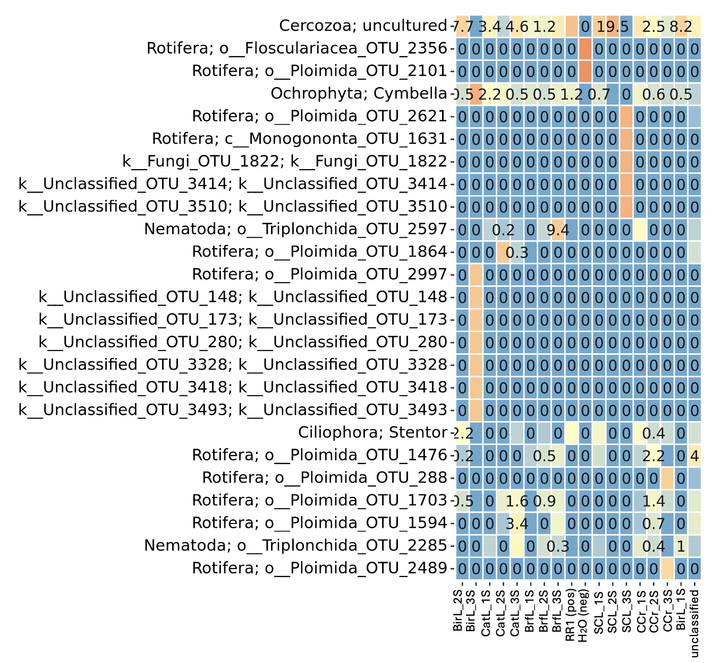
Figure C. Heatmap depicting the relative abundances of 18S OTUs from Zizania palustris rhizosphere soil with taxonomic assignment using the SILVA database of archaeal, bacterial, and eukaryotic 18S sequences (Quast et al. 2012). This heatmap was generated via the ONT-AmpSeq pipeline (Schacksen et al. 2024) using a 97% sequence identity with a read quality cutoff of Q20. Sample IDs indicate the basin from which rhizosphere soil was collected (BirL=Bird Lake, CatL=Cat Lake, BrfL=Beresford Lake, SCL=South Cross Lake, CCr=Cat Creek).

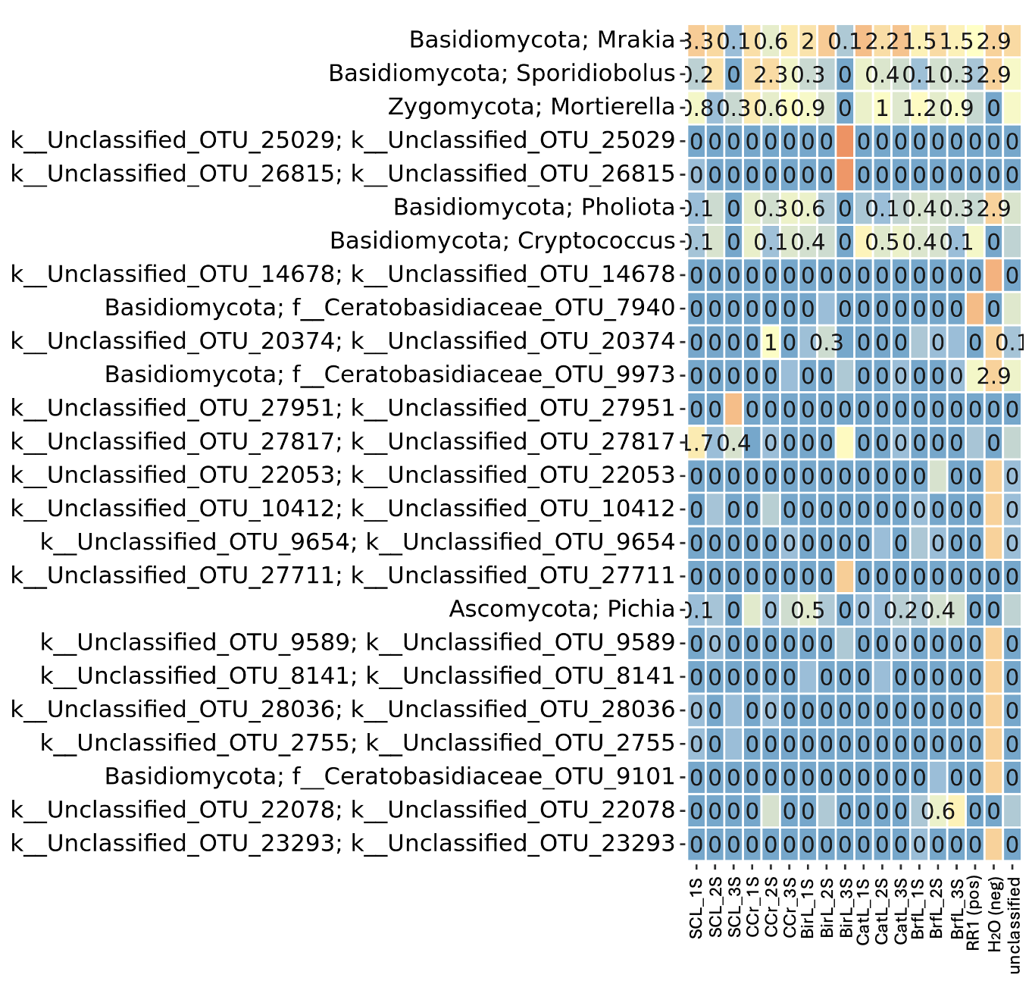
Figure D. Heatmap depicting the relative abundances of ITS OTUs from Zizania palustris rhizosphere soil with taxonomic assignment using the RDP database of fungal ITS sequences (Deshpande et al. 2016). This heatmap was generated via the ONT-AmpSeq pipeline (Schacksen et al. 2024) using a 97% sequence identity with a read quality cutoff of Q20. Sample IDs indicate the basin from which rhizosphere soil was collected (SCL=South Cross Lake, CCr=Cat Creek, BirL=Bird Lake, CatL=Cat Lake, BrfL=Beresford Lake).

