The Impact of Polypyrrole – Carboxymethyl Cellulose Composite Nanostructure on Conductivity and Capacitance
Gamaliel Azariah, Mariam Odetallah, Christian Kuss*
Department of Chemistry, University of Manitoba, Winnipeg, R3T 2N2 Manitoba

Abstract
Polypyrrole is a popular conjugated polymer that becomes highly conductive in its p-doped state. The intrinsically non-polar nature of the conjugated bond network limits the processing options of such polymers. Surfactants and polyanions help increase dispersity of conductive polymer in suitable solvents for processing. However, while such dispersions can be highly stable, they are formed by complex nanostructures that significantly impact the conducting polymer composite’s bulk properties. Similarly, complex nanostructures can be formed when surfactants or polyelectrolytes serve as templates during the polymerization of the conducting polymer precursor. Following the report of Polypyrrole:Carboxymethyl Cellulose composites in battery electrodes as conductive binders, we are here investigating the role that nanostructure control can have in optimizing their performance. Using methyl orange as a structural template, we can control the composite’s nanoscopic shape between nanospheres and nanofibers. In the bulk material, the latter gives rise to significantly increased electronic conductivity and capacitance in battery use conditions, underlining the opportunities for improved performance of conducting polymer composites by controlling synthesis conditions.
Keywords: Conducting polymers, battery binders, polymer nanostructure, capacitance

1. Introduction
Modern consumer electronics, ranging from smartphones to electric vehicles, are reliant on rechargeable lithium-ion batteries as energy storage systems. The dominance of lithium-ion batteries in this sector can be attributed to their superior energy density compared to other rechargeable battery systems¹. The ever-growing consumer demands and energy needs have pushed for the development of battery systems capable of greater energy storage, charge-discharge rates, maximized cost-effectiveness, and reduced environmental impact². The pursuit of these goals led to the exploration of alternative materials capable of higher energy capacity, faster charge and mass transport, greater stability, lower cost, greater abundance, and lower environmental impact. In many cases, such explorations led researchers to materials beyond the highly reversible intercalation chemistry of lithium-ion batteries. Examples include alloying materials as seen in silicon- and tin-lithium alloy based batteries, as well as conversion reactions found in lithium-sulfur batteries and lithium-air batteries³. These alternatives provide benefits in terms of production ease and reduction in overall manufacturing costs through the utilization of more abundant and/or easily accessed natural sources. Unfortunately, these alternative chemistries are frequently limited by extreme volume changes or dissolution and deposition reactions, that come with accommodating higher energy densities. With continuous volume changes due to the charging and discharging process, electrode degradation occurs which lowers overall battery performance over time⁴.
To tackle this issue, binder materials are used as additional components in electrode matrices. Despite accounting for but a fraction of the overall electrode mass, binder materials provide structural maintenance and integrity of electrode matrices as destructive volume changes occur⁵. Thus, novel binders have become essential components for new-generation higher energy density batteries. Materials designed to act as binders must therefore exhibit strong binding and adhesion with both the active material and the current collector it adheres to. Polymers such as sodium carboxymethyl cellulose (CMC), have demonstrated great adhesive properties as binders due to their strong polar interactions⁶. The insulating nature of CMC requires further a conductive additive, commonly carbon black. However, like other electrode components with a non-polar surface, carbon black easily agglomerates, lacks good contact with the active materials, and thus leads to deteriorating conduction paths in large-volume-change electrodes. Given that the salt-form of CMC is a polyanion, p-doped conducting polymers that are polycations, such as polypyrrole (PPy), are ideal composite partners to CMC. Such composite materials can be obtained through in-situ polymerization of PPy in the presence of CMC, which initiates doping of PPy by the CMC’s carboxylate groups. The resulting composite material demonstrates adhesiveness and conductivity, suitable for use as a binder and conductor in composite battery electrodes⁷. In addition, the ability of PPy:CMC to be synthesized and processed in bulk under aqueous conditions, allows it to be a more cost-effective and environmentally friendly binder compared to industrial binders such as polyvinylidene fluoride/carbon (PVDF/C)⁷.
Although PPy:CMC composites have shown great promise as binders on various fronts, their conductivity lacks behind traditional carbon blacks. Moreover, these composites have been applied in supercapacitors as capacitive elements before⁸. As such, the capacitive contribution of such binders to charge storage in batteries should be determined. The polymerization of PPy can be achieved through various routes and methods, with oxidative polymerization being the easiest and most cost-effective method⁹. The usage of organic dye additives in oxidative polymerization has been a known method for altering the nanoscale morphologies of PPy from nanospheres to nanofiber and nanotubular shapes¹⁰. The alteration of PPy morphology to those of greater surface area have been noted to correlate with enhancement in conductive and capacitive behavior¹¹, opening up a promising path to further enhance PPy:CMC as a binder. In this study, we incorporated the usage of methyl orange as an organic dye additive to the in situ oxidative polymerization of PPy:CMC formulated in previous studies¹². We examined the nano-morphology altering ability of this new synthetic route through material characterization and imaging of the thus prepared composites. Furthermore, we investigated the relationship between the altered composite morphology with its electrical conductivity and capacitance within battery electrolytes through four-point probe analysis and cyclic voltammetry experiments on symmetric cells.
2. Experimental
2. 1. Chemicals
The synthesis of PPy:CMC with and without methyl orange additive included pyrrole (Py) (98%, Sigma Aldrich), iron(III) chloride hexahydrate (FeCl₃.6H₂O) (Sigma-Aldrich), sodium carboxymethyl cellulose (Na-CMC) (MW = 700,000 kDa, degree of substitution: 0.9, Sigma-Aldrich), methyl orange (Sigma-Aldrich), ethanol (95%, Fisher), and reverse osmosis (RO) water.
Electrode and symmetric coin cell fabrication included methanol (95%, Fisher) as electrode surfactant and lithium hexafluorophosphate (LiPF₆) in ethylene carbonate/dimethyl carbonate (EC/DMC) (50:50, v/v, Sigma-Aldrich) as the coin cell electrolyte.

2.2. PPy:CMC Synthesis with and without methyl orange additive
Prior to polymerization, oligomers of pyrrole were removed by passing the neat pyrrole solution through silica powder. Homogeneous CMC solution was made by transferring 500 mg of Na-CMC in 50 mL RO water into a polytetrafluoroethylene (PTFE) jar with 10 agate balls, followed by overnight ball milling at 300 rpm. Lastly, oxidant solution was prepared by dissolving ~ 4 g of FeCl₃.6H₂O in 50 mL RO water.
The synthesis took place via in situ oxidative polymerization, which was adapted from a previous study¹². 500 μL of purified pyrrole was added to the Na-CMC solution. For samples polymerized in the presence of methyl orange, an additional 45 mg of methyl orange was added. Polymerization was initiated with the complete addition of oxidant solution followed by vigorous mixing for 4 hours at 10ºC. Afterward, the mixture was quenched with excess ethanol and left to settle for 24 hours. Product in the form of black precipitates were then vacuum filtered, washed with excess ethanol, and dried at 80ºC under vacuum overnight. The product was stored under dry vacuum conditions in a desiccator.
2.3. PPy:CMC electrode and symmetric coin cell fabrication
Slurries of PPy:CMC were prepared by transferring 500 mg of finely ground product and 3 mL solution of RO water and methanol (84:16, v/v) unto a (PTFE) jar alongside 10 agate balls, followed by ball milling at 300 rpm for 4 hours. Slurries were then immediately cast unto a 25 µm thick aluminium foil sheet (MTI, USA) using a doctor blade and left for overnight drying in a vacuum oven. 12.7 mm diameter electrode discs were then cut from the dried sheets using a circular disc punch. Subsequent storage of electrodes and symmetric coin cell fabrication took place inside an argon-filled glove box at an oxygen and moisture level of below 0.1 ppm. Two PPy:CMC electrode discs were compacted inside a coin cell infrastructure with a separator of WhatmanTM glass fiber discs (Fisher) doused with 115 μL LiPF₆ in EC/DMC electrolyte (figure SI.1).
2.4. Material Characterization
Finely ground samples underwent Fourier-transform infrared spectroscopy (FTIR) with an attenuated total reflectance sampling accessory and x-ray photoelectron spectroscopy (XPS) analyses utilizing the Agilent Cary 670 spectrometer and Kratos Axis Ultra XPS instrument in triplicates respectively. These methods allowed for product identification and surface chemistry elucidation.
Morphologies of isolated samples were characterized through scanning electron microscopy (SEM) imaging of finely ground sample powders and partitions of electrodes affixed to carbon tapes using the FEI Quanta 650 FEG environmental SEM instrument. Additional transmission electron microscopy (TEM) imaging was conducted on sample powders to obtain higher-resolution images. Sample preparation for TEM imaging involves dissolving finely ground PPy:CMC composites in ethanol under sonication. The resulting mixture was then drop-cast onto a carbon film on a 200-mesh gold grid and left to dry. Subsequent TEM imaging followed by EDX measurements for elemental mapping were done using the FEI Talos F200X instrument.
Electrical conductivity measurements were performed on samples in pellet form. Pellets were made by compressing finely ground sample powders at 200 MPa using a hydraulic press and pellet mold. Measurements of pellets were then conducted using the four-point probe method utilizing the Miller Design FPP-5000 probe and a Gamry Interface 1010 E potentiostat under galvanostatic conditions of 1 mA current. The resulting voltage readings were then used to calculate electrical conductivity values using the equation below.
$σ= \frac{1}{4.53 × \frac{V}{i} × T}$ Eq. 1
Where σ represents conductivity (S.cm⁻¹), V and i represent measured voltage (V) and applied current over pellet surface area (A/cm²) respectively, followed by T representing overall pellet thickness.
2.5. Electrochemical Testing
Potentiostatic cyclic voltammetry (CV) of symmetric coin cells was conducted using the Metrohm Autolab potentiostat/galvanostat instrument. CV experiments were done under scan rates between 1 to 5 mV/s with increments of 0.5 mV/s and a potential window of 0.2 V between – 0.1 and 0.1 V. Total areas of voltammograms generated at each scan rate, which corresponds to the amount of charge stored, were then used to calculate capacitance values.
$C_{S}=\frac{∫IdV }{2 ×Me × V × υ }$ Eq. 2
Where C_{S} represents specific capacitance (F/g), ∫ I dV represents the voltammogram area (A.V), and Me, V, and v represent total electrode mass (g), potential window (V), and CV scan rate (V/s) respectively.

3. Results and Discussion
3.1. Chemical and Structural Analysis
To establish the impact of PPy:CMC nano-structure, two materials should be investigated that only differed in nano-structure, but are chemically undistinguishable. As such, this study began with the careful analysis of XPS survey spectra (elemental composition) and FTIR spectra (significant differences in chemical bonding) for any chemical differences. Figure SI.2 shows that no such differences could be found between native PPy:CMC samples, and those formed in the presence of methyl orange. FTIR spectra included previously reported characteristic peaks of the PPy:CMC composite¹² at 1320 cm⁻¹ and 960 cm⁻¹. The strong carbonyl stretching vibration overlaps with the PPy amine group’s vibrations just below 1600 cm⁻¹ and highlights that CMC is present in its salt form. XPS spectra show the expected carbon, oxygen, and nitrogen signals, alongside a small chloride contamination, stemming from the chloride oxidant, which acts as PPy co-dopant. Throughout triplicate sample measurements, no significant differences were found between the elemental ratios of oxygen, carbon, and nitrogen of samples synthesized with and without methyl orange (with a confidence interval of 95%: surface atomic compositions of native PPy:CMC consisted of 34% ± 1.5 oxygen, 63% ± 1.5 carbon, and 3% ± 0.05 nitrogen. Methyl orange synthesized PPy:CMC consisted of consists of 35% ± 0.9 oxygen, 62% ± 0.9 carbon, and 3.2% ± 0.12 nitrogen.). Throughout all samples of PPy:CMC, oxygen signals (indicative of CMC) were higher than nitrogen signals (indicative of PPy). This is consistent with previous observations of PPy:CMC composites deposited from aqueous solution, which exhibited surfaces dominated by the much more hydrophilic CMC¹². TEM-EDX analysis of the samples demonstrate a bulk nitrogen to oxygen ratio that represents the expected 1:1 mass ratio of PPy:CMC, and shows that, within the error of the method, PPy and CMC are homogenously distributed (figure SI.3). Methyl orange contains sulfur, but no sulfur could be detected in any of these methods. As such, we are confident that no significant contributions of methyl orange remained in the sample, and that no impact of methyl orange on chemical composition of the PPy:CMC samples is observable. In addition, we have noted yield percentages of 92.7% and 87.5% for native and dye-synthesized PPy:CMC respectively.
SEM imaging (SI.4.a,b) of composites synthesized without methyl orange exhibited distinct nanosphere morphologies which are to be expected for PPy polymerized in this method¹². It can also be observed that these nanospheres are clustered together similarly to SEM imaging observed by studies on the in situ oxidative polymerization of PPy:CMC. This clustering can be attributed to the envelopment of PPy nanospheres by amorphous CMC, forming the composite. In contrast, SEM imaging (SI.4.c,d) of composites synthesized with methyl orange showed a combination of both nanosphere and nanofiber morphologies. Although nanofibers are expected to dominate, if not compose the entirety of isolated product, a previous study on utilizing methyl orange as a polymerization additive has shown possibilities of both morphologies coexisting¹⁰. The presence of PPy as both nanofibers and nanospheres was noted to occur due to factors influencing the self-assembly process of monomers into fibers, such as the method of monomer addition. However, the observed morphological coexistence depicted nanospheres localized on the surfaces of formed nanofibers¹⁰. Meanwhile, large clusters of nanospheres localized separately from nanofibers can be observed (SI.4.c). It is possible that the presence of CMC during PPy polymerization had a similar impact in influencing nanofiber self-assembly, albeit more significantly due to the high amounts present during polymerization as well as the doping which occurs between the two polymers. Upon higher magnification (SI.4.d), variation in nanofiber sizes can be observed. This may also be another form of nanofiber self-assembly disruption due to the presence of CMC. Higher resolution imaging of PPy:CMC composites (figure 1) through TEM confirmed the morphological trends observed in SEM imaging (SI.4). The overall sizes of the nanospheres appearing in both dye and without dye polymerization appears to vary, with average sizes around 60 nm in the sample without dye, and about 40 nm in the methyl orange dye-containing sample. While individual nanofibers exhibit a diameter of 50 to 100 nm, their length can be tens of micrometers. Interestingly, both nanofiber and nanotube morphologies were observed with reduced density in the center of the tube.
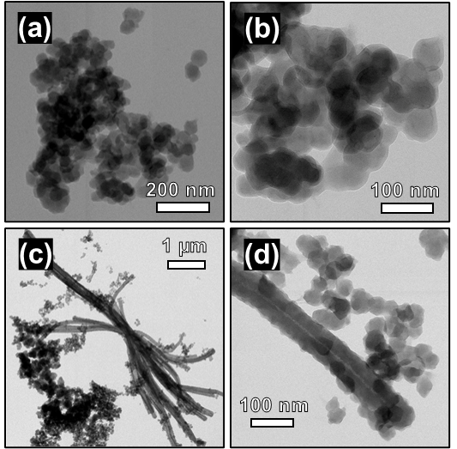
Figure 1. Transmission electron microscopy (TEM) images at different magnifications of PPy:CMC synthesized without dye additive (a & b) and with methyl orange additive (c & d).
Upon casting the composite on a current collector and drying, the microstructure is largely independent of the presence of methyl orange, while the different nano-structures persist (figure 2). In comparing figures 1 b and d, small hair-like extensions within material gaps can be observed in the sample that was synthesized with methyl orange additive. Such structures can contribute to enhancing long-range conductivity in the PPy:CMC material and composite electrodes.
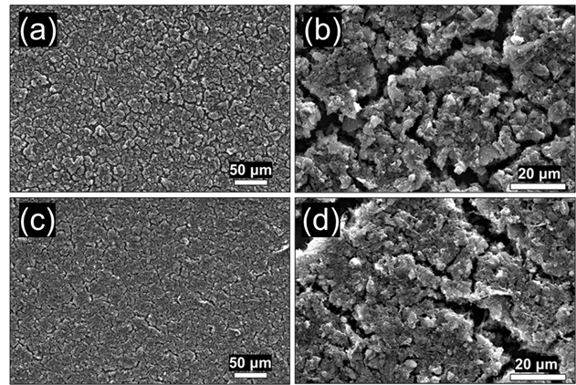
Figure 2. Scanning electron microscopy (SEM) images at different magnifications of electrodes consisting of PPy:CMC synthesized without additive (a & b) and with methyl orange (c & d).
Imaging and spectroscopic characterization thus confirm the formation of PPy:CMC and the independence of its chemical composition on the presence of methyl orange during polymerization. They also show obvious nanostructure differences between the two materials, with the formation of long fiber structures upon addition of methyl orange. We expect that these will significantly impact long-range conduction, as well as specific surface area, which affects capacitance.
3.2 Electrical Conductivity
To assess this hypothesis, we conducted electrical conductivity measurements by four-point-probe measurements. PPy is known to be an effective electrical conductor upon p-doping. Dependent on the PPy molecular weight, structure, dopant chemistry, and doping level, conductivities well above 100 S cm⁻¹ have been reported¹³. In this composite, that includes the non-conductive CMC as a significant component, the measured conductivities are increased from just under 1 S cm⁻¹ in the native PPy:CMC to near 3.5 S cm⁻¹ in the PPy:CMC composite synthesized in the presence of methyl orange (figure 3).
Prior work demonstrated that conductivity in native PPy:CMC composites is limited by tunneling conduction across CMC shells between PPy:CMC particles¹². As such, the composite’s conductivity is severely affected by inter-particle contact resistances. The number of contacts is drastically reduced by the formation of nanofiber and nanotube structures, thus increasing overall composite conductivity. As such, our data was able to confirm our hypothesis that the nanostructure impacts composite electronic conductivity.
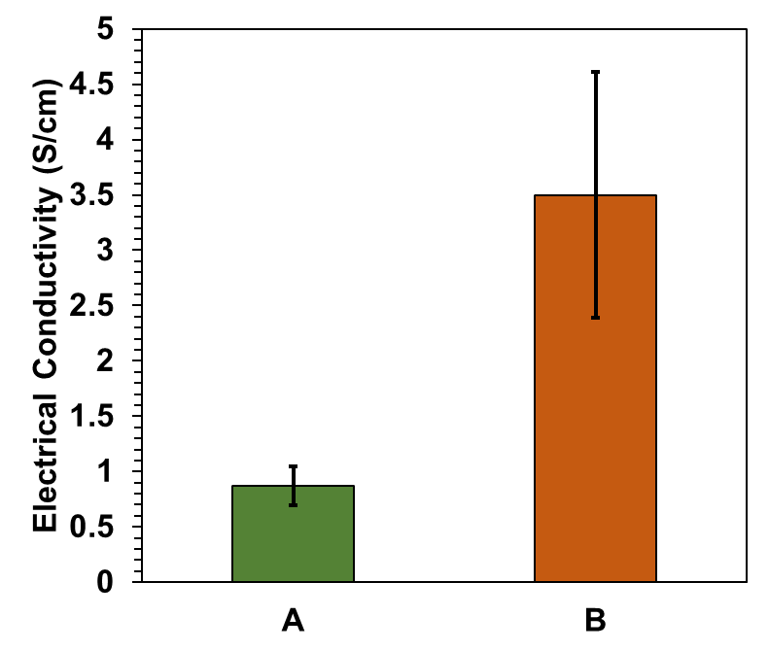
Figure 3. Average electrical conductivities of PPy:CMC composites synthesized without (A) and with methyl orange additive (B).
3.3 Capacitance
As PPy, like other conducting polymers, can be oxidized and reduced, it has been used in batteries and supercapacitors as charge-storing materials⁸. As the target application of PPy:CMC is as battery electrode binder, understanding the capacity contributions of the binder to the battery is of great relevance. To measure the capacitance of the material, we conducted cyclic voltammogram experiments at varying scan rates. The difference in oxidation and reduction current represents capacitive current contributions. Given the linear dependence of capacitive currents on scan rate, the slope of the voltammogram’s area plotted against the scan rate can be used to extract the material’s capacitance (figure 4). Average capacitance values were extracted with high reproducibility, showing a nearly seven times higher capacitance of the PPy:CMC material synthesized in the presence of methyl orange over the native control (figure 5). The high aspect ratio of nanofibers and nanotubes in comparison to the nanosphere morphology of the native PPy:CMC composite results in a vastly increased specific surface area of the conductive PPy component. As capacitance is proportional to the surface area of the electrode, the measurement is confirming our hypothesis that the PPy:CMC nanostructure impacts material capacitance.
Furthermore, this data allows the assessment of the capacity contribution that PPy:CMC binder can make to the capacity of a battery electrode. Battery electrode compositions commonly do not exceed 20% of binder contributions. Given the measured capacitance and assuming a typical cycling voltage range of up to 2.0 V, the binder’s capacity can reach approximately 25 mAh g⁻¹. In a lithium-ion electrode with 170 mAh g⁻¹ active material capacity, the binder could thus contribute as much as 3.5% to the overall electrode capacity.
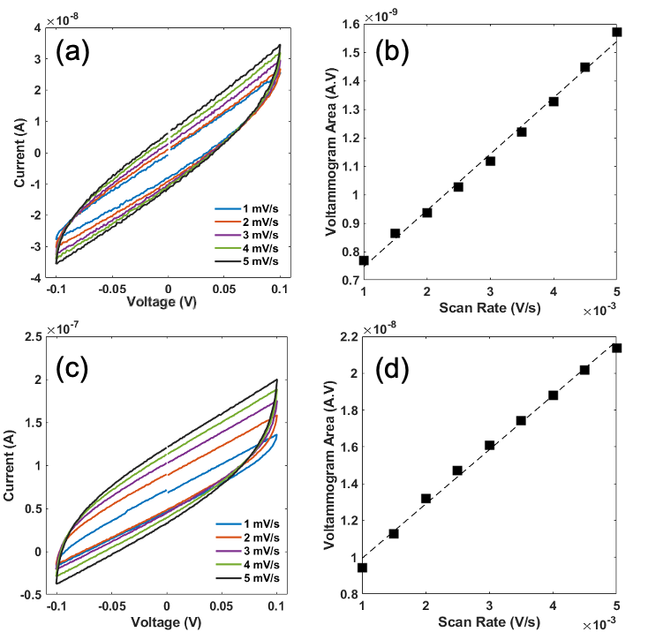
Figure 4. Representative voltammograms at various scan rates (1 mV/s, 2 mV/s, 3 mV/s, 4 mV/s, and 5 mV/s) of non-dye synthesized (a) and dye synthesized (c) symmetric coin cells. The linear relationship between voltammogram areas to increasing CV scan rates of non-dye synthesized (b) and dye synthesized (d) symmetric coin cells, were used to calculate capacitance values.
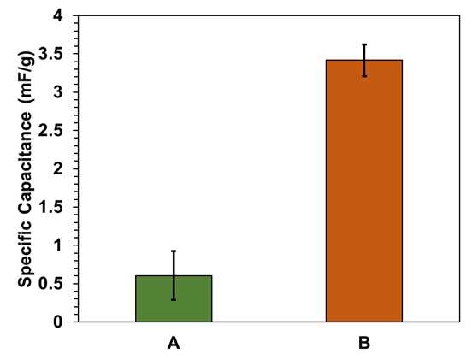
Figure 5. Average capacitance values of PPy:CMC synthesized without (A) and with methyl orange additive (B) based on CV analysis shown in figure 5.
4. Conclusions
Understanding the complex interplay between chemical composition, microstructure, nanostructure, and relevant material properties is crucial to designing conducting polymer composites with targeted properties. This work has assessed the impact that nanostructure has on electronic conductivity and capacitance of relevant PPy:CMC composites. These properties are crucially important in their application as binders in composite battery electrodes. It demonstrates that controlling the PPy:CMC composite nanostructure can improve conductivity and capacitance. While composite lithium-ion battery electrodes have been demonstrated to be able to operate with PPy:CMC as the only electrode additive, foregoing the use of other binders and conductive additives⁷, this work lays the foundation for the optimization of these binders that increases their battery application scope and performance.

Acknowledgements
We gratefully acknowledge financial support from the Natural Sciences and Engineering Research Council Canada (NSERC) and from the University of Manitoba.

Competing interests: The authors declare no competing interests.

Data Availability: Data is available upon reasonable request from the authors.

References
- Choi, J. W.; Aurbach, D. Nat. Rev. Mater. 2016, 1, 16013. doi: 10.1038/natrevmats.2016.13.
- Manthiram, A. ACS Cent. Sci. 2017, 3, 1063. doi: 10.1021/acscentsci.7b00288.
- Bresser, D.; Passerini, S.; Scrosati, B. Energy Environ. Sci. 2016, 9, 3348. doi: 10.1039/C6EE02346K.
- Shi, Y.; Zhou, X.; Yu, G. Acc. Chem. Res. 2017, 50, 2642. doi: 10.1021/acs.accounts.7b00402.
- Hu, J.; Wang, Y.; Li, D.; Cheng, Y. -T. J. Power Sources. 2018, 39, 223. doi: 10.1016/j.jpowsour.2018.06.103.
- Buqa, H.; Holzapfel, M.; Krumeich, F.; Veit, C.; Novák, P. J. Power Sources. 2006, 161, 617. doi: 10.1016/j.jpowsour.2006.03.073.
- Nguyen, V. A.; Wang, J.; Kuss, C. J. Power Sources Adv. 2020, 6, 100033. doi: 10.1016/j.powera.2020.100033.
- Xu, Y.; Zhang, Y. Mater. Lett. 2015, 139, 145. doi: 10.1016/j.matlet.2014.10.074.
- Pang, A. L.; Arsad, A.; Ahmadipour, M. Polym. Adv. Technol. 2020, 32, 1428. doi: 10.1002/pat.5201
- Joulazadeh, M.; Navarchian, A. H. Synth. Met. 2015, 199, 37. doi: 10.1016/j.synthmet.2014.10.036.
- Gupta, S.; Acharya, U.; Pištěková, H.; Taboubi, O.; Morávková, Z.; Kašparová, M.; Humpolíček, P.; Bober, P. ACS Appl. Polym. Mater. 2021, 3(12), 6063. doi: 10.1021/acsapm.1c00775.
- Nguyen, V. A.; Odetallah, M.; Bakir, G.; Gough, K.; Kuss, C. ACS Omega. 2022, 7, 41937. doi: 10.1021/acsomega.2c03461.
- Carrasco, P. M.; Grande, H. J.; Cortazar, M.; Alberdi, J. M.; Areizaga, J.; Pomposo, J. A. Synth. Met. 2006, 156, 420. doi: 10.1016/j.synthmet.2006.01.005.

