Current Management of Opioid Use Disorder and Barriers to Prescribing Opioid Agonist Therapy by Primary Care Providers in the Interlake-Eastern Health Region

Brittany Devaney PA-S2, BSc., BScN, RN
6852067
umdevanb@myumanitoba.ca
Supervisor: Ian Jones MPAS, CCPA, PA-C, DFAAPA
Regional Support: Kelly Bartmanovich BScPN, RPN

A capstone project submitted to the Faculty of Graduate Studies of The University of Manitoba
in partial fulfillment of the requirements for the degree of
MASTER OF PHYSICIAN ASSISTANT STUDIES (MPAS)

Master of Physician Assistant Studies
University of Manitoba
Winnipeg, MB

August 25th, 2022
TABLE OF CONTENTS
ABSTRACT 4
INTRODUCTION 5
Research Problem 6
Objectives 9
Primary Objectives 9
Secondary Objectives 9
METHODS 10
Participant Sampling, Recruitment, and Eligibility 10
Study Design 10
Study Procedures and Data Analysis 11
RESULTS 11
Participant Characteristics 12
Current Management 13
Provider Attitudes 14
Role of the Primary Care Provider 14
Efficacy of OAT in the Absence of Psychosocial Interventions 15
Efficacy of OAT in Primary Care vs. Specialized Addictions Clinics 15
Barriers to Prescribing OAT in Primary Care 17
Lack of Knowledge/Experience with the Interventions 17
Time Requirements 17
Training Requirements 18
Lack of Mental Health Resources 18
Lack of Patient Readiness for Treatment 18
Difficult Patient Interactions 19
Lack of Perceived Need in Practice Environment 19
Lack of Access to OAT at the Local Pharmacy 20
Stigma 20
Facilitators to OAT Prescribing in Primary Care 21
Improved Recruitment Settings 21
Access to Consultation/Expert Opinion 21
Partnership with other Prescribers 22
Sense of Fulfillment in Helping Others 22
Definition of Treatment Success 23
Alternative Primary Care Treatment Model or Remuneration 23
Current Willingness 24
DISCUSSION 26
Study Recommendations 28
STUDY LIMITATIONS 30
CONCLUSIONS 31
REFERENCES 32
APPENDIX A: Interview Guide 35
APPENDIX B: Barriers to Prescribing OAT in Primary Care 38
APPENDIX C: Facilitators to OAT Prescribing in Primary Care 43

ABSTRACT
Background: Opioid agonist therapy (OAT) is the first-line treatment for opioid use disorder. It has traditionally been provided through specialized addictions clinics, but more recently, there has been a push for primary care providers (PCPs) to take on this service. This has been met with reluctance by providers who cite a lack of adequate time, knowledge, and remuneration, among other barriers. Objective: The primary objective of this study was to explore provider-reported attitudes on and barriers to integrating OAT into primary care, specifically within the Interlake-Eastern Health Region (IERHA). The aim was to improve regional access by generating actionable recommendations to address these barriers. A secondary objective was to explore how PCPs currently manage opioid use disorder. Methods: This study employed a quality improvement design. Participants were purposively sampled from PCPs in the IERHA who did not have licensure to prescribe OAT. Structured individual interviews were conducted from May to June 2022. Transcripts were analyzed for overarching themes as they related to the study objectives. Results: Fourteen participants were included in the study. Fee-for-service providers were largely unwilling to prescribe OAT in the primary care setting and cited a multitude of factors for this such as lack of adequate remuneration, time, and perceived need. Notably, many providers were frustrated with the limited nature of mental health resources and expressed a sense of futility in providing OAT without these supports. Conclusion: Overall, fee-for-service providers in the IERHA expressed a myriad of barriers with respect to their unwillingness to prescribe OAT. At present, priority should be placed on contracted providers in expanding primary care access. Fee-for-service providers would be best utilized for maintenance prescriptions or OAT induction in a small number of less complex patients.

INTRODUCTION
Drug overdose deaths are rising in Manitoba, and opioids are to blame. According to the Office of the Chief Medical Examiner, one Manitoban lost their life to addiction each day in 2021. Overdose deaths in 2021 represent a 200% increase from 2018 and 2019 statistics. One or more opioids were involved in 68% of these deaths (1,2).
Opioid use disorder (OUD) is defined by the Diagnostic and Statistical Manual of Mental Disorders 5th Edition as a “problematic pattern of opioid use leading to clinically significant impairment or distress” (3). It commonly follows a relapsing-remitting course with ensuant psychosocial and physical harms (4).
Opioid agonist therapy (OAT) consisting of methadone and buprenorphine-naloxone (hereafter referred to as Suboxone) is considered the first-line treatment for OUD. Suboxone, given its superior safety profile, is recommended as the initial agent by the Canadian Medical Association (5). In comparison to more traditional methods such as opioid withdrawal (i.e., detoxification), agonist therapy has proven safer and more effective (5,6). In addition to reducing drug-related deaths, OAT has been shown to produce a greater than 50% decrease in all-cause mortality (7). Despite this demonstrated efficacy, it remains underutilized (8).
For practical purposes, OAT is regulated in Canada at the provincial level. Provider training requirements and prescribing guidelines differ by province, and in Manitoba are set forth by the College of Physicians and Surgeons of Manitoba (CPSM) (9). Educational requirements in the province vary with respect to methadone and Suboxone. A clinician intending to provide both must complete two full days of didactic training (through a CPSM-provided course), followed by four half-days of preceptorship with an experienced provider (10). These training requirements are known to represent a significant barrier to provider uptake (11).
In addition to the training requirements, OAT is a laborious process for both the patient and the prescriber. Due to the potential for toxicity/diversion, OAT is closely monitored in terms of induction and witnessed daily dosing. Patients’ progression to take-home dosing or “carries” is based on maintenance of a stable dose, treatment adherence, abstinence from illicit opioids, and evidence of clinical stability. Physicians themselves are taxed with the frequent need for monitoring, dose adjustments, and liaison with pharmacy (12).
OAT has traditionally been siloed into addictions medicine, and as such has primarily been made available through specialized clinics. However, with the growing problem of opioid use, there has been a push for primary care clinicians to provide this service (13). The provision of OAT in the primary care setting has been demonstrated as equally (if not more) effective in primary care as in addictions clinics (14). Furthermore, the provision of OAT in primary care makes use of pre-existing access points in the system and serves to decrease stigma (13).
Given the intent of long-term treatment with agonist therapy, OAT in primary care allows recipients to build rapport and establish continuity of care with a provider (4,13). In recognizing that persons with opioid use disorder (PWOUD) often possess poor primary care quality indicators, OAT in this setting provides an opportunity for simultaneous chronic disease management (15,16). In this regard, prescribing OAT in primary care has also been shown to reduce emergency room visits (17).
Despite the advantages of providing OAT in primary care, clinicians have been slow to adopt this practice (18). They cite a lack of adequate remuneration, support, time, and knowledge among a multitude of other barriers (19,20).

Research Problem
The Interlake-Eastern Regional Health Authority (IERHA) is not immune to the opioid crisis in Manitoba. Naloxone kit acquisition by the Selkirk Harm Reduction Team has increased 450% over the years 2019-2021, suggesting an overall trend of increasing opioid use (21).
Much of the region currently relies on the Selkirk Rapid Access to Addictions Medicine (RAAM) Clinic as a central hub for low-barrier access to addictions treatment and, more specifically, OAT prescribing (22). From its inception in 2018, the clinic has seen a relatively steady number of new client assessments each year. In contrast, follow-up appointments have continued to rise and in 2021 made up 89% of the total yearly clinic visits (23). See Figure 1. Given that the RAAM clinic currently operates on a one-day-per-week model, it is unsurprising that this volume of follow-up visits has exceeded the site’s capacity. Furthermore, a lack of qualified primary care OAT prescribers has given rise to a bottleneck in the system where stable patients cannot be offloaded from specialist care (22). As of June 2022, only seven regionally employed primary care providers were licensed to prescribe OAT. Many of these providers were concentrated in one area of the region leaving other sites vastly underserved (24). See Figure 2 and Table 1.
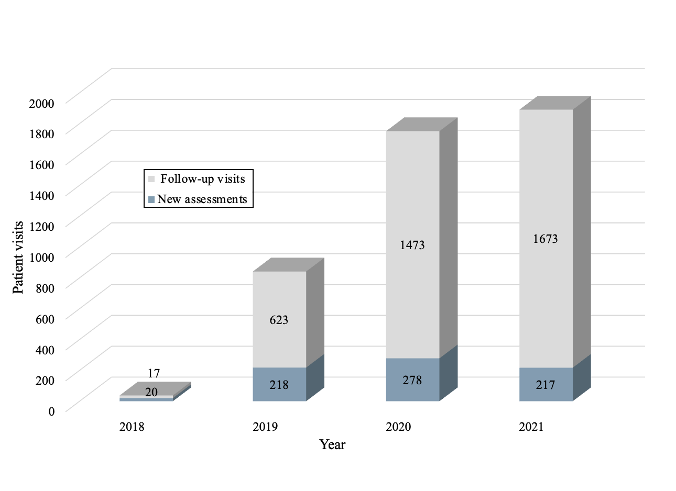

Figure 1. Selkirk RAAM Clinic Utilization. Note: clinic opening date of mid-November 2018. Data provided by Kelly Bartmanovich Clinical Team Manager, Mental Health and Addictions IERHA (23). Figure adapted from Substance Use Disorder in Interlake-Regional Health Authority: An Interdisciplinary Student Project. Impacts of the COVID-19 Pandemic on People Who Use Substances in the IERHA (21).

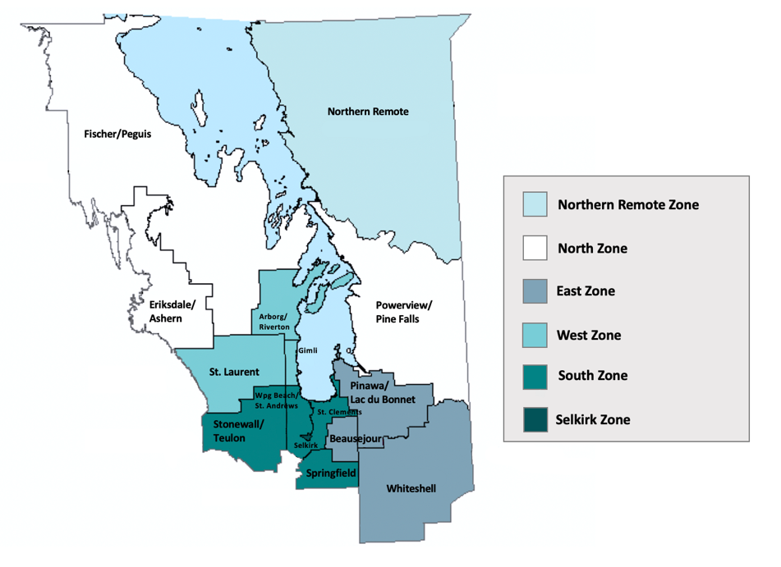
Figure 2. Subdivisions of the IERHA. Figure adapted from Interlake-Eastern Regional Health Authority Community Health Assessment 2019 (25).

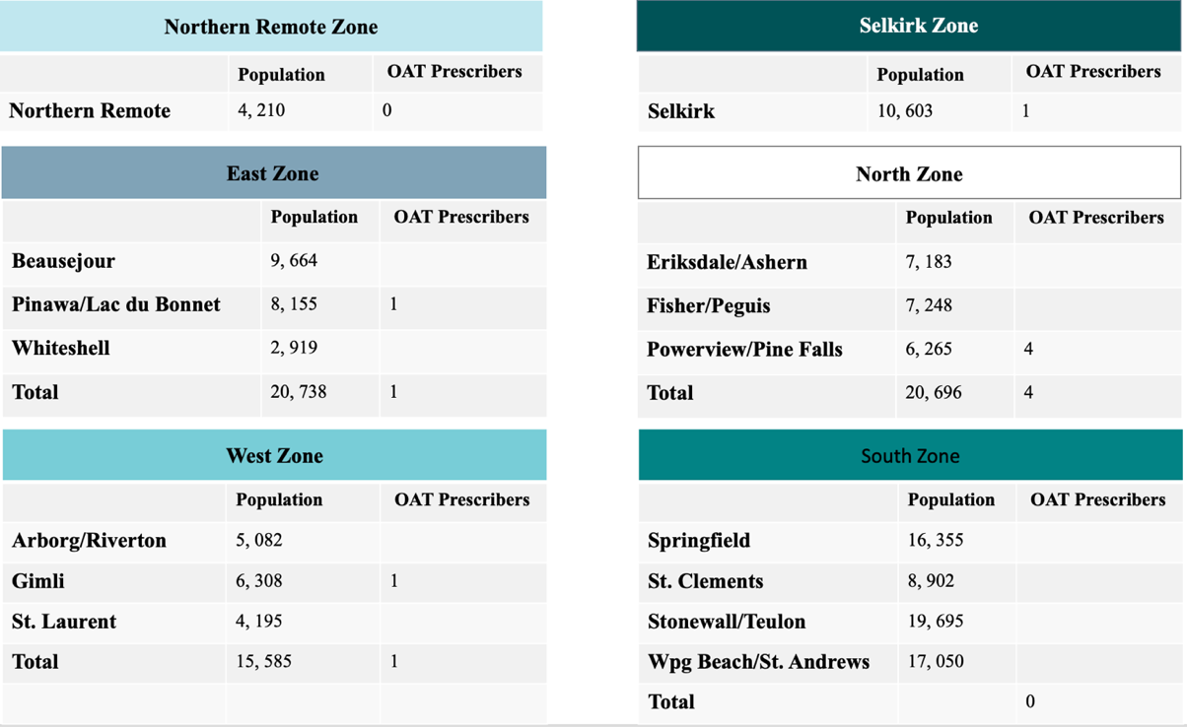
Table 1. OAT Prescriber Locations within the IERHA by zone and community. Population data as of June 1, 2020 (26). OAT prescriber data as of June 2022 (24). Table adapted from Population Report Interlake-Eastern RHA (26)
In recognition of this problem, the region has identified the recruitment of primary care OAT prescribers as essential to improving access to OUD care. The goal of this recruitment is not only to alleviate the burden on the RAAM Clinic but also to address the transportation barrier rural clients face when relying on a centralized access site (19,22). In acknowledging the reluctance of clinicians to take on this service, the region held preliminary discussions with primary care providers. Lack of training, support, and adequate remuneration were identified as significant barriers to provider uptake (22).
The purpose of this study was to explore provider-reported attitudes on and barriers to the integration of OAT into primary care practice. The aim was to improve regional patient access to OAT through the generation of actionable recommendations to address these barriers.

Objectives
Primary Objectives
- What are provider attitudes toward opioid use disorder management/OAT prescribing in primary care?
- What are the barriers and facilitators to providing OAT in the primary care setting?
- What is the current willingness of providers in the IERHA to prescribe OAT in the primary care setting?

Secondary Objectives
- How do primary care providers in the IERHA currently manage opioid use disorder?

METHODS
The study employed a quality improvement design. As such, the results are not intended to be generalizable but instead address the unique needs of the context under study (27).

Participant Sampling, Recruitment, and Eligibility
Participants were selected through purposive sampling methods to promote feasibility. Eligible providers at all medical clinics listed on the IERHA website were offered participation in the study to enhance fairness. The primary investigator employed various methods to recruit participants, such as phone calls to clinic administrative staff, direct communication with providers, distribution of a study invitation letter via email, as well as referrals from prior study participants. To generate results representative of regional providers, attention was paid to including clinicians from as many distinct communities as possible. Providers were eligible to participate in the study if they were currently practicing as a primary care provider (physician or nurse practitioner) in the Interlake-Eastern Health Region and did not hold licensure to prescribe OAT at present or in the past.

Study Design
Due to poor survey response rates in prior regional studies, individual interviews were chosen as the data collection method. Although this method limited the sample size, the open-ended question interviewing style was deemed superior in facilitating an in-depth exploration of provider attitudes and beliefs. Interview content was derived from studies examining the barriers to OAT prescribing in the primary care setting (19,20). Some questions were included verbatim (28). Other questions were designed by the primary investigator to elicit information on the designated objectives. See Appendix A for the interview guide. Study materials and procedures were approved by the University of Manitoba Health Research Ethics Board (HS2534). Regional approval for the study was also obtained. Of note, the study was conducted on behalf of the primary investigator and was not affiliated with the IERHA. Results of the study were intended to be made available to the region for consideration of the study-derived recommendations.

Study Procedures and Data Analysis
Documentation of informed consent was obtained prior to participants taking part in the study. Scripted individual interviews of approximately 45 minutes in length were conducted by the principal investigator in May and June of 2022. Due to restrictions of the COVID-19 pandemic, interviews were conducted over the Zoom videoconferencing platform in accordance with the University of Manitoba Guidelines for Virtual Research Involving Participants (29). Recorded interview content was extracted from audio files using the Zoom transcription feature and verified for accuracy by an assigned transcriptionist. An exit survey was administered to ensure participant safety given the sensitive nature of the topics discussed. Interview data was analyzed by the principal investigator within the context of each question and as a whole to elucidate overarching concepts as they related to the specific objectives.

RESULTS
Study results are grouped under the main headings of current management, provider attitudes, barriers, facilitators, and willingness to prescribe in accordance with the defined objectives. See Appendix B and C for a more exhaustive list of provider-perceived barriers and facilitators with supporting quotes. Direct quotations from participants were used in the results section to illustrate pertinent concepts and edited for readability. Participants were assigned coded identifiers (e.g. P1) to maintain confidentiality.

Participant Characteristics
Fourteen participants from nine communities within the IERHA were enrolled in the study. The majority of these participants (79%) practiced in a fee-for-service model. 21% were compensated through contracts. Early career clinicians (1-5 years in practice) comprised slightly more than half of the sample (57%). Male providers outnumbered females with a gender distribution of 64% and 36%, respectively. Although not currently licensed to prescribe OAT, 57% of interviewees had obtained additional education in addictions medicine through residency or continuing education. At the time of study enrollment, one participant had registered for (but not yet completed) OAT prescriber training. Another participant had completed the course and was awaiting the commencement of the required preceptorship component.

Overall (N=14) | n | %
Years in Practice
1-5 | 8 | 57%
6-10 | 2 | 14%
11-15 | 0 | 0%
16-20 | 1 | 7%
21-25 | 2 | 14%
≥ 26 | 1 | 7%
Gender
Male | 9 | 64%
Female | 5 | 36%

Overall (N=14) | n | %
Method of Compensation  Fee-for-service  Contract  Practice Environment | 11  3 | 79%  21%
Solo | 4 | 29%
Group | 10 | 71%
OAT Prescriber at Practice Location
Yes | 2 | 14%
No | 12 | 86%
Elective Education in Addictions
Yes | 8 | 57%
No | 6 | 43%
Other
Enrolled in OAT Prescriber Training | 1 | 7%
Awaiting Preceptorship | 1 | 7%
Communities Represented | 9

Table 2. Participant Characteristics

Current Management
Unlicensed providers described their current engagement in addressing OUD as primarily focused on judicious opioid prescribing, screening, and referral. Participants reflected on the role of prescription medications in contributing to the opioid crisis and emphasized their efforts to combat this through careful opioid prescribing. They described their attempts to "keep [patients] on the lowest amount” (P1) possible when prescribing chronic opioids and highlighted their efforts in opioid de-prescribing.
Providers displayed broad variation in their approach to screening for OUD. While some endorsed screening all patients, others showed bias in focusing on high-risk demographics or those with a history of opiate use. As one provider stated, “you probably play your hunches a little bit and screen those where you have a bit more [of a] suspicion” (P9). Overall, participants were more likely to screen for OUD in the context of initial patient visits or chronic opioid prescriptions. One provider denied any screening for illicit opiate use.
All but two participants endorsed having a referral relationship with an OAT prescriber. While some relied on the RAAM Clinic, others had formed connections with providers in neighbouring communities. Those providers who referred patients to the RAAM Clinic discussed minimal collaboration with clinic prescribers. One provider described it as largely “separate from the primary care world” and felt that the “RAAM clinic need[ed] to engage more with primary care providers” (P9).

Provider Attitudes
Role of the Primary Care Provider
Providers viewed the primary care setting as a natural "first point of contact for somebody that needs help" (P6). They spoke about the need to create a "safe space" (P4) where providers are open to "recognizing the signs and symptoms that people are bringing forward. (P12). They also expressed the importance of providers displaying a "willingness to provide [those] resources or referrals” (P14).
Participants spoke about the important role they played in screening and connecting patients to resources. Overall, participants did not believe it was their responsibility to provide OAT. However, as one provider stated, “If I’m not prescribing the Suboxone then I think my role is to get them to clinicians who are” (P5).

Efficacy of OAT in the Absence of Psychosocial Interventions
Most providers felt that providing OAT without additional supports would be ineffective. They conceptualized addiction in terms of distinct biochemical and psychosocial components and did not feel that OAT could address the latter. As one provider stated: “I do believe addictions is strongly a biochemical issue, like a genetic thing…by the time they present and are looking for treatment there’s a lot of other factors involved, and tackling the chemical addiction is one thing, but if you don’t address all the other issues, I think it’s not likely to be successful” (P11). One provider viewed psychosocial interventions as the basis of addictions treatment and compared it to the importance of lifestyle changes in managing other chronic conditions: “It would really be doomed to failure…[in] my practice I do a lot of teaching. So, for diabetes, if you don’t have the foundation of diet and exercise, you can add the medical treatment, but if you don’t have the foundation how can you build further? You need that base, same with addictions” (P1). Another provider doubted whether OAT could fully address such a complex problem: “You and I, we don’t have addictions, right? If you put anything in front of us and tell us to pick that or your next breath, we’ll pick our next breath because we like being alive. If you stick a baggie of cocaine or heroin in front of an addict and tell them to take heroin or [their] next breath, they take the heroin…that’s just always sort of resonated with me because there isn’t just one fix for something that powerful” (P12).

Efficacy of OAT in Primary Care vs. Specialized Addictions Clinics
Participants differed with respect to their views on the efficacy of OAT treatment in various settings. More than half of providers (57%) felt that treatment outcomes presently were, or had the potential to be, at least as effective in primary care as in specialized addictions clinics. Providers referred to accessibility and decreased stigma as mechanisms that could possibly even lead to superior efficacy in primary care.
Those who felt that outcomes currently were not at par (but had the potential to be) expressed that as the “average” PCP gains more knowledge and experience, the difference in efficacy between the sites would diminish. For example, one provider stated, “No, just because I think all our knowledge for family providers is a lot less right now…If I was able to understand that whole process of treating and prescribing…I don’t see why that couldn’t be, you know, as equally effective in a primary care setting as in a RAAM clinic” (P2). The remainder of the participants felt that treatment outcomes in primary care were less effective (14%) or were simply unsure (29%). See Figure 3.

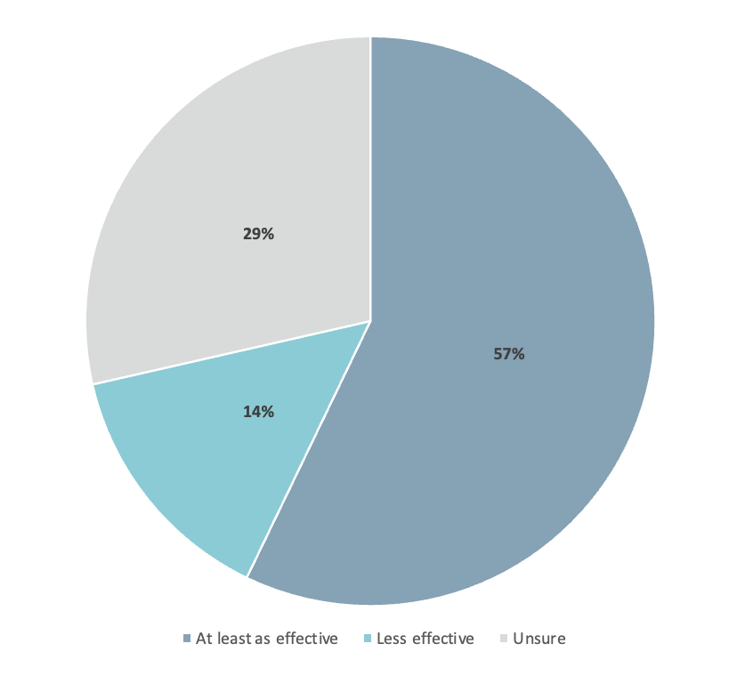

Figure 3. Provider Attitudes on the Efficacy of OAT in Primary Care vs. Addictions Clinics

Barriers to Prescribing OAT in Primary Care
Lack of Knowledge/Experience with the Intervention
Given the restricted nature of OAT prescribing and limited formal education, many providers identified a lack of knowledge as a significant barrier to their willingness to prescribe OAT: “I think that’s the big one, because if you don’t know what something is you’re not going to, you know, bounce up and down saying yeah pick me I’ll do it” (P1).

Lack of Adequate Remuneration
Fee-for-service providers cited a lack of adequate remuneration as a predominant barrier to pursuing greater engagement in addictions medicine. They anticipated needing more lengthy clinic visits to address the complex needs of PWOUD and emphasized that current billing tariffs did not allow the physician to bill appropriately: “I own my own practice. The supplies need to be paid for, the staff needs to be paid for, and to do that I gotta be seeing more than one person an hour. Even though I know this person needs the help, it doesn’t work in the model” (P12).

Time Requirements
Many fee-for-service providers doubted whether they had the time to provide adequate care in a typical clinic visit: “When it comes to management and when it comes to psychiatry, and the time that I’m allotted to see a patient, 10 minutes isn’t enough. So I just feel horrible” (P7). Others expressed concern for their existing patient population: “I’m going to be spending much more time with the patients, so that’s going to take away from my other patients” (P3).

Training Requirements
Providers spoke about the training requirements as a significant barrier to prescribing OAT. Many felt that the training course should be more accessible in terms of timing and location. Others questioned the need for a training requirement at all: “It’s kind of funny because we prescribe T#3s like nobody’s business, right? Nobody goes to a special clinic to get their T#3s. So just from a theoretical level, why do you go to a special clinic to get your OAT? It doesn’t make sense” (P9).

Lack of Mental Health Resources
Providers commonly recognized the co-occurring nature of mental health and addictions. As such, they expressed a sense of futility in providing OAT without adequate mental health supports: “Just opening up like a clinic where I can go and prescribe OAT is all well and fine, but it’s only half the treatment plan. And without enough addictions mental health workers and providers, I don’t think we’re going to get ahead of it, and that will frustrate providers. And unfortunately, then people won’t want to do it because they’ll just feel like they’re banging their head against the wall” (P12).

Lack of Patient Readiness for Treatment
Several providers found it "quite frustrating...to see a lot of patients at the pre-contemplative or contemplative stages of change" (P3). Participants felt that over and above providing access to OAT, there was a need for patients to recognize and be willing to address problematic opioid use: "You've got to know...how to convince your patients...I may be able to screen them as opioid use disorder or diversion, or whatever. But until, you know, until they agree, I could have all the OAT license you want" (P1).

Difficult Patient Interactions
Some participants were hesitant to discuss addictions with their patients as they felt ill-prepared to address such a sensitive topic: “Without that formal education…how to discuss with your patients, they tend to think that you are judging them” (P1). Others mentioned difficulties in encouraging patients to address their problematic opioid use: “Motivational interviewing, I haven’t been able to wrap my head around it. So, I think if, you know, somebody was to give us a talk” (P8).

Lack of Perceived Need in Practice Environment
Ninety-three percent of providers expressed a need for improved access to OAT in the region as a whole (1 provider had no response). Notably, only 46% of these providers perceived a need in their individual practice. Many felt that becoming an OAT prescriber would lack significant effect given the demographics of their patient population: “I don’t think it would have a huge positive impact for me at the moment just because it’s not something that…I [often] need to find someone to do this for me” (P6). Half of the providers discussed more commonly encountering PWOUD in the emergency setting and some felt that offering OAT in that environment would be more useful.

Lack of Access to OAT at the Local Pharmacy
Participants often spoke about the transportation barriers PWOUD face in accessing treatment. They acknowledged the significant burden daily dispensing placed on patients and questioned whether treatment would be effective in communities without pharmacy access: "I guess I might have a couple [patients] that [becoming a prescriber] would work. But for a lot of my patients, the barrier for them is still needing a daily ride into town to pick up the prescription" (P1). Providers also noted the competing demands on patients in the acute phase of illness: "Their next thought is not about how am I going to go and get my meds? It's how am I going to get my next fix, because they have a disease...how are they going to get from [location] to [location] daily is not sort of top of their list" (P12). Ultimately, lack of local pharmacy access dissuaded providers from pursuing training in OAT.

Stigma
A few providers acknowledged the stigmatizing views on OUD in reflecting on the barriers to implementing OAT in their practice. One provider noted that “some colleagues might not be happy with the fact, you know, if a clinic is now being sort of known as a drug rehab clinic…so that might affect who you work with” (P8). Another provider felt their patients would be hesitant to seek OAT care locally: “I think for my people they’d have to be treated somewhere close to home, but not at home…because they don’t want the small town to know” (P1).

Facilitators of OAT Prescribing in Primary Care
Improved Recruitment Strategies
Providers felt recruitment strategies could be improved to gain the attention of potentially interested parties: "It's maybe not as advertised as I would maybe like to see it. You know, every now and then we kind of get an email saying this is available to you...I think if the region promoted that a little bit more, I feel like providers will be more open to having that skill" (P2). One provider questioned why he had not been approached directly: "Nobody asked from now, up to now, why Dr. [redacted] you went to this post, why didn't you become a prescriber?...last year somebody called me from the region and said can you be a supervisor for [redacted]? I never wanted to, but I take it. If the region wants I will do it, because this region helped me to be a doctor here. So why they don't reach these doctors and have a good discussion?" (P13). Another provider expressed a desire to be included in discussions around improving access to OAT: "As a provider in [redacted] they could have had one meeting...in each town there's people that could be interested" (P1). Overall, participants felt that personalized recruitment strategies by the region would better facilitate provider uptake.

Access to Consultation/Expert Opinion
Given the general lack of knowledge and education surrounding OAT, providers highlighted the need for support from other providers if they were to take on OAT prescribing: “I think as long as I had a colleague that I could, you know, sort of phone a friend type idea…when we’re not sure what we’re doing” (P2). They also expressed the importance of guidance and oversight by addictions specialists: “I [can] continue the prescriptions in primary care with the advice from the RAAM Clinic…you know, that sort of a specialist keeping an eye on me” (P8).

Partnership with Other Prescribers
Participants identified partnership with other prescribers as imperative to their willingness to take on OAT: "You truly do need a group of providers...my colleagues, we're a group of [redacted] physicians and we said that we would need [redacted] of us to be on board with OAT prescribing before we even considered doing it in primary care" (P9). They acknowledged the heightened responsibility placed on OAT providers and expressed concern for prescription coverage in the absence of such support: "If there was only two of you...it would be almost impossible, because you would have to have your phone on 24/7, not be able to go on vacation" (P9). Providers felt they may become overwhelmed with requests if they were to act as the sole prescriber in a practice: "A lot of times I feel like, too, okay I'm going to take on OAT, and I'm the only one, which means that it's all my problem...I don't get a break from it...I'm inundated with all this work now on top of my regular work, like the load is not spread out" (P12). One provider suggested it would be helpful for the region to distribute a list of current prescribers: "Even if it is every six months. Hey, here's an FYI, we have this list of physicians in the region that are prescribing this if you have any need" (P3).

Sense of Fulfillment in Helping Others
Despite the often-challenging nature of addictions medicine, some providers expressed a sense of fulfillment in helping others achieve treatment success: "To watch that sort of progression of being in the depths of addiction and moving to, you know, what they consider a quality of life...it's quite rewarding" (P2). Another provider put it this way: "At the end of the day it is not [the] number of patients, it is how much good things you did as a whole, right?" (P13).

Definition of Treatment Success
While participants acknowledged that the ultimate success in treating OUD would be sustained remission, many accepted that relapse was an expected event in the course of chronic disease management: “Realistically…anybody who maintains contact with a provider…then maybe happens to fall off the wagon but comes back and keeps return[ing], any of that [would be a treatment success]” (P1). Most participants defined successful treatment from a harm-reduction standpoint in terms of improved functionality (at work, school, or in relationships), achievement of patient-defined goals, dose-reduction, use of clean drug supplies, or progressively longer periods of remission. This perspective was felt to facilitate willingness to engage in addictions care. Without this view, one provider simply stated: “You’d never do this again” (P12).

Alternative Primary Care Treatment Model or Remuneration
Most fee-for-service providers felt that “the model of care from a family physician [perspective] ma[de] it a barrier to provide in that environment” (P14). They suggested the need for a “different environment or at least a different compensation model” to make OAT prescribing feasible in that setting. Some suggested that rather than providing OAT during regular office visits, providing care in a fashion “similar to what the RAAM has going on” would better facilitate OAT prescribing (P3). One provider suggested “ask[ing] us to work in a contracted model once a week or once a month” (P3). Others felt that managing less complex patients with the option for escalation of care to the RAAM would better facilitate primary care prescribing OAT. Participants also discussed the potential for changes to the billing tariffs. Notably, contracted providers did not express a need for an alternative model or better remuneration.

Current Willingness
At the time of the interview, more than half of the participants (8 individuals or 57%) were not interested in prescribing OAT as part of their primary care practice. 4 providers (36%) expressed current willingness, one of whom was registered in an upcoming training course, and another who had completed didactic training but had not yet begun preceptorship. Of note, all participants compensated through contracts endorsed a willingness to prescribe OAT. Furthermore, all willing participants expressed an interest in providing both methadone and Suboxone. They were also open to both initiating and maintaining OAT prescriptions. One participant did not provide an answer. See Figure 4.
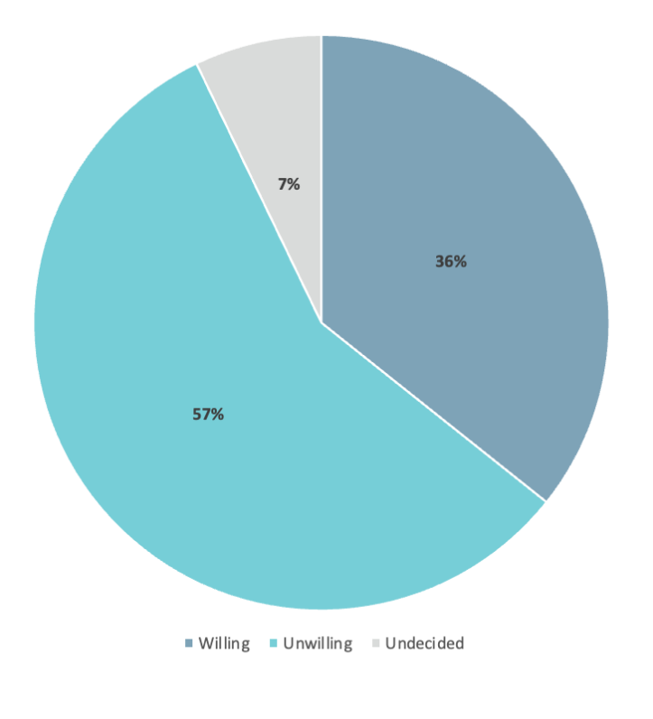
Figure 4. Current Willingness to Obtain Licensure and Prescribe
OAT in the Primary Care Setting

DISCUSSION

This study explored provider attitudes on and barriers/facilitators to OAT prescribing in primary care. The purpose was to generate actionable data to direct activities that would increase provider uptake. A secondary objective was to examine the current management of OUD by primary care providers in the IERHA.

With respect to current management, primary care providers emphasized a strong commitment to judicious opioid prescribing and regular reassessment of chronic opioid prescriptions. Interestingly, this unanimous attention to prescribing did not carry over to screening efforts. While providers collectively spoke about screening as a major part of their role, participants varied broadly in their approach. Some endorsed screening all patients, while others denied any formal efforts. Many expressed lacking the knowledge or experience to confidently discuss the sensitive topic of addiction with patients. This lack of perceived efficacy may represent a significant deterrent to screening efforts.

Another interesting theme was the discrepancy between providers’ perceived need for OAT in their practice versus the region as a whole. While nearly all providers endorsed a sense of need in the region, only half endorsed this same need in their practice. This may be explained by the inclusion of participants from regions of lesser need (as those in areas of higher need would be more likely to be licensed and thus ineligible). Alternatively, if this is not the case, one may question, if providers are not seeing this population in their practice, do these persons have a primary care provider? Further elucidation of this matter is warranted.

In terms of barriers to OAT in primary care, a notable attitude was the perception of a majority of providers that OAT lacked efficacy in the absence of psychosocial interventions. Overall, participants felt OAT was effective in addressing cravings, but lacked effect on the psychosocial factors associated with OUD (which they believed to be a main driver of the disorder). This view directly contradicts the literature which has shown no significant difference in the outcomes of OAT in the absence of such supports (30). Given providers’ frustration with the lack of mental health resources and the perceived inefficacy of OAT in its absence, this may represent a major barrier to provider uptake.

In addition to the barriers mentioned above, fee-for-service providers expressed a myriad of other barriers to prescribing OAT in primary care. As such, they were largely unwilling to take on this service, as opposed to contracted providers who did not express the same barriers.
Study Recommendations
The following recommendations were derived from interview data as a whole, including provider attitudes, perceived barriers, and facilitators:

Primary Care Screening for OUD
- Efforts should be made to promote the use of evidence-based screening methods in primary care
- This should include education on communication strategies that will assist the provider to feel more confident addressing the topic of addiction
Provider Education
- As general knowledge of OAT is low among unlicensed providers, the region should continue to invite primary care providers to take part in learning opportunities
- These opportunities should address the misconception that OAT is ineffective in the absence of psychosocial supports (which may represent a major barrier to provider uptake in the region) (30)
Prescriber Recruitment
- Direct, personalized recruitment strategies should be employed with a focus on knowledge-sharing and inclusion of all interested providers

Provider Utilization
- Given that the current fee-for-service model is not well-suited to OAT, priority should be given to utilizing contracted providers such as nurse practitioners to expand access to OAT in primary care
  - Notably, these providers have indicated a willingness to accept referrals from other providers
- In the current state, fee-for-service providers would be best utilized in providing maintenance OAT to allow offloading of patients from the RAAM Clinic
  - OAT induction, if done by these providers, would be best suited to a small number of less complex patients
Community Provider Support
- Community providers should be supported at a distance through easy consultation with addictions experts, similar to the existing Rapid Access to Consultative Expertise Model(31)
  - Pathways to the RAAM Clinic should be established in the event that care needs escalate or become unmanageable in the community
- All prescribers of OAT (whether providing induction or maintenance treatment) need clearly established partnerships with other providers and the local pharmacy
  - The region should play an active role in facilitating these partnerships
Access to Information
- The region should maintain an updated list of licensed OAT prescribers for distribution among regional providers
- It would be similarly advantageous for the RAAM Clinic to maintain a roster of licensed prescribers willing to accept patients on maintenance OAT
Alternate Primary Care Model/Remuneration
- Consideration should be given to models that facilitate OAT prescribing by fee-for-service providers
- This includes the potential for satellite RAAM clinics operated by primary care providers in a contracted model (e.g. OAT prescribing one afternoon a week)
OAT Induction in the Emergency Setting
- As participants mentioned that they were more likely to encounter PWOUD in the emergency setting, provider attitudes toward the induction of OAT in this setting should be explored
- Robust pathways for follow-up with community OAT providers would need to be established for the success of this model
Long-term Goals
- The region should continue to lobby higher levels of government with respect to improved remuneration for OAT prescribing
- Efforts should also be made to lobby for the de-regulation of OAT prescribing which represents a major barrier to provider uptake both in this sample and in the literature (11)

LIMITATIONS:
Despite the valuable recommendations derived from this endeavour, this study is not without its limitations. Notably, the participant demographics were unequally distributed with respect to provider gender, experience, and compensation method. Given that 79% of the sample was compensated through a fee-for-service model, the provider attitudes in this study are likely biased toward factors affecting this population. Further bias was introduced as two providers were enrolled in OAT prescriber training at the time of interview. Although employed for feasibility, the purposive sampling methods used did not allow equal opportunity for participation. Also, self-selection bias is likely as participants may have been more inclined to participate if they had an interest in OAT or held strong views on the subject matter. Lastly, although stigma toward PWOUD was not a prominent theme in this study, it is noted that social desirability bias is likely to have played a role given the interview style of data collection.

CONCLUSION
Overall, fee-for-service providers in the IERHA were unwilling to prescribe OAT in the primary care setting and expressed a multitude of barriers to engagement in this practice. At present, priority should be placed on contracted providers in expanding primary care access to OAT. Fee-for-service providers would be best utilized for maintenance prescriptions or OAT induction in a small number of less complex patients. As one provider stated, “It’s not that we don’t want to help. It’s just artificial barriers that are stopping us from doing it at this time” (P9).

REFERENCES
1. Unger D. Manitoba’s drug-related deaths have more than doubled since 2019 | CTV News. CTV News. 2022.
2. Coubrough J. Drug overdose deaths in Manitoba surge by 87% in 2020. CBC News Manitoba. 2021.
3. American Psychiatric Association. Diagnostic and Statistical Manual of Mental Disorders. 5th ed. 2013.
4. Strang J, Volkow ND, Degenhardt L, Hickman M, Johnson K, Koob GF, et al. Opioid use disorder. Nat Rev Dis Primers. 2020 Jan 1;6(1).
5. Bruneau J, Ahamad K, Goyer MÈ, Poulin G, Selby P, Fischer B, et al. Management of opioid use disorders: A national clinical practice guideline. CMAJ. 2018 Mar 5;190(9):E247–57.
6. Srivasta A, Kahan M, Nader M. Primary care management of opioid use disorder. Canadian Family Physician [Internet]. 2017;63:200–5. Available from: www.cfp.ca
7. Santo T, Clark B, Hickman M, Grebely J, Campbell G, Sordo L, et al. Association of Opioid Agonist Treatment with All-Cause Mortality and Specific Causes of Death among People with Opioid Dependence: A Systematic Review and Meta-analysis. JAMA Psychiatry. 2021 Sep 1;78(9):979–93.
8. Deflavio J, Rolin S, Nordstrom B, Kazal J la. Analysis of barriers to adoption of buprenorphine maintenance therapy by family physicians. Rural Remote Health [Internet]. 2015;15:1–11. Available from: http://www.rrh.org.auAvailable:http://www.rrh.org.au
9. Eibl JK, Morin K, Leinonen E, Marsh DC. The State of Opioid Agonist Therapy in Canada 20 Years after Federal Oversight. Canadian Journal of Psychiatry. 2017 Jul 1;62(7):444–50.
10. The College of Physicians and Surgeons of Manitoba. CPSM/CPhM/CRNM Process to Obtain OAT Prescribing Approvals or Dispense OAT in Manitoba Methadone Process [Internet]. 2022. Available from: www.cphm.ca
11. Haffajee RL, Bohnert ASB, Lagisetty PA. Policy Pathways to Address Provider Workforce Barriers to Buprenorphine Treatment. Am J Prev Med. 2018 Jun 1;54(6):S230–42.
12. The College of Physicians and Surgeons of Manitoba. Manitoba Methadone & Buprenorphine Maintenance Recommended Practice. 2014 Jul.
13. Donroe JH, Bhatraju EP, Tsui JI, Edelman EJ. Identification and Management of Opioid Use Disorder in Primary Care: an Update. Curr Psychiatry Rep. 2020 May 1;22(23).
14. Korownyk C, Perry D, Ton J, Kolber MR, Garrison S, Thomas B, et al. Opioid Use Disorder in Primary Care PEER Umbrella Systematic Review of Systematic Reviews. Canadian Family Physician. 2019 May;65:e194–206.
15. Spithoff S, Kiran T, Khuu W, Kahan M, Guan Q, Tadrous M, et al. Quality of primary care among individuals receiving treatment for opioid use disorder. Canadian Family Physician. 2019 May;65:343–51.
16. Rowe TA, Jacapraro JS, Rastegar DA. Entry into primary care-based buprenorphine treatment is associated with identification and treatment of other chronic medical problems. Addiction Science and Clinical Practice. 2012 Aug 28;7(1).
17. Kendall CE, Boucher LM, Mark AE, Martin A, Marshall Z, Boyd R, et al. A cohort study examining emergency department visits and hospital admissions among people who use drugs in Ottawa, Canada. Harm Reduct J. 2017 May 12;14(1).
18. Basky G. Too Few Doctors Prepared to Provide Opioid Addiction Treatment in the North. Vol. 191, CMAJ : Canadian Medical Association journal = journal de l’Association medicale canadienne. NLM (Medline); 2019. p. E1392.
19. Livingston JD, Adams E, Jordan M, MacMillan Z, Hering R. Primary Care Physicians’ Views about Prescribing Methadone to Treat Opioid Use Disorder. Subst Use Misuse. 2018 Jan 28;53(2):344–53.
20. Haffajee RL, Andraka-Christou B, Attermann J, Cupito A, Buche J, Beck AJ. A mixed-method comparison of physician-reported beliefs about and barriers to treatment with medications for opioid use disorder. Subst Abuse Treat Prev Policy. 2020 Sep 14;15(1).
21. Fryza A, Beer J, Law-Quon K, Lalonde V, Schroeder K. Substance Use Disorders in Interlake-Eastern Regional Health Authority: An Interdisciplinary Student Project Impacts of the COVID-19 Pandemic on People Who Use Substances in the IERHA. Selkirk; 2021 Aug.
22. Olafson P. Addictions Medicine in the Interlake-Eastern Regional Health Authority: A 3-year capacity building plan review. 2020 Oct.
23. Bartmanovich K. RAAM Clinic Utilization. Personal Communication Clinic Team Manager Mental Health and Addictions Interlake-Eastern Regional Health Authority. 2022.
24. Kelly Bartmanovich. IERHA-Employed Primary Care Providers Licensed to Prescribe Opioid Agonist Therapy. Personal Communication Clinical Team Manager, Mental Health and Addictions Interlake-Eastern Regional Health Authority. 2022.
25. Interlake-Eastern Regional Health Authority. Interlake-Eastern Regional Health Authority Community Health Assessment 2019. 2020 Jun.
26. Manitoba Health S and AL. Population Report - Interlake-Eastern RHA. 2020 Jun.
27. Foster J. Differentiating quality improvement and research activities. Clinical Nurse Specialist. 2013 Jan;27(1):10–3.
28. Wiercigroch D, Hoyeck P, Sheikh H, Hulme J. A qualitative examination of the current management of opioid use disorder and barriers to prescribing buprenorphine in a Canadian emergency department. BMC Emerg Med. 2021 Dec 1;21(1).
29. University of Manitoba. UM Guidelines for Virtual Research Involving Participants [Internet]. Available from: https://umanitoba.ca/about-um/tools-
30. Amato L, Minozzi S, Davoli M, Vecchi S. Psychosocial combined with agonist maintenance treatments versus agonist maintenance treatments alone for treatment of opioid dependence. Cochrane Database of Systematic Reviews. 2011 Oct 5;
31. Winnipeg Regional Health Authority. Introducing Rapid Access to Consultative Expertise.

APPENDIX A: Interview Guide
Demographics
- How many years have you been in practice?
- In what method are you compensated for your role in primary care? Fee-for-service or contract?
- Are you employed in a solo or a group practice?
- Do any of your practice partners prescribe OAT as part of their primary care role?

Perceived Need
- Do you perceive a need for OAT in your practice/the region? Explain.

Current Engagement/Perceived Efficacy
- To what extent are you involved in addictions management or treatment as part of your primary care practice?
- Do you have any referral relationships with providers of OAT?
- Describe your perceived self-efficacy in screening for, diagnosing, and managing patients with OUD.

Knowledge and Beliefs About the Intervention
- Describe your beliefs on the effectiveness of OAT for the treatment of OUD in the absence of psychosocial interventions.

- What patient outcomes would you consider a treatment success in providing OAT to patients?

Experience/Education
- Describe your experience with addictions medicine as part of your formal education (medical school/residency).
- What has been your experience with OAT (methadone or Suboxone) while in practice?
- Describe your experiences working with patients with OUD? How have you found interacting with these patients?

Role of the Primary Care Provider
- What do you consider the role of the primary care provider in addressing opioid use disorder (OUD)?
- In what setting do you feel patients with OUD are best treated and why?
- Do you think outcomes are the same for patients treated with OAT in primary care and addictions clinics (e.g. RAAM clinics)?

Barriers/Facilitators
- What facilitators are there in your current practice/the region that would support you in prescribing OAT?
- What are the challenges or barriers to prescribing OAT in your practice?
- What solutions can you suggest that might help to overcome these challenges?

- What effect do you think OAT prescribing would have on: your practice, your practice partners, your patient population?
- Do you feel supported by the region in treating patients with addictions/prescribing OAT?

Willingness
- Are you currently willing to obtain licensure and prescribe OAT?
- Are you willing to prescribe methadone, suboxone, or both? If not both, then why?
- Are you willing to initiate OAT, provide maintenance OAT, or both? If not both then, why?

APPENDIX B: BARRIERS TO OAT PRESCRIBING IN PRIMARY CARE

Barrier 1: Lack of Knowledge/Experience with the Intervention

- "I think that's the big one, because if you don't know what something is you're not going to, you know, bounce up and down saying yeah pick me I'll do it." (P1)
- "I don't know exactly what goes into all the initiation because I haven't done the courses. So, anything that's a grey area to me, I put [it] in the hard and scary box. If I know about it and it's like actually fine, but it's kind of an unknown area to me at the moment." (P6)
- "Having the education, what exactly does it mean? What does it mean that would happen in your practice? You know, is there policies around it?..because you're putting something new in..." (P1)
- "I don't really have much experience with it...after I left my home country lots more patients were involved in addictions. But back home then it wasn't really a big thing to have all of these addictions." (P4)
- "I don't think it's a matter of willing, it's a matter of exposure." (P14)
"BC residents will get their methadone license in their first year of residency, so then they can go into practice with the comfort and experience of providing that. Whereas I think people are a lot less likely to get into it once they are already in practice if they haven't had much exposure to it." (P14)

Barrier 2: Lack of Adequate Remuneration

- “I own my own practice, the supplies need to be paid for, the staff needs to be paid for, and to do that I gotta be seeing more than one person an hour. Even though I know this person needs the help, it doesn't work in the model." (P12)

Barrier 3: Time Requirements

- "When it comes to management and when it comes to psychiatry and the time that I'm allotted to see a patient, 10 minutes isn't enough. So, I just feel horrible..." (P7)
- "We try not to be really rigid with the timing...there is a point where you have to kind of cut if off. And I know I've had a couple of patients before that took that insultingly and they weren't interested in coming back or talking about it anymore because they didn't feel like they were getting the time...which is fair." (P12)
- "It's not like a blood pressure check or a diabetes appointment, or a cold. There's so many layers to it. You don't want to shortchange anybody." (P12)
- Some of the patients can be coming in every day to monitor and be taken care of with Suboxone." (P5)
- "I'm going to be spending much more time with the patients, so that's going to take away time from my other patients." (P3)

Barrier 4: Training Requirements

- "Getting the course itself is kind of difficult because it gets filled very, very quickly...but then after that finding someone to shadow or supervise while you start is a very difficult thing to do because, again, there's only that little bit of time when they're prescribing [redacted] in Selkirk and coordinating that." (P5)
- "The course itself can be quite expensive, so I saw that as a barrier for myself right now. And then, just being able to take the time to complete the course...because I am the only prescribing provider, when I'm not there it has a significant impact on my practice. And that can result in a lot of catch-up." (P2)
- If CPSM took away the requirement for special licensure for OAT, that would make this more sustainable." (P9)
- "It's kind of funny because we prescribe opioids like nobody's business, right? Nobody goes to a special clinic to get their T#3s. So just from a theoretical level, why do you go to a special clinic to get your T#3s? It doesn't make sense.” (P9)

Barrier 5: Lack of Mental Health Resources

- "Just opening up like a clinic where I can where I can go and prescribe OAT is all well and fine but it's only half the treatment plan. And without enough addictions, mental health workers and providers I don't think we're going to get ahead of it, and that will frustrate providers. And unfortunately, then people won't want to do it because they just feel like they're banging their head against the wall." (P12)
- "And if you screen for something you have to be able to do something about it. There's no use in screening for a condition if we're not going to address the issues." (P9)
- "It's just it's so prevalent and so underfunded and there's just no supports for it and all of us feel like we're just going in circles and it's dejecting a lot of time." (P12)
- "To me it's all access, whether it's mental health, whether it's addictions medicine, whatever. There isn't anything that's there to help people in a timely manner, right? Like how many patients overdose and die waiting for help when they asked months ago. Like they've been ready to go when you've been telling them to just hang onto this life threating illness as long as they can. And when they give in, we call them junkies or addicts. And what did they think was going to happen? But six months ago they came in asking to get help or whatever. And we don't focus on it, we don't say anything about it. The media doesn't cover it, the region doesn't care. Any they just, oh there you go another opiate-related overdose or death or whatever. And nothing changes." (P12)
- "I think that they just need to start supporting us. They know that mental health is one of the biggest issues and a lot of mental health is drug use." (P3)

Barrier 6: Lack of Patient Readiness for Treatment

- "Quite frustrating...to see a lot of patients at pre-contemplative or contemplative stages of change. So, they're either not interested in changing, or they're kind of coming into emergency after a scare or into my clinic after a scare. And them thinking of oh no I need to change, but then don't really do anything about it." (P3)
- "Patients also have to be willing. So management is often patient-directed and patient-based, because if a patient isn't willing, they're not going to comply with therapy regardless if I have the ability to prescribe or not." (P3)
- "You've got to know...how to convince your patients...because it's, it's no different than having, you know, somebody...that I know is an alcoholic...he goes on a bender and every time he goes to emergency because he gets stomach pain. You can't get him to the point where he'll go to, you know, a treatment. And it's somewhat the same with some of my others. I may be able to screen them as opioid use disorder or diversion or whatever. But until, you know, until they agree, I could have all the OAT license you want." (P1)

Barrier 7: Difficult Interactions

- "Motivational interviewing, I haven't been able to wrap my head around it. So, I think if, you know, somebody was to give us a talk..." (P8)
- “Without that formal education, or more formal, how to discuss with your patients, they tend to think that you are judging them." (P1)
- "It's a very touchy subject, you're just bringing it up with a patient...can at times kill the patients-doctor relationship, especially when they are abusing drugs. So if you would just bring it up, I think most of them might X you and decide not to come back." (P8)
- "I think sometimes it's knowing the right thing to say and I'm not experienced enough to always identify that." (P6)
- "Sometimes I feel more like a babysitter." (P1)

Barrier 8: Lack of Perceived Need in Practice Environment

- "I don't think it would have much [effect]. There would be instances that it could be beneficial, but I don't think in my day-to-day practice it would change much." (P14)
- "I think I could do it really easily if I wanted to, I just don't think I need it." (P6)

Barrier 9: Lack of Access to OAT at the Local Pharmacy

- "Besides provider access is pharmacy access...You can't get these drugs at the pharmacy next door to my clinic. You can't get them in [location redacted]...I can prescribe anything I want and if they're not going to pick it up it was a waste of time...Their next thought is not about how I am going to go and get my meds. It's how am I going to get my next fix, because they have a disease. They have an addiction, and how are they going to get from [location] to [location] daily is not sort of top of their list" (P12)
- I mean it's not just the primary care providers, but also the pharmacists who have to dispense it as well too. The pharmacist here doesn't." (P5)
- "I guess I might have a couple [patients] that [becoming an OAT prescriber] would work. But for a lot of my patients the barrier for them is still needing a daily ride into town to pick up the prescription." (P1)

Barrier 10: Stigma

- "Some colleagues might not be happy with the fact, you know, if a clinic is now being sort of known as a drug rehab clinic...so that might affect who you work with." (P8)
- "They're very challenging to deal with in a private clinic. They're often disruptive. They can be very challenging with our staff." (P9)
- "If it [OAT prescribing] kicks off in the clinic they [existing patient population] might not want to come because there's stuff like that"... (P8)
- "I think for my people they'd have to be treated somewhere close to home but not at home...because they don't want the small town to know." (P1)

Barrier 11: Concerns for Medication Misuse

- "Some are very interested in the help and they are compliant with the medications. Some you just feel, okay now about the methadone, I want a higher dose and I'm like no we're not meant to get a higher dose we're meant to be decreasing what you are taking." (P8)
- "...asking them to do UDS [urine drug screen], and what happened is these people are cheating. They put water and sometimes they exchange bottles..." (P13)

Barrier 11: Lack of Capacity to Take on Complex Patients

- "I don't tend to take on those kinds of patients, because I do so many different things...I don't have a capacity for like high needs people..." (P6)
- "Do I then want to take on a bunch of complicated addictions patients? I probably should want to, but like, I'm already busy right. I'm saying no to regular people who are asking to be part of the practice, right, and eventually you become responsible for the patients that you're taking care of..." (P12)

Barrier 12 - Mental/Emotional Toll

- "There's opiate addiction in my family, so I think it's a bit of a trigger." (P12)
- "This takes a lot of (not so much the prescribing part, but the mental, the counseling, and addictions counseling)...mental energy. So this is not an appointment I want to throw in at 10:30 in the morning. Because I'm gonna see them, and now I'm emotionally drained depending on how it goes. And I got another five hours of clinic with other people who need my emotional availability." (P12)

Barrier 13 - Increased College Oversight

- "The way the regulations are with CPSM is that as soon as you start prescribing OAT you're basically like, you owe that to the patient. And if something goes wrong, like it's on you. Way more than with any other medication." (P9)

APPENDIX C: Facilitators to OAT Prescribing in Primary Care
Facilitator 1: Improved Recruitment Strategies

- "Nobody asked from now, up to now, why Dr. [redacted] you went to this post, why you didn't become a prescriber?...last year somebody called me from the region and said can you be a supervisor for [redacted]? I never wanted, but I take it, if the region wants I will do it because this region helped me to be a doctor here. So why they don't reach these doctors and have a good discussion?" (P13)
- "It's maybe not as advertised as I would maybe like to see it. You know, every now and then we kind of get an email saying this is available to you...I think if the region promoted that a little bit more, I feel like providers will be more open to having that skill." (P2)
- "I don't think there's anyone who has actually sat down to tell me the benefit...I would have expected that coming newly to a system, I should probably get people [physicians] from addiction [medicine]...there are many things out of my lane. And I feel that it's not really very encouraging, it's not, it's not really what I expect it kind of a setting to be, you know, you have to look around for things yourself..." (P7)
- "As a provider [in] [location redacted] they could have had one meeting, and because I think we, in each town there's people that could be interested, or at least be given the opportunity" (P1)

Facilitator 2: Access to Consultation/Expert Opinion

- "I think as long as I had a colleague that I could, you know, sort of phone a friend type idea right, when we're not sure what we're doing" (P2)
- "I can see it [prescribing OAT], but then you'd probably need some help, bounce ideas off somebody." (P1)
- "I continue the prescriptions in primary care with the advice from the RAAM clinic...you know, that sort of a specialist is still keeping an eye on what's going on." (P8)
- "We need good communication from the authority like from RAAM... [we need] somebody to ask if you are having any, and when I said yes I have this problem they should help me." (P13)

Facilitator 3: Coverage from Other Prescribers

- "You truly do need a group of providers...My colleagues, we're a group of [redacted] physicians and we said that we would need [redacted] of us to be on board with OAT prescribing before we even considered doing it in primary care." "Like if you, if there was only two of you, like it would be almost impossible because you would have to have your phone on essentially 24/7, not be able to go on vacation." (P9)
- "So I think if anything happens, more than one provider at each site able to do that [prescribe OAT], which is to kind of alleviate the burden of one person having to do it all the time." (P3)
- "I want to be an OAT prescriber, but I will not be until they provide me at least another two prescribers in the same facility." (P13)
- "A lot of times I feel like, too, okay I'm going to take on OAT. And I'm the only one, which means that it's all my problem. Right, it's not, I don't get a break from it...like I'm inundated with all this work now on top of my regular work like the load is not spread out." (P12)
- "Notifying the region even if it is every six months, hey here's an FYI, we have this list of physicians in the region that are prescribing this, if you have any need." (P3)

Facilitator 4: Sense of Fulfillment in Helping Others

- “It’s honestly been a very positive experience…to watch that sort of progression of being in the depths of addiction and moving to, you know, what they consider quality of life is actually, it’s quite rewarding and it’s quite positive to see that you can make that big of an impact on somebody.” (P2)
- “My number of patients decrease, but it is compensated by what you feel in your mind. At the end of the day, it’s not number of patients, it is how much good things you did to as a whole, right?” (P13)

Facilitator 5: Definition of Treatment Success

- I guess the ultimate success would be that they go off and they never go back. But realistically…anybody who maintains contact with a provider…maybe happens to fall off the wagon but comes back and keeps return[ing], any of that would be. I think any amount not using opioids could be a treatment success, because everybody relapses whether they’re a diabetic, or you know, high blood pressure, weight loss, any of those.” (P1)
- Success for me is that patients are able to get back to what they feel is a good quality of life.” (P2)
- “Of course relapse is going to happen, it’s almost inevitable with all these types of things, but if we are getting them further and further out from relapsing…I still call that quite successful.” (P3)
- “I feel like the focus is way too much on complete and utter abstinence.” (P12)

Facilitator 6: Alternative Primary Care Treatment Model or Remuneration

- “I think the model of care from a family physician makes it a barrier to provide in that environment. I think we do sort of need a different environment, or at least a different compensation model.” (P14)
- “Ask us to work in a contracted model once a week or once a month…probably similar to what the RAAM has going on.” (P3)
- “The primary care setting is a good place to start. Especially for mild to moderate use disorders…but if it’s not going well then they need places where they adequately treat for this.” (P4)

