Arthropod Diversity Within The Three Sisters Cropping System
by
Tessa Ferch
A thesis submitted to the Department of Biological Sciences, University of Manitoba, in partial fulfilment of the requirements of the course
BIOL 4100 (Honours Thesis)
for the degree of Bachelor of Science (Honours)
© April, 2024

Abstract

The Three Sisters is an indigenous cropping method that dates back hundreds of years. It is comprised of the simultaneous planting of corn, bean, squash, and sometimes sunflower. However, there has been no published research into arthropod communities and interactions with this cropping system. My study examined arthropod abundance and taxa to the family level at three areas: uncultivated, fields planted with The Three Sisters, and field edges. This was done at three sites in Manitoba: Ian N. Morrison Research Farm near Carman, Glenlea Research Station near Glenlea, and Brokenhead Ojibway First Nations Reserve. I placed 8 sticky cards within each area at each site starting in July 2023, and had 4 bi-weekly sampling rounds. The number of samples collected and processed was 288. I conducted a perMANOVA test, and ran multiple negative binomial generalized linear mixed models, testing the abundance and number of taxa present in relation to the site, area type, date, colour, and using trap number as a random effect. All sites were significantly different from each other. Glenlea had the highest diversity, and Carman had the least diversity. The uncultivated areas differed from both the field and edge areas, and the fields and edges also differed from each other at all sites. The field and edges had higher diversity than the uncultivated areas. The most important finding of my study was that The Three Sisters is an agricultural method that can allow for higher diversity of arthropods than uncultivated areas.

Acknowledgements

My thanks go out to my advisor Dr. Kyle Bobiwash, and my co-advisor Dr. Anne Worley. My thanks also go out to Dr. Jim Roth and Dr. John Markham for serving on my committee. I also want to acknowledge Victoria Smelko, Vanessa Siemens, Céline Chevrefils, and Jaqueline Bowles for their help and support.

Table of Contents:

Introduction………………………………...1
Hypothesis………………………………….4
Materials and Methods……………………..4
Results……………………………………...9
Discussion…………………………………20
Conclusion………………………………...23
Literature Cited……………………………24

List of Tables

Table 1. The statistical results of the perMANOVA between the sites and areas…………11
Table 2. The post-hoc test results of all combinations of site and areas…………………...13
Table 3. Statistical summary of the negative binomial results for total abundance per sample……………………………………………………………………………………...15
Table 4. Statistical summary of the negative binomial results for total families per sample………………………………………………………………………...……………16

List of Figures

Figure 1. The Three Sisters planting arrangement for each group………………………..5
Figure 2. PCA ordination plot of families and abundances of arthropods grouped by site and area………………………………………………………………………………..………12
Figure 3. Bar plot of total abundance per sample grouped by site and area……………...18
Figure 4. Bar plot of total families per sample grouped by site and area………………...19

Introduction

The Three Sisters is an Indigenous cropping method in which squash, corn, bean, and sometimes sunflower are grown together (Mt. Pleasant 2016). Beans are capable of fixing nitrogen into the soil, squash may help reduce the presence of weeds, corn can provide stability for the beans, and sunflowers can provide a floral resource for pollinators (Ngapo et al. 2021). This agricultural method may have been used since 1070 AD and is considered to have been relatively common in the 1500s (Zhang et al. 2014; Ngapo et al. 2021; Kapayou et al. 2023). Despite the importance and widespread usage of this cropping method, there is almost no scientific research that examines The Three Sisters, especially in relation to arthropod communities.

The Three Sisters is a method of intercropping, contrasting with monocropping, which is the planting and growth of only one crop in an area such as a field. Monocropping is a very common agricultural method in North America, especially as our agriculture became very industrialized (Olfert et al. 2005; Crist and Peters 2014; Vankosky et al. 2017). Monocropping has been associated with increases in pest presence within crop fields, habitat fragmentation, the loss of biodiversity, and nutrient poor soils (Altieri 1999; Crist and Peters 2014; Zytynska and Meyer 2019). These issues may lead to increased reliance on and
applications of fertilizers and pesticides, which can lead to pollution of water sources, and negatively impact non-target organisms such as wild pollinators (Zytynska and Meyer 2019; Busse et al. 2021). These negative effects have led some researchers to suggest introducing plant diversity into the cropping system or the surrounding areas (Zytynska and Meyer 2019). One of the suggestions that aims to try and increase diversity within monocropping has been termed ‘Beetle Banks’, which are strips of non-cropped areas, often composed of plants such as types of grasses (Altieri 1999; Gurr et al. 2003). These strips can harbour natural enemies of pests such as ground beetles (Coleoptera: Carabidae), which can then move into crop fields and reduce the pest populations (Olfert et al. 2005). This in turn, may then reduce the need for pesticide applications (Gurr et al. 2003). However, there is no guarantee the predators will move fully into the field or reduce the need for chemical pesticides (Olfert et al. 2005; Rand et al. 2006). Another strategy is the addition of floral strips, which are strips of non-cropped land adjacent or within a crop field that are purposefully seeded with flowering plants in order to attract, and provide a possible habitat for pollinators (Rand et al. 2006; Nicholls and Altieri 2013; Vankosky et al. 2017; Zamorano et al. 2020). Another method for increasing plant diversity to remedy some of the problems resulting from monocropping in crop systems is the usage of crop rotations, which is the practice of planting different crops on the same land in different years (Liu et al. 2020). Overall, there is increasing research into attempts to increase arthropod predator presence within cropping systems.

Arthropods comprise most of the earth’s animals, with 1-10 million species, the vast majority being undescribed (Samways 1993; Raven and Wagner 2021). Arthropods are also important contributors to ecosystems, with a variety of roles such as herbivores, predators, parasites, scavengers, and pollinators (Samways 1993; Busse et al. 2021).
A more diverse ecosystem comprised of arthropods with different roles may be a more stable ecosystem, possibly being able to tolerate higher stressors than systems that are less diverse (Duelli et al. 1999; Olfert et al. 2005; Vankosky et al. 2017). Currently, many arthropods are at risk of becoming endangered or extinct in what has been described as the sixth mass extinction (Samways 1993). Agriculture may be a major contributing factor to the loss of diversity of Arthropods (Zytynska and Meyer 2019; Busse et al. 2021; Raven and Wagner 2021). Thus, to conserve arthropod species, changing our agricultural practices may be beneficial (Busse et al. 2021; Raven and Wagner 2021). This is especially important as the human population continues to keep growing past 8 billion, and thus our need for food and other resources becomes stronger. Since arthropods are extremely abundant, it is important to examine them when assessing community dynamics and the functioning of ecosystems (Samways 1993; Busse et al. 2021).

An increase in plant diversity is commonly correlated with an increase in arthropod diversity (Gurr et al. 2003; Crist and Peters 2014; Zytynska and Meyer 2019). One possible reason for this is that an increase in plant diversity increases the niches that are available, and thus allows for more arthropods to use these niches (Altieri 1999; Zytynska and Meyer 2019). However, an increase in arthropod diversity due to increasing plant diversity may not occur in every situation (Altieri 1999; Gurr et al. 2003; Coco et al. 2022). While natural enemies of herbivorous insects don’t eat the plants, the vegetation can provide shelter and other benefits, for natural enemies, allowing them to influence populations of insect herbivores (Gurr et al., 2003; Coco et al., 2022).

My study examines whether arthropod diversity within The Three Sisters crop fields differs from arthropod diversity in adjacent uncultivated areas. My study may provide evidence that some agricultural methods can help arthropod conservation, which may be especially true in areas where a lot of the uncultivated land that surrounds the agricultural land is dominated by one or two types of plants such as grasses, or weeds such as Canada thistle (Cirsium arvense L.) and burdock (Arctium sp.).

Hypothesis

H₁: The fields and the edges of The Three Sisters have higher arthropod abundance and diversity than the uncultivated areas.

Methods and Materials

I conducted the project in three locations in Manitoba; Ian N. Morrison Research Farm, West Carman (49.498656 N, -98.029260 W); Glenlea Research Station, Glenlea, Manitoba (49.64548 N, -97.130381 W); Brokenhead Ojibway First Nations Reserve Scanterbury, Manitoba (50.337151 N, -96.584218 W). At each site there was a crop field of The Three Sisters planted in a 25 x 25m area surrounded by an electric fence. Each field had 49 1m² areas, hereby referred to as a group that had 2 squash (Cucurbita pepo L.), 2 beans (Phaseolus vulgaris L.), 2 corn (Zea mays L.), and 2 sunflowers (Helianthus annus L.) planted within. Each group was 2m apart from each other, and the ones on the edges were 2.5m from the electric fence.

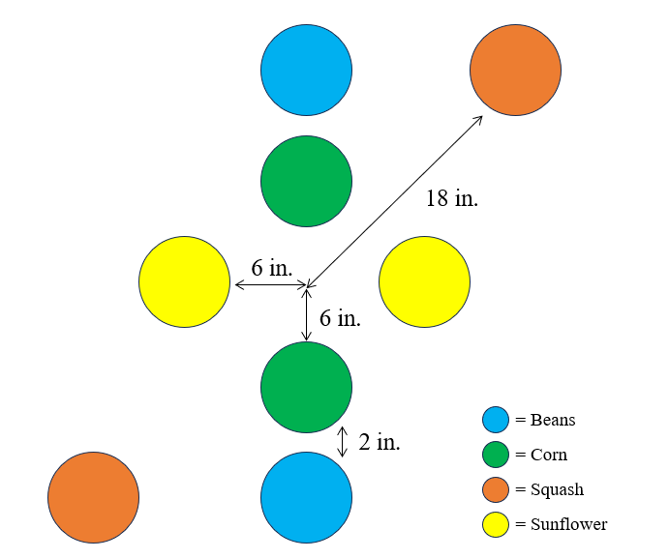
Figure 1. The planting arrangement of each group. There were two corn, two sunflowers, two beans, and two squash per group. There were 49 groups for each field at each site.

Planting began in May 2023, with the corn and sunflowers being planted simultaneously 6 inches from the centre of each group (Fig. 1). There were 4 holes in a cross shape that were dug at a depth of 1-2 inches. In the holes that were towards the sides designated as the top and bottom of the field, there were 2 corn seeds that were placed within them (Fig. 1). In the holes that were towards the field edges that were adjacent to the top and bottom field edges, 3 sunflower seeds were placed within each hole (Fig. 1). Planting of the corn and sunflowers occurred in May 2023 at all sites. Once this was completed, squash seeds were planted at a depth of 1-2 inches in plastic trays and placed in a growth chamber at the University of Manitoba. Once the corn was approximately 6 inches tall, the squash were transplanted into the field on a diagonal, 18 inches from the centre point (Fig. 1). Beans were also planted during this time, approximately 2 inches away from the corn towards the outside of the group, at a depth of 1-2 inches, with 2 beans placed in each hole (Fig. 1). This was completed in June 2023. Once all the crops had emerged, any extra plants that had emerged were cut out so that each group would have 2 squash, 2 corn, 2 beans, and 2 sunflowers, which serve as a Fourth Sister.

The fields were maintained by hand, with the removal of weeds, and manual watering with jugs when it was deemed appropriate. No fertilizers or pesticides were applied to the fields, and all fields were tilled before planting began.

The areas used to measure local arthropod biodiversity were 25 x 25m fields nearby the crop fields at each site that were not actively being used as a crop field, and are hereafter referred to as uncultivated areas. At Glenlea only, this area was burned at the start of the year and was dominated by grasses. At Carman, the uncultivated area was dominated by alfalfa and grass. The uncultivated area at Brokenhead was dominated by grasses, with patches of sweet clover (Melilotus sp.), Canada thistle (Cirsium arvense L.), and other types of clover (Trifolium spp.).

Sampling:

Sampling occurred from the end of June 2023 to the end of August 2023, after all plants had started emerging within the field. Sampling occurred every 2 weeks, and there
were 4 rounds of sampling in total. At each site there were 8 sticky cards placed in a random configuration as determined by RStudio in the field, and 8 sticky cards placed in a random configuration within the uncultivated area. There were also 8 sticky cards placed 1m away from the electric fence on the outside edges in the middle and on the corners of each field edge. These cards were secured at the same height, roughly 1-2 inches away from the ground and attached to poles with large binder clips to prevent them from blowing away due to wind. Sticky cards were placed out for one week at a time before being collected and placed in a freezer at the University of Manitoba. At Brokenhead and Glenlea, all the sticky cards that were used were clear. At Carman, half the cards were yellow and half were clear. The chosen placement of the sticky cards did not change, but the corresponding colour of sticky card that went with each placement was randomized each time. Overall, there were 288 total sticky cards collected, with one sticky card being one sample. All arthropods were identified when possible to the family level, except for the mites, which were grouped together based on morphospecies.

Data Analysis:

I conducted my statistical analysis in RStudio (RStudio Team 2020). Before any statistical analysis was completed, assumptions were checked visually. A histogram was made of abundance of each arthropod family for each sticky card using the ggpubr package in R to examine normality (Kassambara 2023). Multicollinearity was also examined using the package car for all variables tested against the total abundance per sticky card before any models were run (Fox and Weisberg 2019). Since the data were not normally distributed, in part due to the high number of zeros present, I chose to run a perMANOVA examining the combined abundance for each family using the package vegan, with the Bray-Curtis distance
measure (Oksanen 2022). This was done because perMANOVA is a non-parametric method of analysis, and the multiple independent variables that were used. The dependent variable was the distance matrix of abundance values for all families at all sites, and for all sampling rounds. The independent variables were area nested within the site, colour, and trap number was included as a random variable. Area refers to the treatment a sample was collected from at a particular site such as field, edge, or uncultivated. Site corresponds to the places the experiment was conducted at which were Brokenhead, Glenlea, and Carman. Colour was included to control for any possible differences between the card colour at Carman, and trap number was included as a random effect to account for any possible differences between the sample placements that may have led to differences between samples. For a post-hoc test, I used the package pairwiseAdonis to determine which elements were significantly different from each other within an independent variable (Martinez Arbizu. 2020). For all statistics, the level of significance was p<0.05. A PCA plot was created using the package ggfortify to visualize the results (Horikoshi and Tang 2018).

To observe differences between the independent variables when only abundance or only number of taxa were examined, I ran multiple generalized linear mixed models using the package MASS (Venables and Ripley 2002). The dependent variables used were the total abundance of all insects on a sample, and the total count of families found on that sample. I conducted a Shapiro-Wilk test on both variables to examine normality using the package dplyr (Wickham et al. 2023). Both had non-normal distributions so a negative binomial distribution was used for analysis to avoid overdispersion. The independent variables were area nested within site, colour, sampling round, and trap number as a random effect. Sampling round was included to add a variable accounting for time. A second model was run with the same independent variables, but the total count of families present for each sample was used as the dependent variable. Graphs were made using the package ggplot2 (Wickham 2016).

Results

Observations:

There were over 50 000 arthropods collected and identified to over 100 separate taxonomic families. The most common families observed were multiple families of springtails (Hexapoda: Collembola), mites (Arthropoda: Acari), the dark winged fungal gnats (Diptera: Sciaridae), the minute black scavenger flies (Diptera: Scatopsidae), frit flies (Diptera: Chloropidae), aphids (Hemiptera: Aphididae), leafhoppers (Hemiptera: Cicadellidae), and plant-feeding thrips (Thysanoptera: Thripidae). These are herbivorous arthropods, although without going to the species level, it is not possible to know more specific ecological preferences such as food and oviposition preferences. At all sites some notable egg parasitoid families (Hymenoptera: Mymaridae; Trichogrammatidae) were observed in noticeably higher numbers in the uncultivated areas than in the field and edge areas. Glenlea had a higher proportion of natural enemies within the field sites such as minute pirate bugs (Hemiptera: Anthocoridae), and ladybird beetles (Coleoptera: Coccinellidae) than the other sites.

PerMANOVA:

I observed that all three sites (Brokenhead vs. Glenlea vs. Carman) significantly differed in community composition of arthropods from each other for all areas combined (df=2, F=41.24, p<0.001) (Table 1). Area (Field vs. Edge vs. Uncultivated) for all sites pooled together was significantly different from each other (df=2, F=12.45, p<0.001), as well as when area was nested within the sites (df=4, F=8.63, p<0.001). The fields and the edges had higher arthropod diversity than the uncultivated areas. Both field vs. uncultivated (df=1, F=14.76, p<0.001), and edge vs. uncultivated (df=1, F=9.37, p<0.001) strongly differed from each other. Field vs. edge were also significantly different (df=1, F=2.46, p=0.017) (Table 2). All combinations of sites significantly differed from each other as well (Table 2). A PCA plot was constructed to visualize the sites and area with the combined abundance and family level taxa (Fig. 2).

Table 1. The results of the variables for site, area, and area nested within site for the perMANOVA analysis of arthropod abundance and families which used Bray-Curtis as a distance measure. The dependent variable was the distance matrix of both the family and abundance of arthropods (n=288). All significant values are bolded (p<0.05).
Variable | df | F | p-value
Site | 2 | 41.24 | 0.001
Area | 2 | 12.45 | 0.001
Site:Area | 4 | 8.63 | 0.001

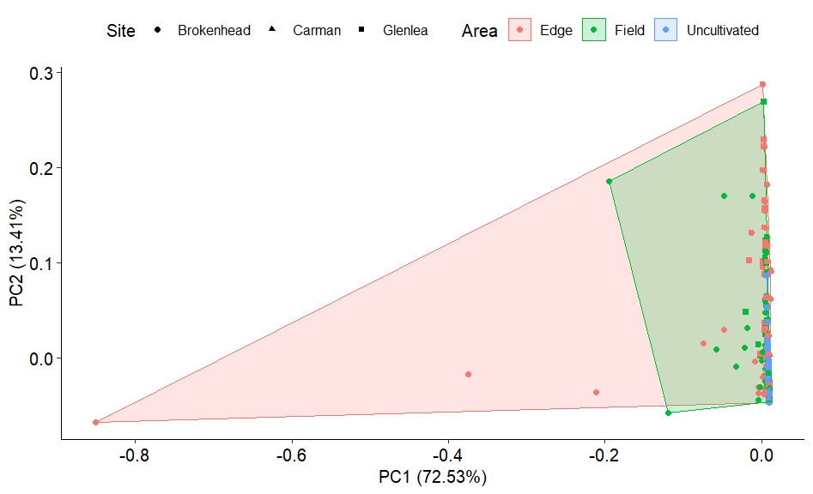
Figure 2. A PCA ordination plot of the abundances and families of arthropods. Three sites in southern Manitoba (Brokenhead; Carman; Glenlea) were sampled, with three areas (Field; Edge; Uncultivated). n=288. Two factors accounted for 85.94% of the variation of the data. All the sites significantly differed from each other (p<0.001). The uncultivated area significantly differed from both the field and edge areas (p<0.001). The field and edge areas also significantly differed (p=0.017). The level of significance was p<0.05.

Table 2. The pairwise post-hoc tests of the variables for site and area for the perMANOVA analysis of arthropod abundance and families using Bray-Curtis as a distance measure. The independent variables examined were the sites (Brokenhead; Carman; Glenlea), the areas (Field; Edge; Uncultivated), and area nested within site. The dependent variable was a distance matrix of family and abundance of arthropods (n=288). All significant values are bolded (p<0.05).
Combination | Variable | df | F | p-value
Brokenhead vs. Carman | Site | 1 | 37.73 | 0.001
Brokenhead vs. Carman | Area | 2 | 8.38 | 0.001
Brokenhead vs. Carman | Site:Area | 2 | 4.46 | 0.001
Brokenhead vs. | Site | 1 | 31.07 | 0.001
Glenlea | Area | 2 | 14.97 | 0.001
 | Site:Area | 2 | 8.97 | 0.001
Carman vs. | Site | 1 | 48.88 | 0.001
Glenlea | Area | 2 | 9.74 | 0.001
 | Site:Area | 2 | 11.74 | 0.001
Field vs. Edge | Area | 1 | 2.46 | 0.017
Field vs. Uncultivated | Area | 1 | 14.76 | 0.001
Edge vs. Uncultivated | Area | 1 | 9.37 | 0.001

Generalized Linear Mixed Models:

Both colour and date were significant predictors for the total abundance of insects per sample (Table 3). In addition, the field and uncultivated areas of Brokenhead, as well as the uncultivated area of Glenlea were also significant in predicting the total abundance of insects per sample (Table 3). Similar results were obtained when the dependent variable was the total number of families per sample. Colour and date were significant predictors, as well as the fields and uncultivated areas of both Brokenhead and Glenlea (Table 4).

Table 3. The negative binomial mixed model results for total abundance of arthropods per sticky card with site (Brokenhead; Carman; Glenlea), area (Field; Edge; Uncultivated) nested within site, colour, and date as independent variables. (n=288), the significant values are bolded (p<0.05).
Variable | Estimate | Standard Error | z-value | p-value
Intercept | 5.57 | 0.11 | 49.21 | <0.001
Carman | -0.77 | 0.14 | -5.57 | <0.001
Glenlea | 0.10 | 0.13 | 0.82 | 0.41
Colour | -0.32 | 0.11 | -3.05 | 0.002
Date | 0.06 | 0.03 | 2.26 | 0.02
Brokenhead: Field | -0.27 | 0.13 | -2.08 | 0.04
Carman: Field | -0.10 | 0.13 | -0.75 | 0.45
Glenlea: Field | -0.16 | 0.13 | -1.23 | 0.22
Brokenhead: Uncultivated | -0.89 | 0.13 | -6.90 | <0.001
Carman: Uncultivated | -0.21 | 0.13 | -1.60 | 0.11
Glenlea: Uncultivated | -1.13 | 0.13 | -8.79 | <0.001

Table 4. The values of a negative binomial model ran with the total number of families per sticky card as the dependent variable, and site (Brokenhead; Carman; Glenlea), area (Field; Edge; Uncultivated) nested within site, colour, and date were the independent variables. (n=288), the significant values are bolded (p<0.05).
Variable | Estimate | Standard Error | z-value | p-value
Intercept | 3.07 | 0.05 | 66.17 | <0.001
Carman | -0.18 | 0.06 | -2.96 | <0.01
Glenlea | 0.04 | 0.05 | 0.95 | 0.34
Colour | -0.16 | 0.05 | -3.37 | 0.001
Date | 0.05 | 0.01 | 4.22 | <0.001
Brokenhead: Field | -0.14 | 0.05 | -2.67 | 0.02
Carman: Field | -0.04 | 0.06 | -0.67 | 0.50
Glenlea: Field | 0.00 | 0.05 | 0.03 | 0.98
Brokenhead: Uncultivated | -0.18 | 0.05 | -3.44 | 0.001
Carman: Uncultivated | -0.12 | 0.06 | -1.95 | 0.05
Glenlea: Uncultivated | -0.28 | 0.05 | -5.30 | 0.001

Carman was very similar between all areas regarding total abundance per sample (Fig. 3). Glenlea had the largest difference in total abundance per sample between the uncultivated area and the edge and field areas (Fig. 3). At Brokenhead and Carman, the fields had the highest total abundance, while at Glenlea the edge had the highest total abundance per sample (Fig. 3). Generally, the edges and fields were relatively similar in terms of family number, while at all sites the uncultivated areas had a lower number of families (Fig. 4).

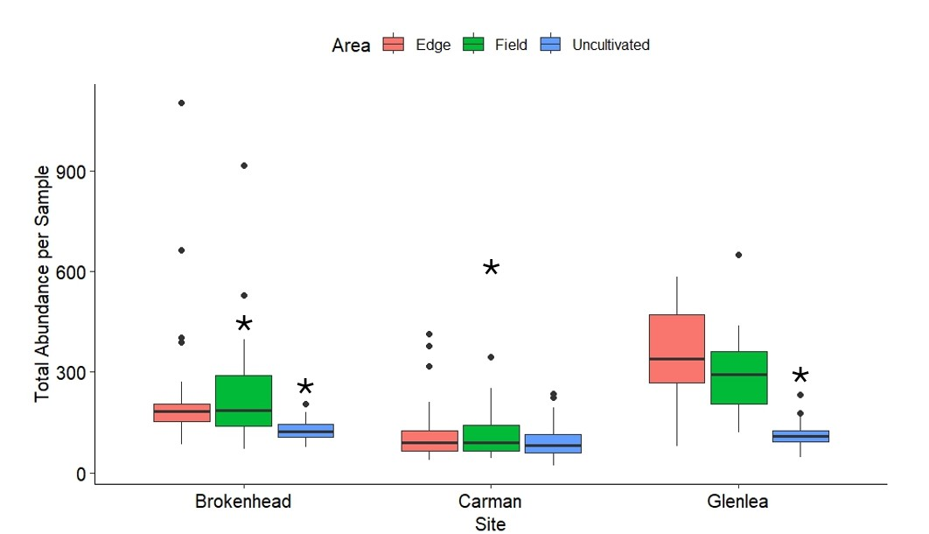
Figure 3. The total abundance of arthropods per sample at three sites in southern Manitoba, and within each area (n=288). The site of Carman, field and uncultivated areas of Brokenhead, and the uncultivated area of Glenlea were significant predictors of the total abundance of arthropods per sample. The asterisks represent significant variables (p<0.05).

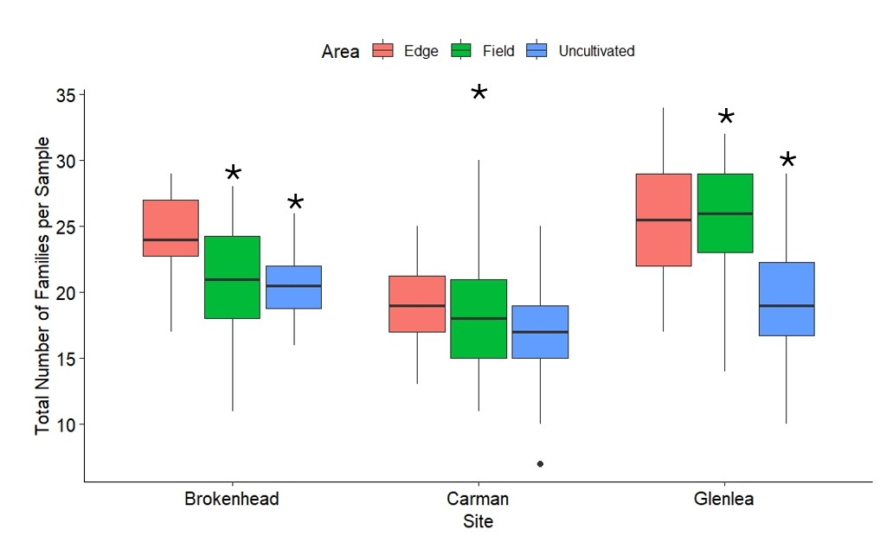
Figure 4. The total count of arthropod families per sample in each area and at each site (n=288). The entire site of Carman, and the fields and uncultivated areas of Brokenhead and Glenlea were significant in predicting the number of arthropod families per sample. The asterisks represent significant variables (p<0.05).

Discussion

The significant differences between the uncultivated areas and the fields provide strong support for my hypothesis that arthropod diversity differs between uncultivated areas and fields planted with The Three Sisters. Especially as at all sites the uncultivated areas had both the lowest total abundance per sample, (Fig. 3) and the lowest number of families per sample (Fig 4). These results are similar to published research in which it has been observed that there are generally more diverse arthropod communities when plant communities have more diversity (Altieri 1999; Gurr et al. 2003; Crist and Peters 2014; Zytynska and Meyer 2019; Coco et al. 2022). The correspondence between insect and plant diversity is consistent with suggestions in literature that a higher number of niches allows a larger abundance and number of taxa to be present within an area (Altieri 1999; Zytynska and Meyer 2019). Many more insect pests were observed in the fields and edges compared to the uncultivated areas; however without direct comparison to agricultural fields, it cannot be stated if The Three Sisters allowed for a reduction of herbivorous pests in comparison to monocultures. However, the pests did not appear to cause any significant yield losses of the crops, and the fields also allowed for a higher abundance of natural enemies (Personal observation). These natural enemies may have been moving into the field to prey on the higher number of herbivorous arthropods that were present in the fields and edges in comparison to the uncultivated area.

Interestingly, there were some nectar feeding flies such as the hover flies (Diptera: Syrphidae), and male biting midges (Diptera: Ceratopogonidae) that were found in the fields more often than in the uncultivated areas. It is possible that they were drawn to these fields because of the sunflowers, although other plants within this cropping system also produce flowers such as both squash and beans, and thus without direct observation the exact plants they are drawn into the field by cannot be stated. Across all sites some of the parasitoids that parasitize eggs (Hymenoptera: Mymaridae; Trichogrammatidae) were found within the uncultivated areas at higher numbers than in the field and edge areas. This may have been observed because their prey may lay their eggs within the uncultivated areas rather than the fields or edges. I also observed that there was a higher abundance of springtails in the field than in the uncultivated areas. A possible explanation for this is that springtails may have preferences in terms of organic matter in the soil, humidity, ground cover, and other properties related to the soil (Van De Bund 1970). Since soil data were not collected, it is unknown which combination of these factors may have led to this difference between the areas. In addition, there was an unexpectedly large number of mites found on the sticky cards.

I observed that the sites strongly differed between each other in terms of abundance and number of taxonomic families. Glenlea had the highest total abundances and highest number of families for the field and edge per sample (Figs. 3, 4) in comparison to Brokenhead and Carman. In addition, Glenlea also had the highest total abundance per sample in the edge area, while at Brokenhead, the area with the highest abundance per sample was the field (Fig. 3). These differences are not surprising as they all have different cultivation histories, and surrounding landscapes. To elaborate, Glenlea is an organic research farm that has been established since the 1990s and is surrounded by extensive agricultural lands. On the actual research farm there are no synthetic pesticides used. Organic farms may be correlated with larger abundances of insects (Bengtsson et al. 2005), as observed in my study. This contrasts with Carman, which is also a research station surrounded by extensive agricultural lands. However, pesticides and herbicides are actively used in many parts of the research farm and surrounding areas, which may reduce arthropod numbers in the entire area near Carman. The field site at Brokenhead does not have an established history of being used for intensive or industrial agricultural fields, nor is it surrounded by massive and industrialized fields, and is instead surrounded by many trees.

It is important to acknowledge that the presence of an arthropod within an area does not necessarily mean that the arthropod is interacting directly with the crops or serving as a main source of food for other arthropods. An example of this observed in my study was an adult flea that was found on a sample at Brokenhead. Adult fleas (Hexapoda: Siphonaptera) are parasites of vertebrates, and thus was likely not drawn to the uncultivated area due to the crops or arthropod species present (Dobler and Pfeffer 2011). In addition, there was also a family of birds living in the field, and on numerous sticky cards there were bird feathers, indicating that there was a possibility that any arthropods residing on these birds may be transferred to the sticky cards. The birds that were present may also have impacted the data by removing some of the arthropods off the sticky cards although this was not witnessed.

One issue that arises when using sticky cards is that some of these families can be quite diverse in terms of the niches they fill, and unless the specimens are examined at the species level, the ecological niches that are available and taken advantage of may not be able to be determined.

Since more diverse communities are considered to be more stable, and more tolerant of changes, my results suggest that The Three Sisters may be a sustainable form of agriculture that can provide a habitat and resources for a higher number and larger array of arthropod taxa than areas dominated by only a few type of closely related plants, even in small field sizes (Duelli et al. 1999; Olfert et al. 2005; Vankosky et al. 2017). In future studies, it may be beneficial to directly compare monocultures with fields of The Three Sisters. In addition, sticky cards can be an issue when sampling as not all taxa are attracted to them, and thus using other methodology such as sweep-nets may be beneficial (Hoddle et al. 2002; Stephens and Losey 2004). In addition, identifying the arthropods to the species or even genus level would provide more data of exactly which species and their specific niches are more common in fields or uncultivated areas, however this was beyond the scope of this project.

Conclusion

Arthropod biodiversity is declining at a quick rate, in part due to the intensification of agricultural practices (Samways 1993; Zytynska and Meyer 2019; Busse et al. 2021; Raven and Wagner 2021). The Three Sisters is an Indigenous agricultural method in which squash, beans, sunflower, and corn are grown together (Mt. Pleasant 2016). The Three Sisters introduces diversity into cropping systems that may help increase arthropod diversity. This cropping method may lead to benefits in a similar manner to other agricultural strategies that increase the plant diversity such as the reduction of pesticides in the environment (Gurr et al. 2003). I observed that the uncultivated areas had lower total abundances and lower taxa per sample than the field and edge areas at all sites. My study provides evidence that fields planted with The Three Sisters differ in community composition with uncultivated areas.

Literature Cited

Altieri, M.A. 1999. The ecological role of biodiversity in agroecosystems. Agric. Ecosyst. Environ., 74(1): 19-31. doi:10.1016/S0167-8809(99)00028-6

Bengtsson, J., Ahnström, J., and Weibull, A.-C. 2005. The effects of organic agriculture on biodiversity and abundance: a meta-analysis: Organic agriculture, biodiversity and abundance. The Journal of Applied Ecology, 42: 261–269. doi:10.1111/j.1365-2664.2005.01005.x

Busse, M., Zoll, F., Siebert, R., Bartels, A., Bokelmann, A., and Scharschmidt, P. 2021. How farmers think about insects: perceptions of biodiversity, biodiversity loss and attitudes towards insect-friendly farming practices. Biodivers. Conserv., 30(11): 3045–3066. doi:10.1007/s10531-021-02235-2

Coco, A.M., Yip, E.C., Kaplan, I., and Tooker, J.F. 2022. More phylogenetically diverse polycultures inconsistently suppress insect herbivore populations. Oecologia, 198(4): 1057–1072. doi:10.1007/s00442-022-05153-4

Crist T.O., and Peters V.E. 2014. Landscape and Local Controls of Insect Biodiversity in Conservation Grasslands: Implications for the Conservation of Ecosystem Service Providers in Agricultural Environments. Land, 3(3): 693-718. doi:10.3390/land3030693

Dobler, G., and Pfeffer, M. 2011. Fleas as parasites of the family Canidae. Parasites & Vectors, 4(1): 139–139. doi:10.1186/1756-3305-4-139

Duelli, P., Obrist, M.K., and Schmatz, D.R. 1999. Biodiversity evaluation in agricultural landscapes: above-ground insects. Agric. Ecosyst. Environ., 74(1): 33–64. doi:10.1016/S0167-8809(99)00029-8

Fox, J., and Weisberg, S. 2019. An R Companion to Applied Regression, Third edition. Sage, Thousand Oaks CA. https://socialsciences.mcmaster.ca/jfox/Books/Companion/.

Gurr, G.M., Wratten, S.D., and Luna, J.M. 2003. Multi-function agricultural biodiversity: pest management and other benefits. Basic and Appl. Ecol., 4(2): 107–116. doi:10.1078/1439-1791-00122

Hoddle, M.S., Robinson, L., and Morgan, D. 2002. Attraction of thrips (Thysanoptera: Thripidae and Aeolothripidae) to colored sticky cards in a California avocado orchard. Crop Prot., 21(5): 383–388. doi:10.1016/S0261-2194(01)00119-3

Horikoshi, M., and Tang, Y. 2018. ggfortify: Data Visualization Tools for Statistical Analysis Results. Available from: https://CRAN.R-project.org/package=ggfortify.

Kapayou, D.G., Herrighty, E.M., Hill, C.G., Camacho, V.C., Nair, A., Winham, D.M., and McDaniel, M.D. 2023. Reuniting the Three Sisters: collaborative science with Native growers to improve soil and community health. Agric. Hum. Values, 40(1): 65–82. doi:10.1007/s10460-022-10336-z

Kassambara, A. 2023. Ggpubr: ‘Ggplot2’ Based Publication Ready Plots. R package version 3.1.0, https://cran.r-project.org/web/packages/ggpubr/index.html.

Liu, K., Bandara, M., Hamel, C., Knight, J.D., and Gan, Y. 2020. Intensifying crop rotations with pulse crops enhances system productivity and soil organic carbon in semi-arid environments. Field Crops Res., 248: 107657. doi:10.1016/j.fcr.2019.107657

Martinez Arbizu, P. 2020. pairwiseAdonis: Pairwise multilevel comparison using adonis. R package version 0.4. https://github.com/pmartinezarbizu/pairwiseAdonis

Mt. Pleasant, J. 2016. Food Yields and Nutrient Analyses of the Three Sisters: A Haudenosaunee Cropping System. Ethnobiol. Lett., 7(1): 87–98. doi:10.14237/ebl.7.1.2016.721

Ngapo T.M., Bilodeau P., Arcand Y., Charles m.T., Diederichsen A., Germain I., Liu Q., MacKinnon S., Messiga A.J., Mondor M., Villeneuve S., Ziadi N., and Gariépy S. 2021. Historical Indigenous Food Preparation Using Produce of the Three Sisters Intercropping System. Foods, 10(3): 524. doi:10.3390/foods10030524.

Nicholls, C.I., and Altieri, M.A. 2013. Plant biodiversity enhances bees and other insect pollinators in agroecosystems. A review. Agron. Sustain. Dev., 33(2): 257–274. doi:10.1007/s13593-012-0092-y

Oksanen J., Simpson G., Blanchet F., Kindt R., Legendre P., Minchin P., O'Hara R., Solymos P., Stevens M., Szoecs E., Wagner H., Barbour M., Bedward M., Bolker B., Borcard D., Carvalho G., Chirico M., De Caceres M., Durand S., Evangelista H., FitzJohn R., Friendly M., Furneaux B., Hannigan G., Hill M., Lahti L., McGlinn D., Ouellette M., Ribeiro Cunha E., Smith T., Stier A., Ter Braak C., Weedon J. 2022. _vegan: Community Ecology Package_. Available from: https://CRAN.R-project.org/package=vegan.

Olfert, O., Cárcamo, H., and Pepper, J. 2005. Insect pests and arthropod diversity in field margins of western Canada. In Field boundary habitats: implications for weed, insect and disease management. Topics in Canadian weed science, volume 1. Edited by A.G. Thomas. Canadian Weed Science Society, Sainte-Anne-de-Bellevue, Quebec, Canada. Pp. 135–163.

Rand, T.A., Tylianakis, J.M., and Tscharntke, T. 2006. Spillover edge effects: the dispersal of agriculturally subsidized insect natural enemies into adjacent natural habitats. Ecol. Lett., 9(5): 603–614. doi:10.1111/j.1461-0248.2006.00911.x

Raven P.H., and Wagner D.L. 2021. Agricultural intensification and climate change are rapidly decreasing insect biodiversity. PNAS, 118(2): e2002548117. doi:10.1073/PNAS.2002548117

RStudio Team. 2020. RStudio: Integrated Development for R. RStudio, PBC, Boston, MA. Available from: http://www.rstudio.com/.

Samways, M. J. 1993. Insects in biodiversity conservation: some perspectives and directives. Biodivers. Conserv., 2(3), 258–282. doi:10.1007/BF00056672

Stephens, E.J., and Losey, J.E. 2004. Comparison of Sticky Cards, Visual and Sweep Sampling of Coccinellid Populations in Alfalfa. Environ. Entomol., 33(3), 535–539. doi:10.1603/0046-225X-33.3.535

Van De Bund, C. F. 1970. Influence of crop and tillage on mites and springtails in arable soil. Neth. J. Agri. Sci., 18, 308–314. doi:10.18174/njas.v18i4.17336

Vankosky, M.A., Cárcamo, H.A., Catton, H.A., Costamagna, A.C., and De Clerck-Floate, R. 2017. Impacts of the agricultural transformation of the Canadian Prairies on grassland arthropods. Can. Entomol., 149(6): 718–735. doi:10.4039/tce.2017.47

Venables, W.N., and Ripley, B.D. 2002. Modern Applied Statistics with S, Fourth edition. Springer, New York. ISBN 0-387-95457-0, https://www.stats.ox.ac.uk/pub/MASS4/.

Wickham, H. 2016. ggplot2: Elegant Graphics for Data Analysis. Springer-Verlag New York. ISBN 978-3-319-24277-4, https://ggplot2.tidyverse.org.

Wickham, H., François, R., Henry, L., Müller, K., Vaughan, D. 2023. dplyr: A Grammar of Data Manipulation. R package version 1.1.4, https://github.com/tidyverse/dplyr, https://dplyr.tidyverse.org.

Zamorano, J., Bartomeus, I., Grez, A.A., and Garibaldi, L.A. 2020. Field margin floral enhancements increase pollinator diversity at the field edge but show no consistent spillover into the crop field: a meta‐analysis. Insect Conserv Divers., 13(6): 519–531. doi.org:10.1111/icad.12454

Zhang, C., Postma, J.A., York, L.M., and Lynch, J.P. 2014. Root foraging elicits niche complementarity-dependent yield advantage in the ancient “three sisters” (maize/bean/squash) polyculture. Ann. Bot., 114(8): 1719–1733. doi:10.1093/aob/mcu191

Zytynska, S.E., and Meyer, S.T. 2019. Effects of biodiversity in agricultural landscapes on the protective microbiome of insects – a review. Entomologia Experimentalis et Applicata 167(1): 2-13. doi:10.1111/eea.12751

