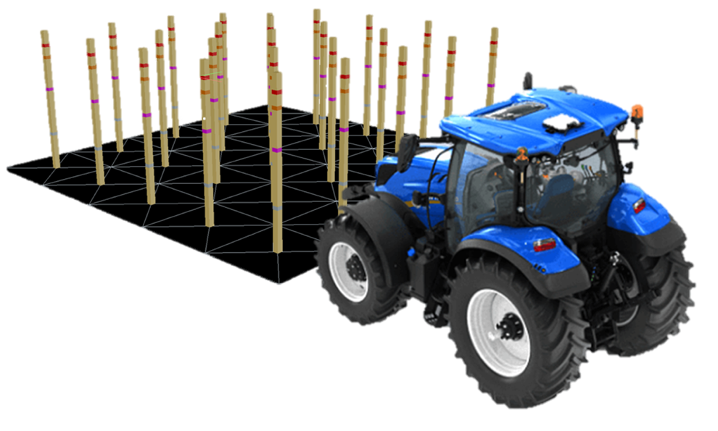

Figure 1 Evaluation grid in front of the tractor.
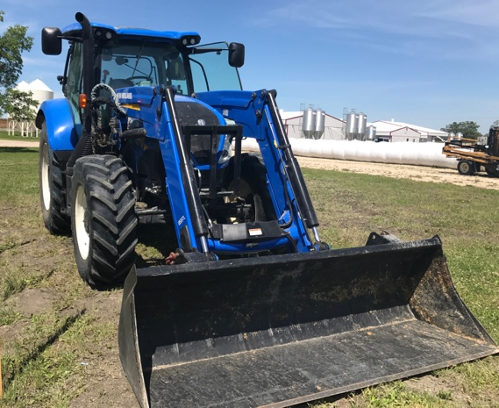 | 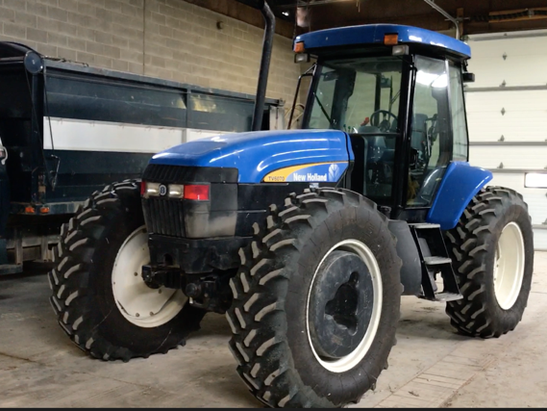
Figure 2 Tractor1(left) and Tractor2(right)

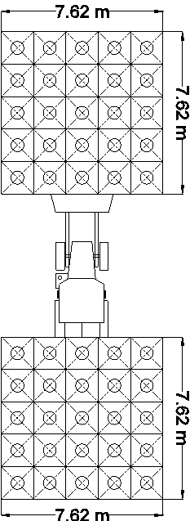 | 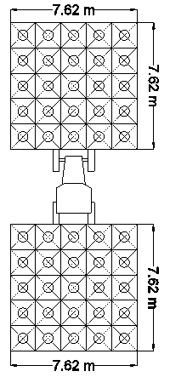
Figure 3 Grids in the front side and rear side for Tractor1(left) and for Tractor2(right)

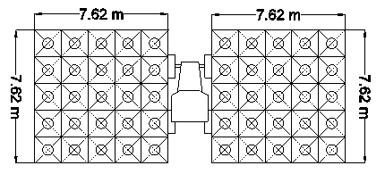
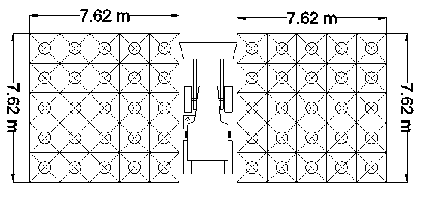
Figure 4 Grid on the two sides in Tractor1 (left) and Tractor2 (right)
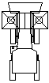

Figure 5 T1_additional grid construction
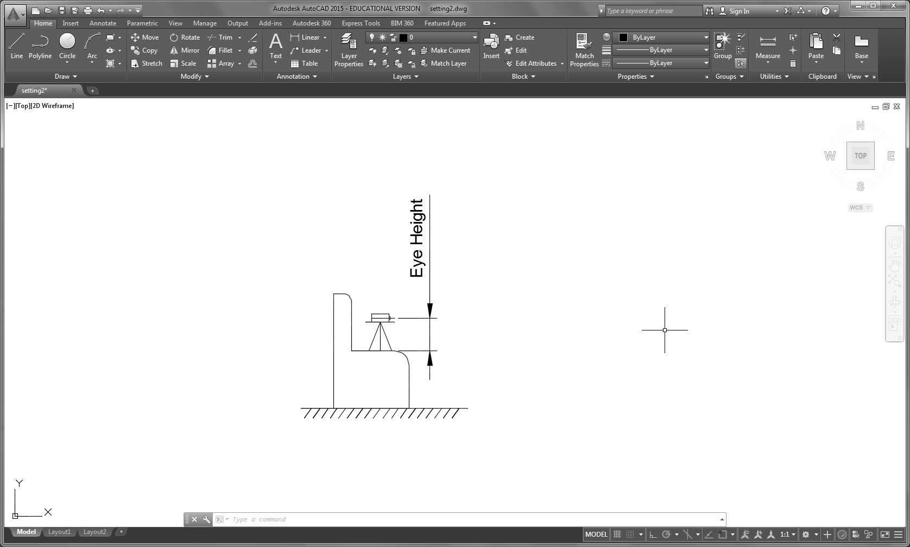
Seated Eye Level

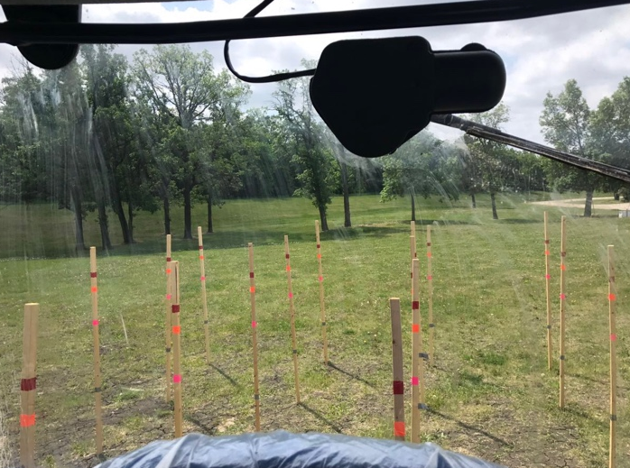
Figure 6 Camera set-up.

Figure 7 An image captured by the camera

K, slumped,5th,without | K, slumped,50th,without | K, slumped,95th,without
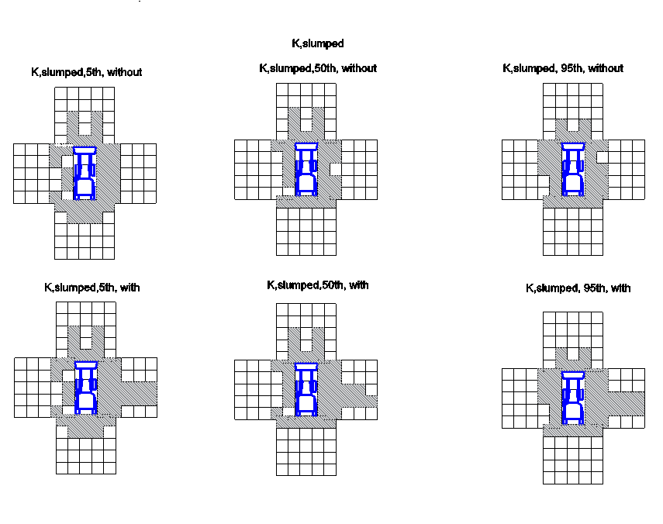

K, slumped,5th,with | K, slumped,50th,with | K, slumped,95th,with
Figure 8 Visibility results for Tractor 1 at the kneeling worker height for a slumped sitting position.

C, slumped,5th,without | C, slumped,50th,without | C, slumped,95th,without
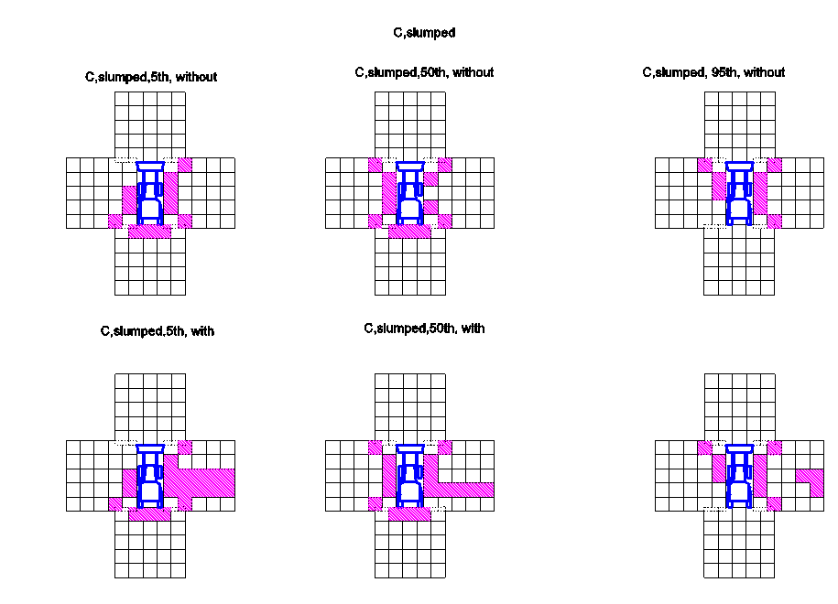

C, slumped,5th,with | C, slumped,50th,with | C, slumped,95th,with
Figure 9 Visibility results for Tractor 1 at the child height for a slumped sitting position.

W, slumped,5th,without | W, slumped,50th,without | W, slumped,95th,without
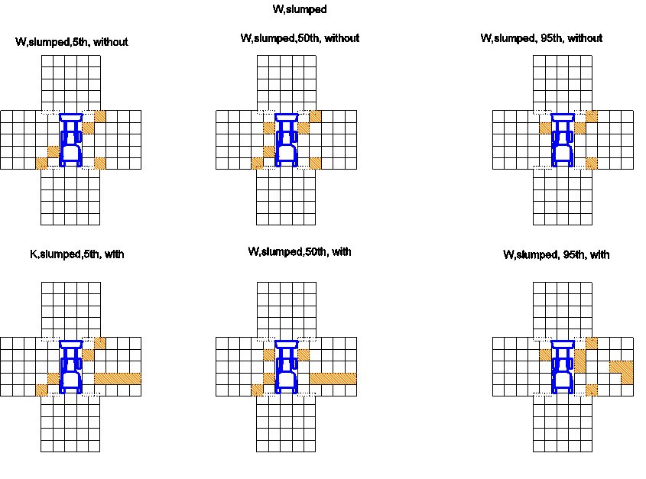

W, slumped,5th,with | W, slumped,50th,with | W, slumped,95th,with
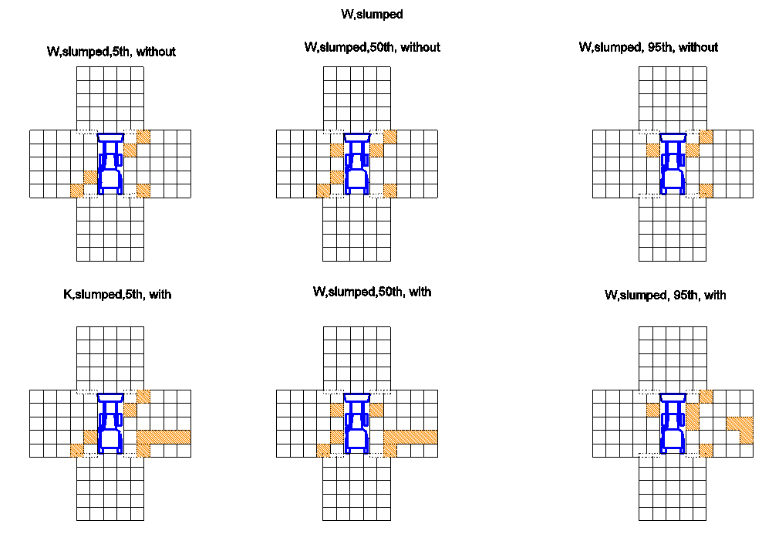

Figure 10 Visibility results for Tractor 1 at the woman height for a slumped sitting position.

M, slumped,5th,without | M, slumped,50th,without | M, slumped,95th,without
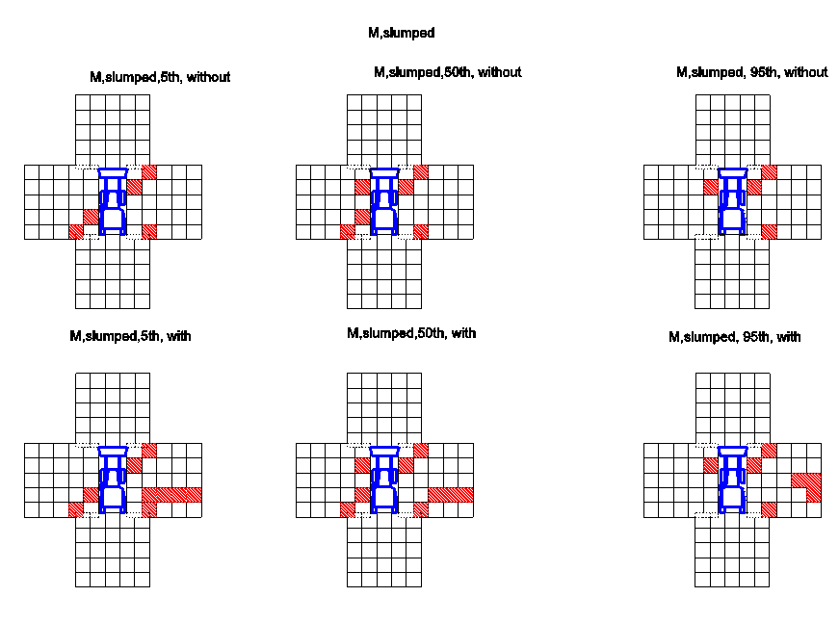

M, slumped,5th,with | M, slumped,50th,with | M, slumped,95th,with
 |  | 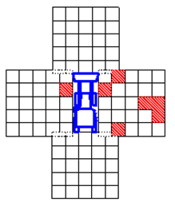
Figure 11 Visibility results for Tractor 1 at the man height for a slumped sitting position.

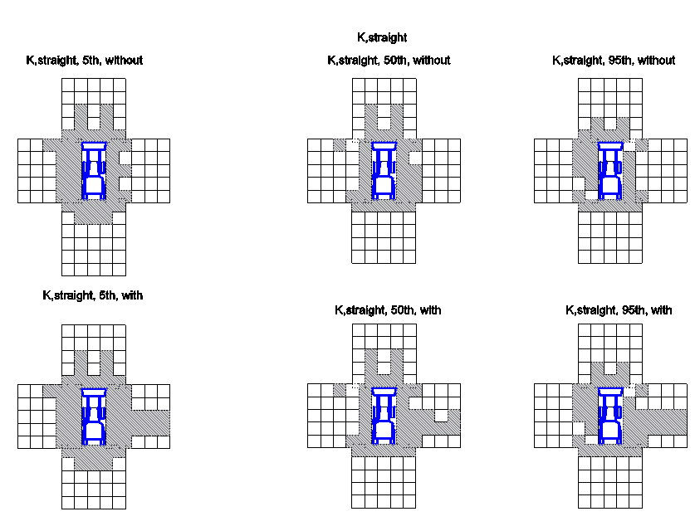  K, straight,5th,without | K, straight,50th,without | K, straight, 95th ,without
 | 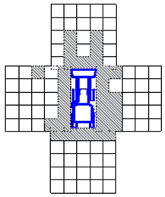 | 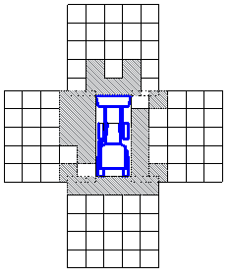
K, straight,5th,with | K, straight,50th,with | K, straight,95th,with
Figure 12 Visibility results for Tractor 1 at the kneeling worker height for a straight sitting position.

C, straight,5th,without | C, straight,,50th,without | C, straight,,95th,without
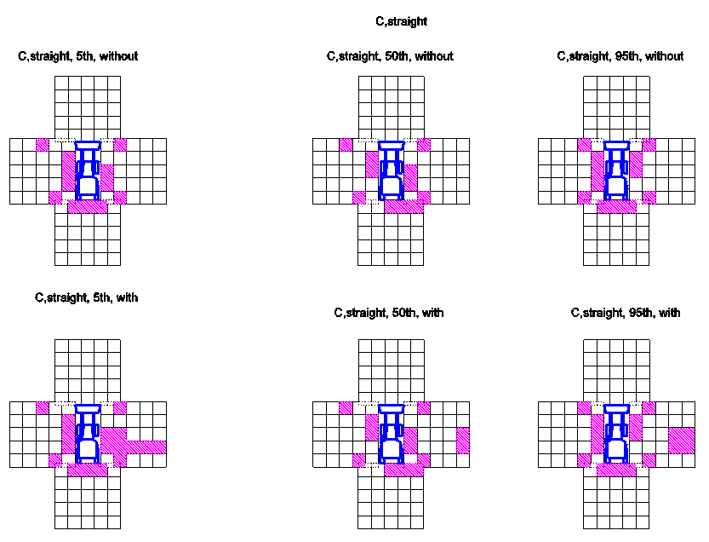

C, straight,5th,with | C, straight,50th,with | C, straight,,95th,with
Figure 13 Visibility results for Tractor 1 at the child height for a straight sitting position.

W, straight,5th,without | W, straight,,50th,without | W, straight,,95th,without
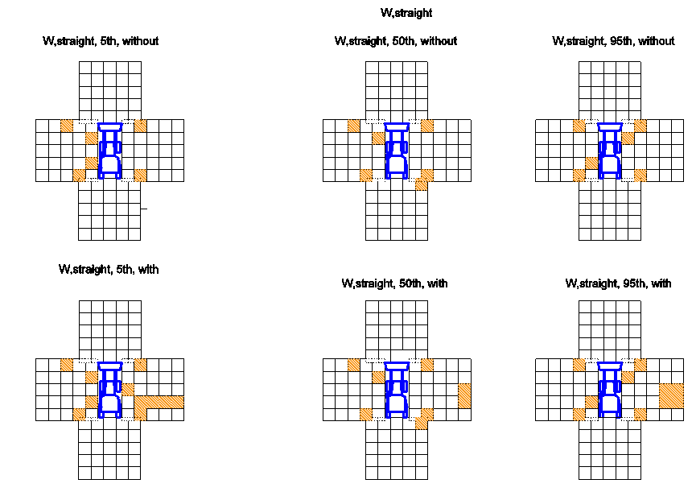 | 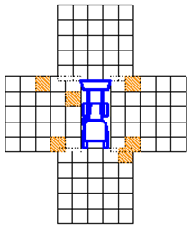
W, straight,5th,with | W, straight,50th,with | W, straight,95th,with
 | 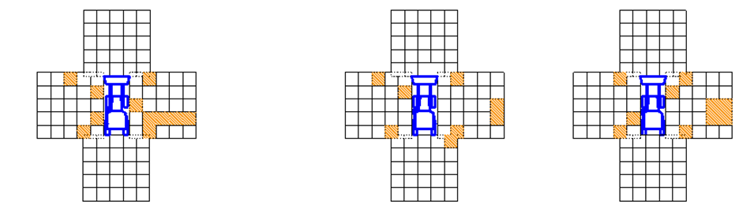
Figure 14 Visibility results for Tractor 1 at the woman level for a straight sitting position.

M, straight,5th,without | M, straight,50th,without | M, straight,95th,without
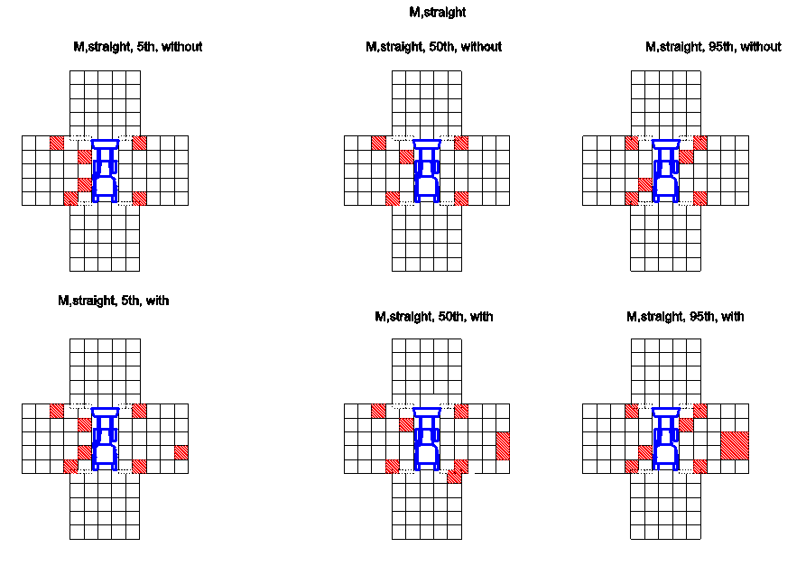 | 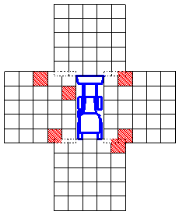 | 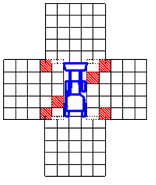
M, straight,5th,with | M, straight,50th,with | M, straight,95th,with
 | 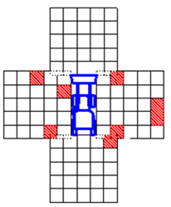 | 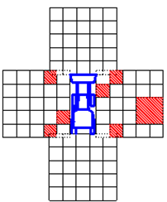
Figure 15 Visibility results for Tractor 1 at the man height for the straight sitting position.

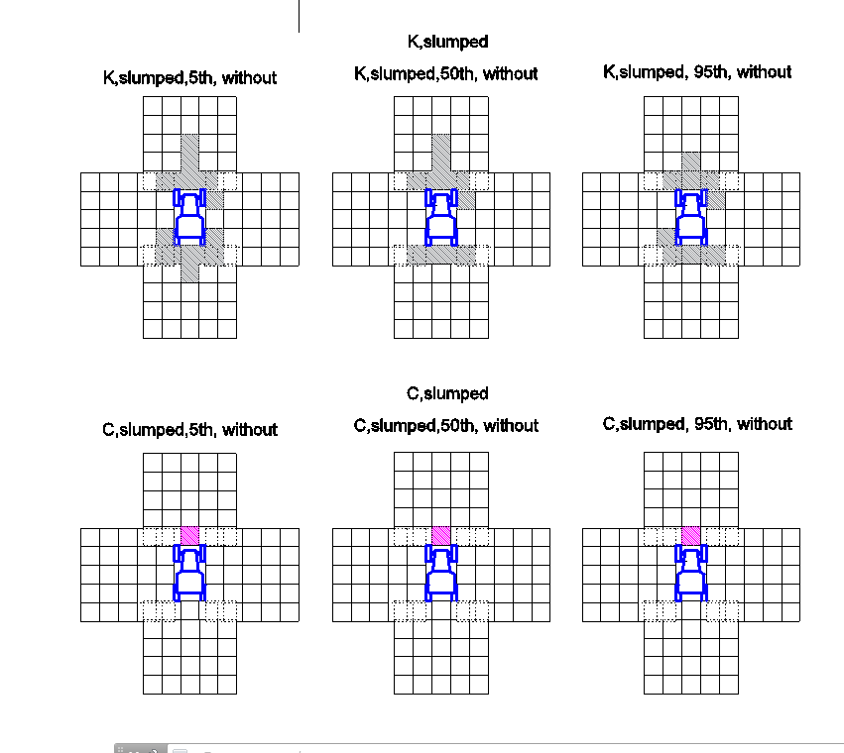

Figure 16 Visibility results for Tractor 2 at the kneeling worker level for a slumped sitting position.

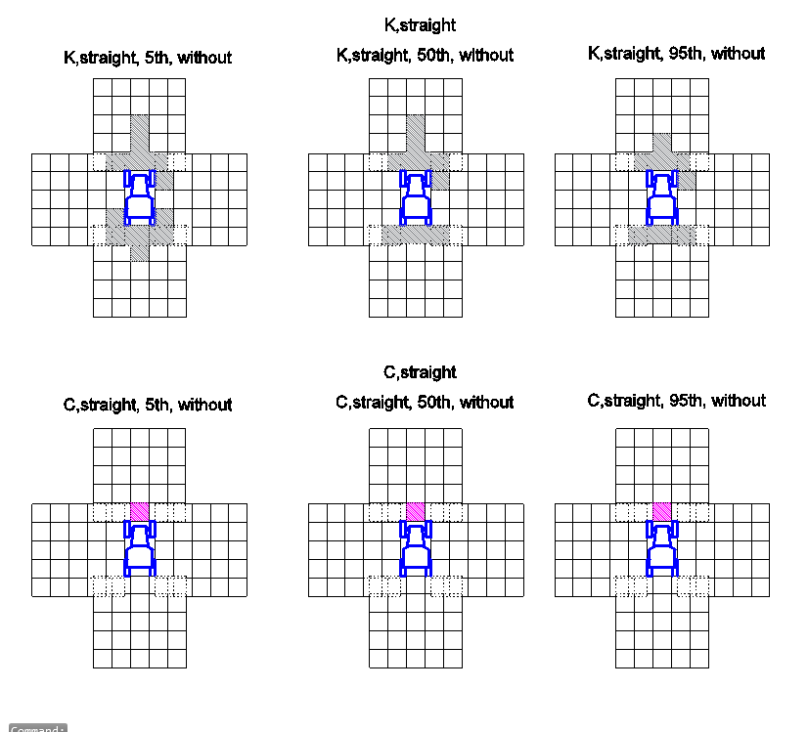
Figure 17 Visibility results for Tractor 2 at the child height for a slumped sitting position.

Figure 18 Visibility results for Tractor 2 at Kneeling worker height for a straight sitting position.

Figure 19 Visibility results for Tractor 2 at the child height for the straight sitting position.
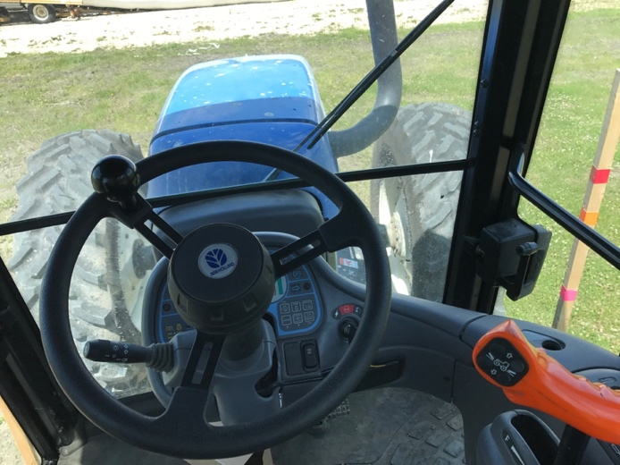

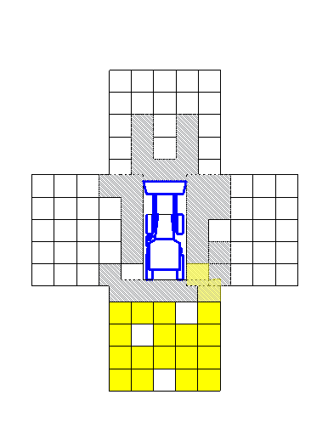
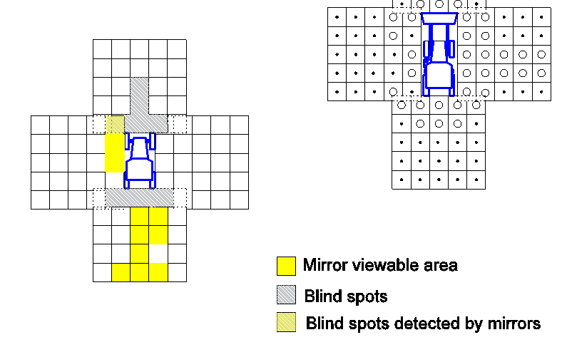
Figure 20 control panel blocked the view.

Figure 21 Mirrors detection area for Tractor 1.

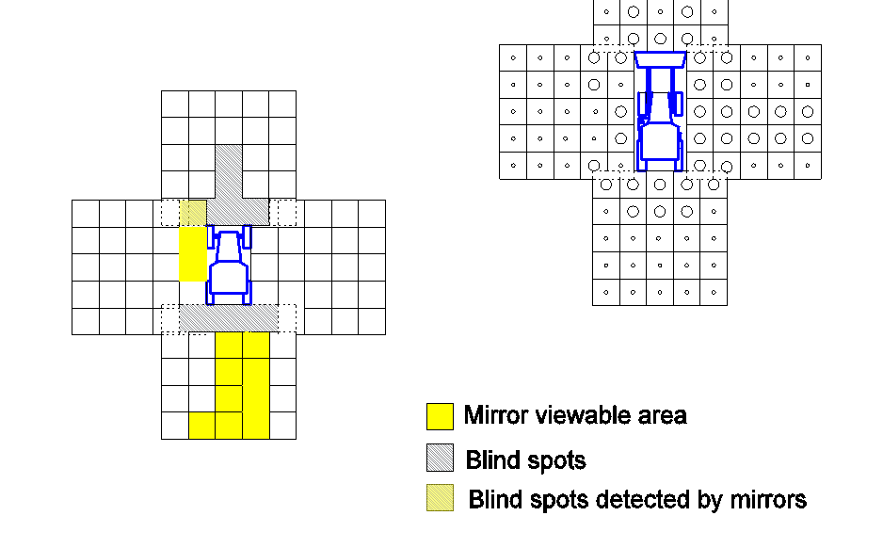

Figure 22 Mirrors detection area of Tractor 2.
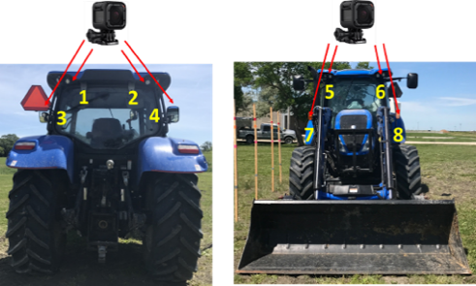
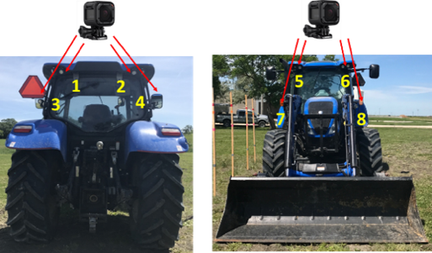
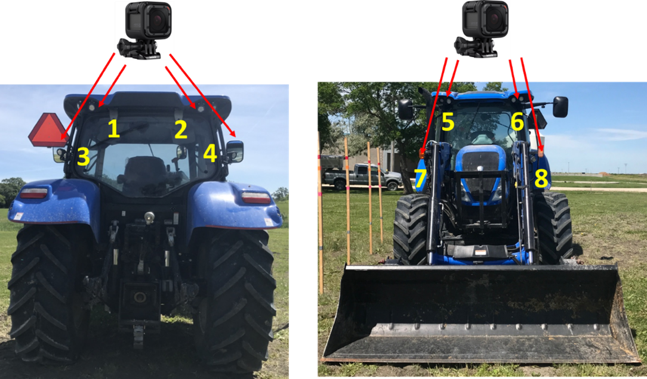

Figure 23 Locations of recommended cameras for Tractor 1.
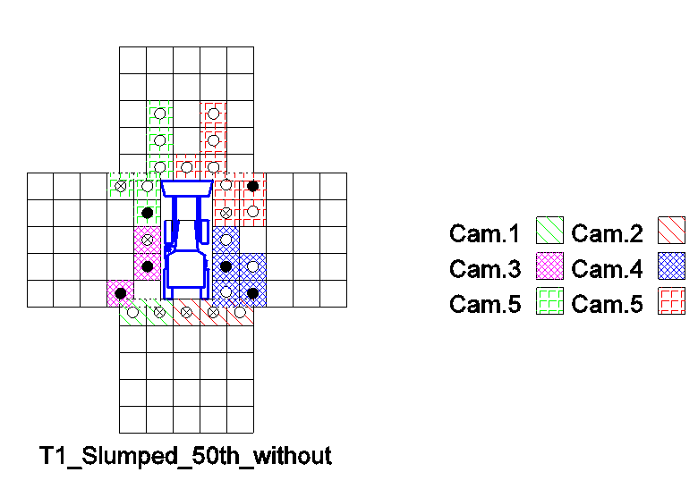
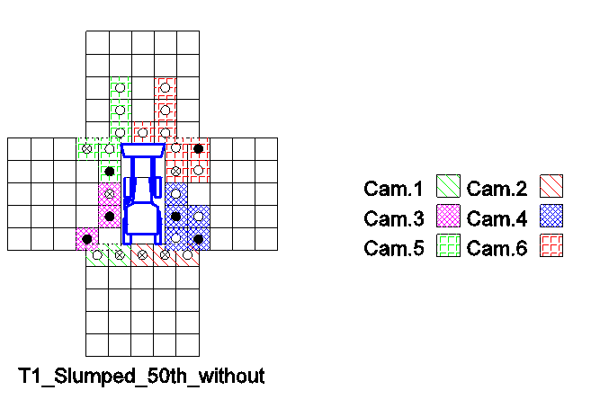

Figure 24 Detection zone for each cameras for Tractor 1.

Figure 25 Locations of recommended cameras for Tractor 2.

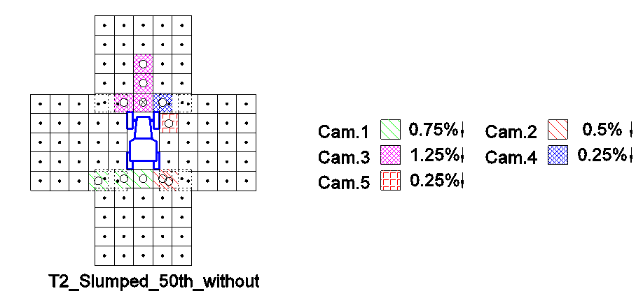
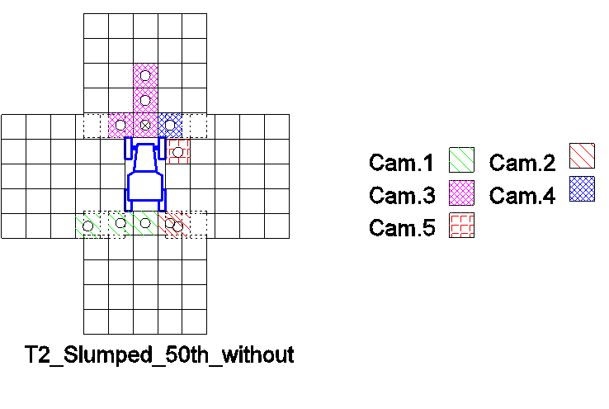

Figure 26 Detection zone for each cameras for Tractor 2.

