Chelonian Conservation and Biology

Growth, sexual maturity, and reproduction of a female Midland Painted Turtle (Chrysemys picta marginata) afflicted with kyphosis

Patrick D. Moldowan¹, Matthew G. Keevil¹, Nicola Koper², Ronald J. Brooks³, and Jacqueline D. Litzgus^{1,4}

¹Department of Biology, Laurentian University, 935 Ramsey Lake Road, Sudbury ON, P3E 2C6, Canada [pmoldowan1@laurentian.ca, keevilm@gmail.com, jlitzgus@laurentian.ca];
²Natural Resources Institute, University of Manitoba, 70 Dysart Rd., Winnipeg, Manitoba, R3T 2N2, Canada [koper@cc.umanitoba.ca];
³Department of Integrative Biology, University of Guelph, 50 Stone Road East, Guelph ON, N1G 2W1, Canada [rjbrooks@uoguelph.ca].

⁴corresponding author: jlitzgus@laurentian.ca
Abstract. — Kyphosis, a congenital humpback condition of the spinal column, has been reported across a broad range of chelonian taxa. These reports are often of single observations and lack background information about the history of the animal(s) involved. A kyphotic female Midland Painted Turtle (Chrysemys picta marginata) reported herein is a member of a long-term mark-recapture study in Algonquin Park (Ontario, Canada), providing a unique opportunity to document life-history characters of a kyphotic turtle over 18 years, and to draw comparisons to other members of her cohort and population. Despite this spinal deformity, the somatic growth, body size, age at sexual maturity, and reproduction of the kyphotic female are similar to those of normal (non-kyphotic) females in our long-term study population. This suggests that the condition has not compromised her fitness.

INTRODUCTION
Kyphosis is a rare, congenital humpback deformity of the spinal column (Ernst 1971, Rothschild et al. 2013). Numerous hypotheses have been proposed to explain the cause of kyphosis and other shell abnormalities in chelonians, but most explanations are related to developmental inconsistencies during embryonic or early development (overview by Plymale et al. 1978; Wilhoft 1980; Rothschild et al. 2013). Kyphosis has been described across a broad range of chelonian taxa, including at least 7 families, 23 genera, and 27 species (summaries by Plymale et al. 1978; Rothschild et al. 2012, 2013).
Kyphosis in Painted Turtles (Chrysemys picta) has been described on a number of occasions (Cagle 1945; summary by Rothschild et al. 2013). However, as with most reports of kyphotic chelonians, these isolated observations lack historical context for the individual(s) involved and rarely report potential effects on life history. Herein we report on somatic growth, maturity, and reproduction of a kyphotic female Midland Painted Turtle (C. p. marginata) of known age from a long-term study.

EARLY HISTORY OF PAINTED TURTLE ID 7023A
A study on the life history of C. p. marginata has been ongoing at Wolf Howl Pond (45°34'41.52"N, 78° 41' 21.39"W), Algonquin Provincial Park, Ontario since 1978. On 15-17 June 1996, eggs were collected, stored and transported at 17 - 20°C to the University of Guelph, and incubated at 29 ± 0.2°C as part of a juvenile growth study (Koper and Brooks 2000). Painted Turtle ID 7023A was hatched on 30 August 1996 and was maintained in a laboratory at the university over the winter of 1996 (see Koper and Brooks 2000 for details on rearing conditions). The duration of the laboratory growth trial was 90 days, approximating the length of a single growing season in this northern population (LeFerve and Brooks 1995; Koper and Brooks 2000). The turtle was marked with notches in the marginal scutes (Cagle 1939) for future identification and was released at the site of egg collection (Wolf Howl Pond) in spring 1997. Thus, Painted Turtle ID 7023A was head-started and experienced the equivalent of two growing seasons in the first year of its life.
Painted Turtle ID 7023A was noted as having shell deformities at hatching and in subsequent years (N. Koper, pers. obs.) Shell defects included irregular bumps on the anterior marginal scutes, six vertebral scutes, a conical peaking of the third vertebral scute, a curved and upturned tail, and additional left plastral, left inframarginal, and right inframarginal scutes. The most readily identifiable deformity of Painted Turtle ID 7023A is the hump-backed shape of the carapace (Figure 1), a congenital condition known as kyphosis.

GROWTH, BODY SIZE, AND AGE AT SEXUAL MATURITY
Following release in 1997, Painted Turtle ID 7023A was first recaptured in Wolf Howl Pond in 2000 (and recaptured in 2004-2006) and later migrated to West Rose Lake (recaptured in 2008, 2010-2014), an overland distance of approximately 1 km. The turtle has a well-recorded growth history and a known age at sexual maturity (Table 1). We compared the growth of Painted Turtle ID 7023A at release with those of free-living juveniles of known age from Wolf Howl Pond by plotting observed growth (Δ cm) against expected growth (Δ cm) of midline plastron length (MidPL) between successive observations (Figure 2). Points on the 1:1 line indicate typical growth rates while points above the line indicate faster-than-expected growth, and points below the line indicate that growth was slower-than-expected (Figure 2). Expected growth for each observation was calculated from MidPL at the beginning of the interval and elapsed time to the next observation using the von Bertalanffy interval equation (Fabens 1965) with parameters previously estimated from the study population (Samson 2003). Expected growth is positively related to interval duration and inversely related to MidPL. Plotted observations record growth intervals from 1 to 4 years (Table 1). All plotted intervals were treated as multiples of one year as all observations of juveniles occurred in April or May while nearly all growth occurs after June 1st in the study population (Keevil et al. unpubl. data). Growth intervals 7-10 for Painted Turtle ID 7023A represent post-maturity growth and are overlapping (Table 1).
At the time of her initial release, Painted Turtle ID 7023A was in the 84th percentile of midline plastron lengths of known-age wild turtles starting their second growing season (n = 144) or in the 20th percentile of those starting their third season (n = 126) in the Wolf Howl Pond population. Therefore, in terms of midline plastron length, Painted Turtle ID 7023A was intermediate in size between naturally-hatched and overwintered turtles from the 1994 and 1995 cohorts.
The sex of Painted Turtle ID 7023A was confirmed as female following her first observed nesting activity in 2008, 11 years after release. Her chronological age at first observed nesting is therefore 12 years, but adjusted to approximately 13.5 years of age (size-wise) when accounting for her head start. At sexual maturity, Painted Turtle ID 7023A had a midline plastron length of 12.98 cm and straight midline carapace length of 12.88 cm. At the time of her first nest, she was in the 34th percentile of midline plastron lengths among a group of wild primiparous female Painted Turtles in the Wolf Howl Pond population (n = 47).

NESTING HISTORY
In her first observed reproductive season (2008), Painted Turtle ID 7023A laid a clutch of five eggs. Despite intensive annual nest surveys at the above mentioned sites, she was not recorded to be reproductively active from 2009 to 2011, but resumed nesting in 2012, laying two clutches in that season (5 eggs and 7 eggs, respectively). In 2013 and 2014, Painted Turtle ID 7023A was recorded demonstrating nest site searching behavior but no nest was observed directly.

INTRAPOPULATION COMPARISON OF SOMATIC GROWTH, MATURITY, AND REPRODUCTION
The growth of Painted Turtle ID 7023A is comparable to natural recruits and headstarted individuals of the same cohort (Figure 2). In addition, size at sexual maturity of Painted Turtle ID 7023A is consistent with normal females in the population. On average, female Painted Turtles in the Wolf Howl Pond population are primiparous at 13.0 cm midline plastron length (range 12.1 to 14.2 cm), 13.1 cm straight midline carapace length (range 12.12 to 14.19 cm), and approximately 14.1 years of age (range 12-15 years) (Samson 2003). The chronological age at sexual maturity of Painted Turtle ID 7023A is at the lower range reported for females in the same population, although her adjusted age at sexual maturity (accounting for her head start) is comparable to that of normal free-ranging females (Samson 2003).
The primiparous clutch size of normal female Painted Turtles in the Wolf Howl Pond population ranges from 3-8 eggs (n = 45, $\overline{x}$ ± SE = 5.96 ± 0.16). Thus, the primiparous clutch size for Painted Turtle ID 7023A is also consistent with normal females in the Wolf Howl Pond population. Egg morphometrics (length, width, and mass) for Painted Turtle ID 7023A were within the normal range of egg sizes for normal females in this population (unpubl. data). In Painted Turtle populations, 50-70% (Moll 1973) and up to at least 82% (Iverson and Smith 1993) of females may reproduce annually. Despite intensive nesting surveys, it is possible that Painted Turtle ID 7023A nested but was not observed in some years (It is estimated that 10-20% of nests are not directly observed in our study population each year; Rollinson and Brooks 2007). Because of the short nesting history of Painted Turtle ID 7023A, we are unable to confirm whether her reproductive frequency, among other reproductive characters, is consistent with normal females in the population.

DISCUSSION
The reproductive capabilities and life-history characteristics of kyphotic turtles are seldom reported. Although afflicted with kyphosis, the growth, size and age at sexual maturity, and clutch size of Painted Turtle ID 7023A are comparable to other normal females in the population. This is consistent with the findings that kyphosis seemingly does not influence male or female sexual maturity in the Australian species Emydura macquarii (Trembath 2009). Kyphosis did not impact overall body size, although it may have slowed growth in female Ringed Map Turtles, Graptemys oculifera (Selman and Jones 2012). A kyphotic Wood Turtle, Glyptemys insculpta, was estimated to be smaller than expected for its age based on growth rings counts (Harding and Bloomer 1979). In contrast, a more rapid mass gain, resulting in a better overall body condition, was recorded in a kyphotic juvenile Snapping Turtle (Chelydra serpentina) relative to normal clutch mates raised in captivity (Wilhoft 1980).
The direct cause of kyphosis in Painted Turtle ID 7023A is unknown but occurred during the embryonic stage given descriptions of the deformity at time of hatching (N. Koper, pers. obs.). Painted Turtle ID 7023A is the only kyphotic turtle of the 947 individuals captured at our study sites from 2009-2013. Thus, the frequency of kyphosis in this population is only 0.11%. This very low prevalence of kyphosis is consistent with findings reported for sea turtles and freshwater turtles (reviewed by Rothschild et al. 2013). As with other reports in the literature (Ernst 1971, 1976; Plymale et al. 1978; Wilhoft 1980; Stuart and Painter 2008; Bujes 2009), the kyphotic condition reported here is accompanied by other abnormalities in scute number and arrangement.
We report the first long-term account of the life-history characters of a freshwater turtle with kyphosis, and found that despite the abnormality the female turtle grew, reached maturity, and reproduced similarly to normal female turtles in the population. This is further suggestive that kyphosis does not deleteriously impact individual fitness.
Acknowledgments
The authors wish to thank the Algonquin Wildlife Research Station for in-kind and logistical support with additional thanks to B. Steinberg, J. Hoare, R. Eckenswiller, and Ontario Parks. We thank D. LeGros and K. Henderson for edits that improved earlier versions of this manuscript. Research was conducted under approved Laurentian University Animal Care Protocols 2008-12-02 and 2013-03-01 and Ontario Parks field research permits.
LITERATURE CITED
Bujes, C.B. 2009. Trachemys dorbigni (Brazilian Slider). Morphology. Herpetological Review 40:437-438.
Cagle, F.R. 1939. A system of marking turtles for future identification. Copeia 1939: 170-173.
Cagle, F.R. 1944. Observations on the life cycles of Painted Turtles (Genus Chrysemys). American Midland Naturalist 52:225-235.
Ernst, C.H. 1971. Observations of the Painted Turtle, Chrysemys picta. Journal of Herpetology 5:216-220.
Ernst, C.H. 1976. Ecology of the Spotted Turtle, Clemmys guttata (Reptilia, Testudines, Testudinidae), in southeastern Pennsylvania. Journal of Herpetology 10:25-33.
Fabens, A.J. 1965. Properties and fitting of the von Bertalanffy growth curve. Growth. 29:265-289.
Harding, J.H. and Bloomer, T.J. 1979. The wood turtle, Clemmys insculpta, a natural history. HERP: Bulletin of the New York Herpetological Society 15:9-26.
Iverson, J.B. and Smith, G.R. 1993. Reproductive ecology of the Painted Turtle (Chrysemys picta) in the Nebraska Sandhills and across its range. Copeia 1993: 1-21.
Koper, N. and Brooks, R.J. 2000. Environmental constraints on growth of Painted Turtles (Chrysemys picta) in northern climates. Herpetologica 56:421-432.
Lefevre, K. and Brooks, R.J. 1995. Effects of sex and body size on basking behavior in a northern population of the painted turtle, Chrysemys picta. Herpetologica 51:217-224.
Moll, E.O. 1973. Latitudinal and intersubspecific variation in reproduction of the painted turtle, Chrysemys picta. Herpetologica 29: 307-318.
Plymale, H.H., Jackson, C.G., and Collier, G. 1978. Kyphosis in Chrysemys scripta yaquia (Testudines: Emydidae) and other turtles. Southwestern Naturalist 23:457-462.
Rollinson, N., and Brooks, R. J. 2007. Proximate constraints on reproductive output in a northern population of painted turtles: an empirical test of the bet-hedging paradigm. Canadian Journal of Zoology 85:177-184.
Rothschild, B.M., Schultze, H.P., and Pellegrini, R. 2012. Herpetological Osteopathology: Annotated Bibliography of Amphibians and Reptiles. New York: Springer, 450 pp.
Rothschild, B.M., Schultze, H.P., and Pellegrini, R. 2013. Osseous and other hard tissue pathologies in turtles and abnormalities of miner deposition. In: Brinkman, R.B., Holroyd, P.A., and Gardner, J.D. (Eds.). Morphology and Evolution of Turtles. New York: Springer, pp. 501-534.
Samson, J. 2003. The life history strategy of a northern population of Midland Painted Turtle, Chrysemys picta marginata. MS Thesis, University of Guelph, Guelph, ON.
Selman, W. and Jones, R.L. 2012. Growth in kyphotic Ringed Sawbacks, Graptemys oculifera (Testudines: Emydidae). Chelonian Conservation and Biology 11:259-261.
Stuart, J.N. and Painter, C.W. 2008. Trachemys gaigeae gaigeae. Kyphosis. Herpetological Review 39:218-219.
Trembath, D.F. 2009. Kyphosis of Emydura macquarii krefftii (Testudines: Chelidae) from Townsville, Queensland, Australia. Chelonian Conservation and Biology 8:94-95.
Wilhoft, D.C. 1980. Kyphosis in the snapping turtle Chelydra serpentina. HERP: Bulletin of the New York Herpetological Society 15:15-26.

Table 1. Body size measurements across captive rearing (Koper and Brooks 2000) and free-ranging capture years for kypotic female Midland Painted Turtle (Chrysemys picta marginata) ID 7023A from Algonquin Provincial Park, Ontario, Canada. Growth interval refers to periods of growth between recapture years while the turtle was free-ranging (1997-2014; Figure 2). MidPL = straight midline plastron, MidCL = straight midline carapace length, CW = carapace width at greatest point, CH = carapace height at greatest point, WHP(e) = Wolf Howl Pond (east), WROSE = West Rose Lake. Note slowing of growth post-maturity (growth intervals 7-10).
Date | Growth interval (Fig. 2) | MidPL (cm) | MidCL (cm) | CW  (cm) | CH  (cm) | Mass  (g) | Life event
30 Aug 1996 | - | - | - | - | - | - | Hatch date
14 Sept 1996 | - | 2.33 | 2.51 | 2.49 | 1.39 | 4.6 | Captive rearing
05 Jan 1997 | - | 2.94 | 3.20 | 3.31 | 1.55 | 8.8 | Captive rearing
26 Jan 1997 | - | 3.36 | 3.62 | 3.83 | 1.76 | 12.7 | Captive rearing
15 Feb 1997 | - | 3.88 | 4.06 | 4.27 | 2.08 | 19.4 | Captive rearing
07 Mar 1997 | - | 4.22 | 4.51 | 4.69 | 2.26 | 25.6 | Captive rearing
27 Mar 1997 | - | 4.46 | 4.76 | 4.93 | 2.39 | 30.7 | Captive rearing
23 Apr 1997 | - | 4.56 | 4.87 | 5.00 | 2.50 | 33.2 | Release year
23 May 2000 | 1 | 8.53 | 8.61 | 7.71 | 4.3 | 190 | Recapture WHP
12 May 2004 | 2 | 11.81 | 11.80 | 9.75 | 5.6 | 255 | Recapture WHPe
09 May 2005 | 3 | 12.18 | 12.18 | 10.00 | 5.8 | 280 | Recapture WHPe
05 May 2006 | 4 | 12.69 | 12.68 | 10.28 | - | 340 | Recapture WHPe
29 May 2008 | 5 | 12.98 | 12.88 | 10.57 | 6.2 | 350 | Recapture WROSE, first nest, one clutch
19 June 2010 | 6 | 13.09 | 13.03 | 10.70 | - | 330 | Recapture WROSE
02 July 2011 | 7 | 13.18 | 13.09 | 10.92 | 6.3 | 380 | Recapture WROSE
17 May 2012 | 8 | 13.22 | 13.17 | 10.93 | 6.5 | 400 | Recapture WROSE, two clutches
15 May 2013 | 9 | 13.25 | 13.18 | 10.91 | 6.4 | 400 | Recapture WROSE, observed nest searching
27 May 2014 | 10 | 13.25 | 13.16 | 10.84 | 6.5 | 385 | Recapture WROSE, observed nest searching

Figure Captions
Figure 1. Painted turtle ID 7023A, adult female (in 2010). Note upturned tail and kyphosis, curvature of the spine. Photo by P. Moldowan.
Figure 2. Growth of kyphotic female Painted Turtle ID 7023A (n = 1, obs = 10, black circles with inset growth interval number; Table 1) compared to other individuals of contemporaneous cohorts. Observed growth (Δ cm) between successive observations of midline plastron length (MidPL) is plotted against expected growth (Δ cm). Growth observations of conspecifics that, like Painted Turtle ID 7023A, were released in the spring of 1997 after being reared overwinter as part of a growth experiment (n = 10, obs = 101, grey circles; Koper and Brooks 2000) are symbolized separately from those of similar size that hatched in the wild between 1994 and 1996 and overwintered naturally (n = 8, obs = 51, grey triangles). Growth while Painted Turtle ID 7023A was captive was not included (<1997; Table 1). Only females and juveniles (unknown sex or males with MidPL< 8.5 cm) are plotted. Expected growth for each observation was calculated from MidPL using the von Bertalanffy interval equation (see text). Growth intervals 7-10 for Painted Turtle ID 7023A represent post-maturity growth and are overlapping (Table 1).
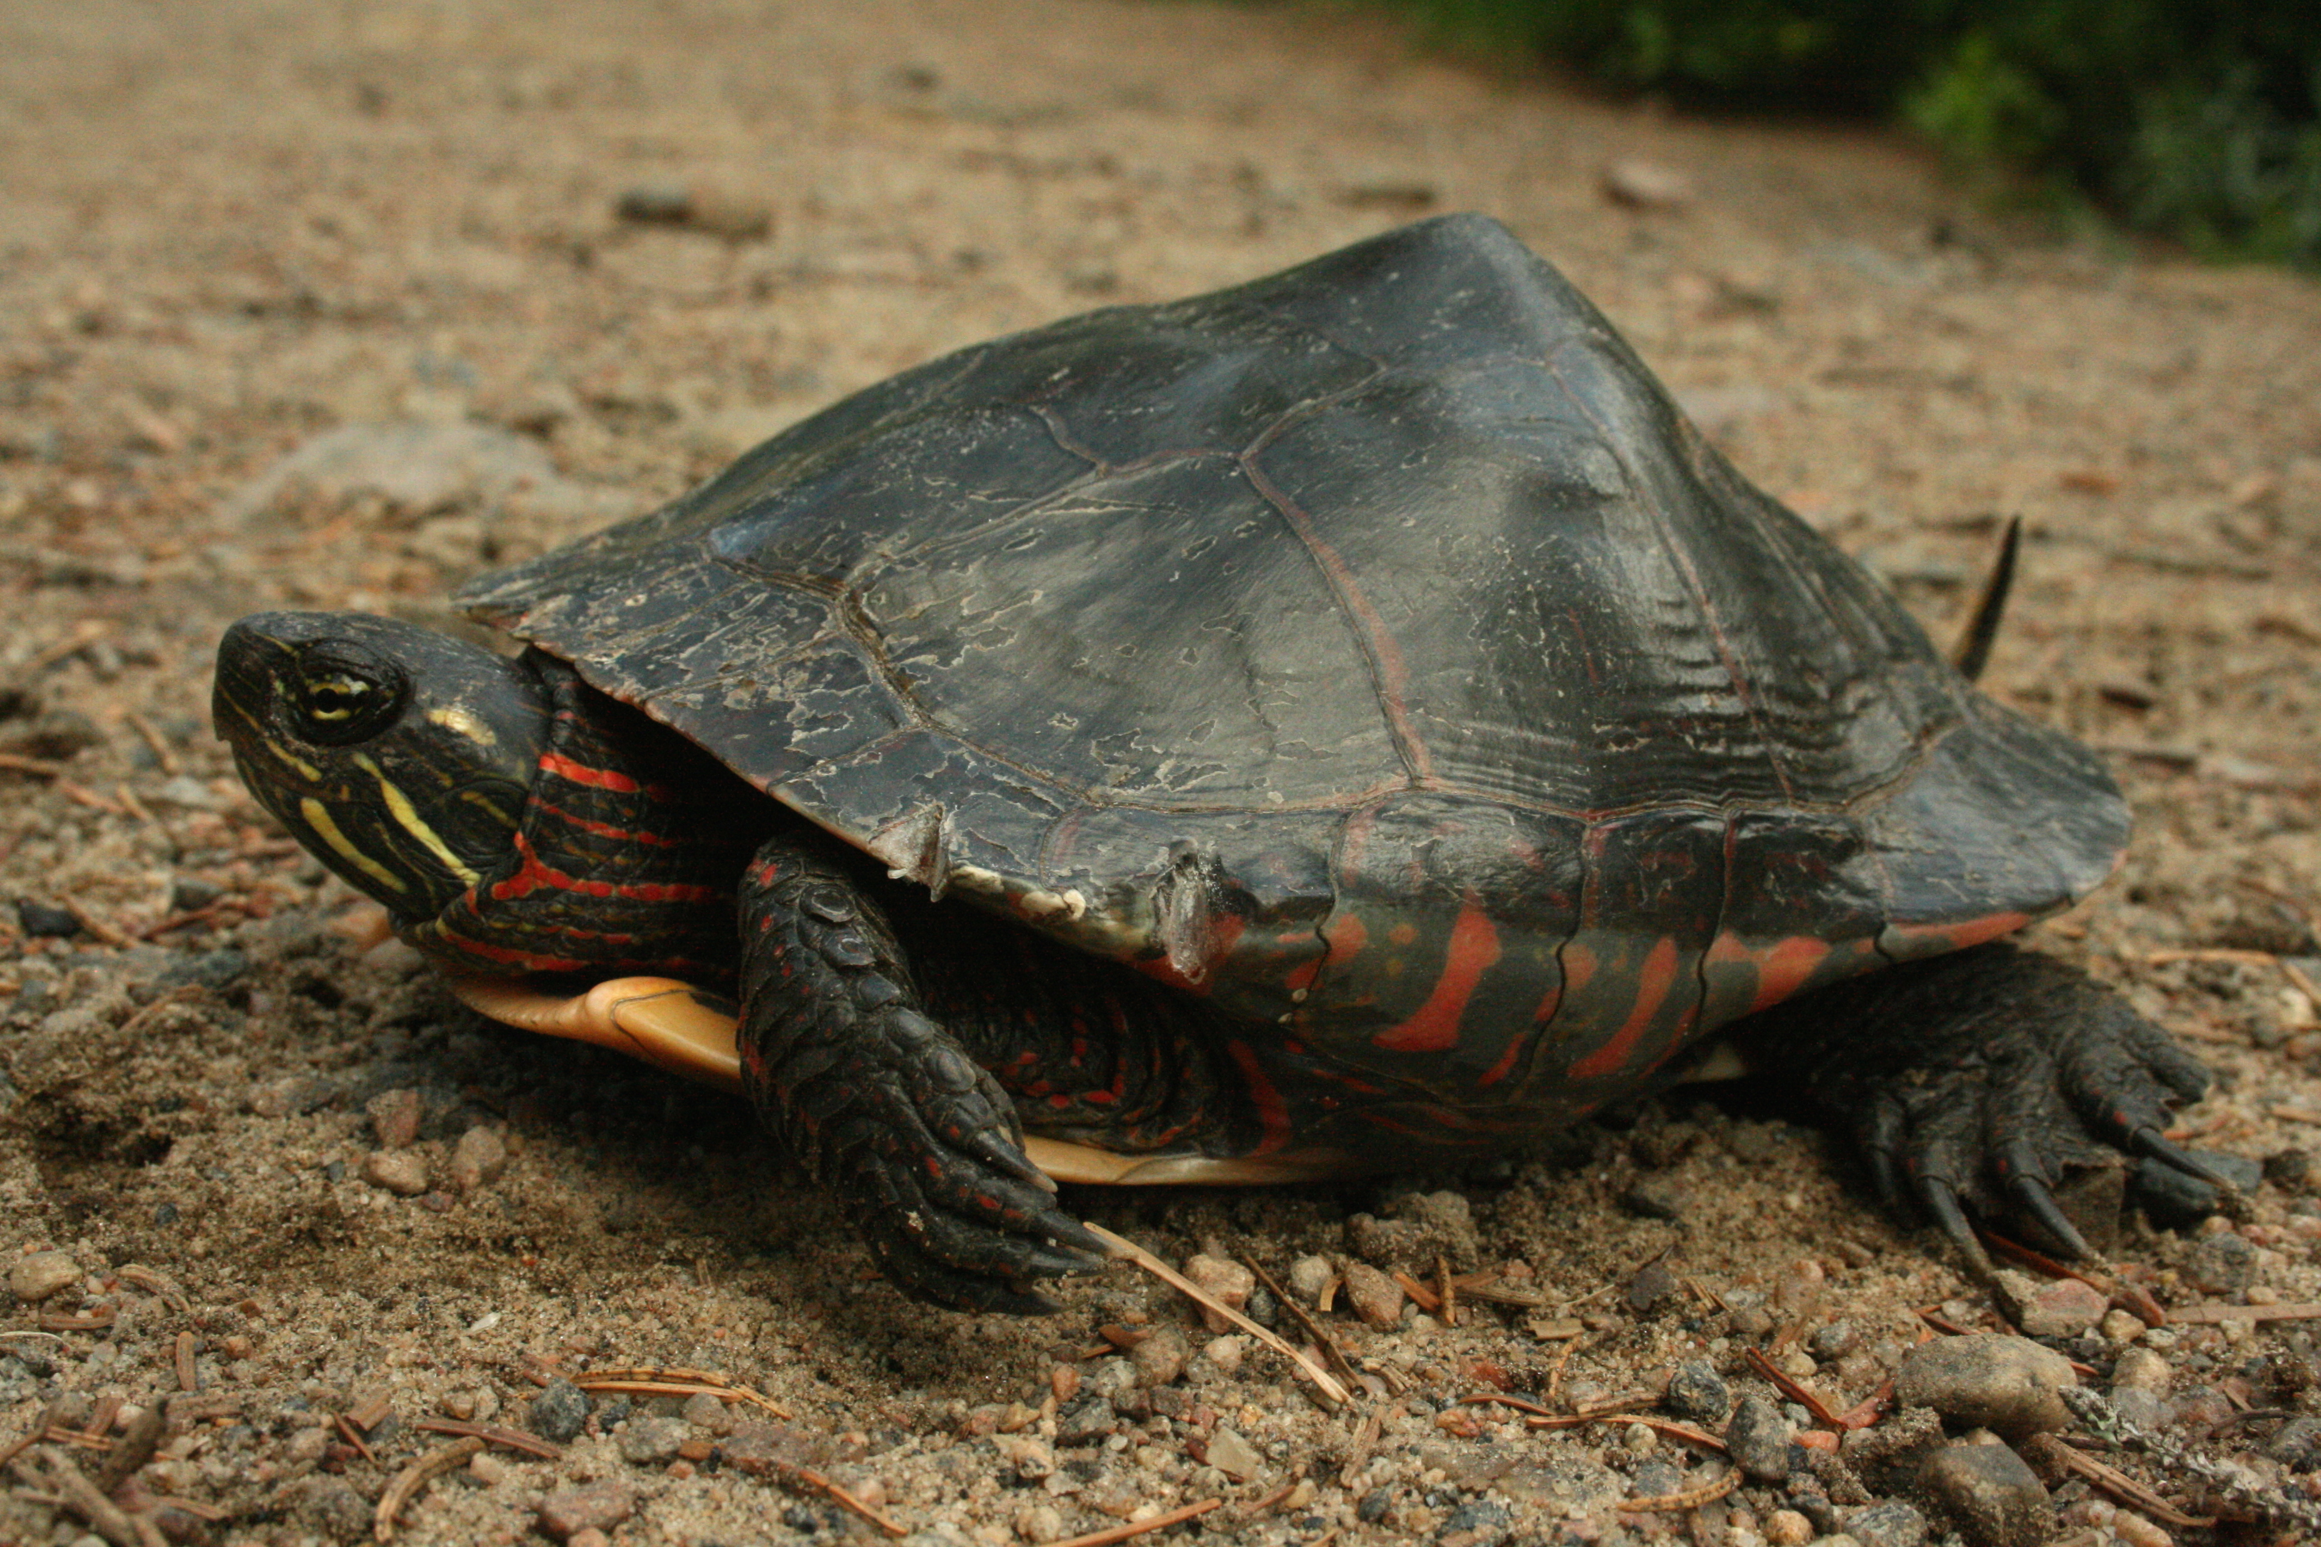
Moldowan et al. Figure 1
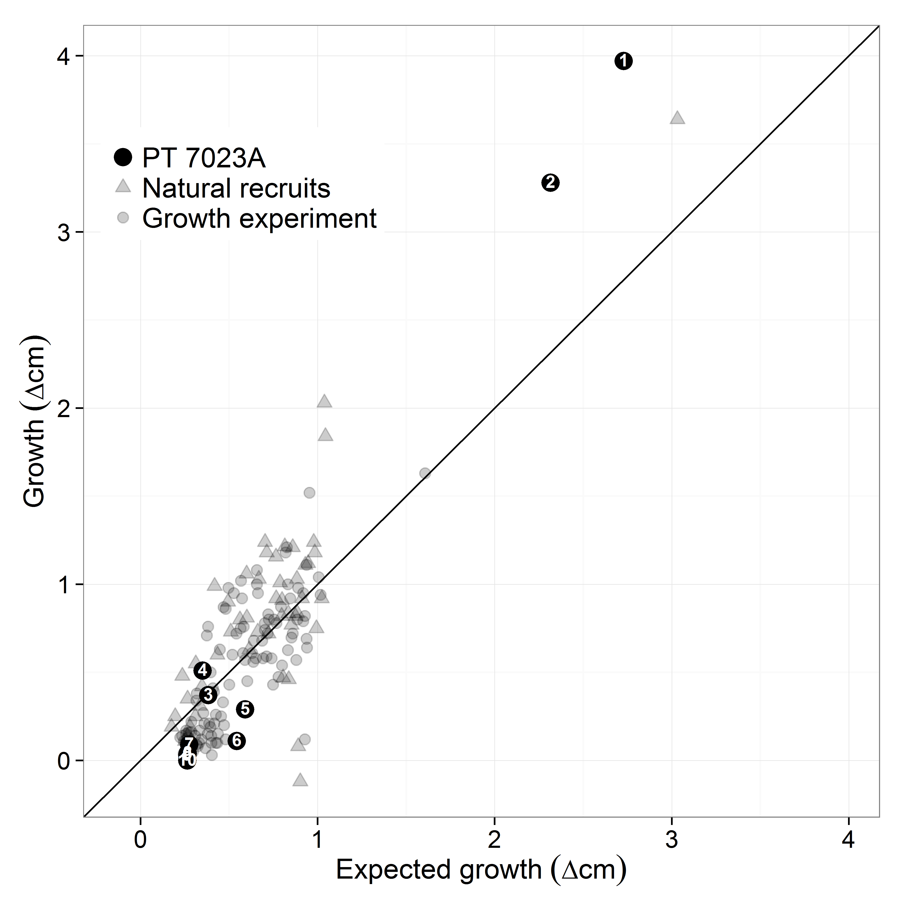
Moldowan et al. Figure 2

